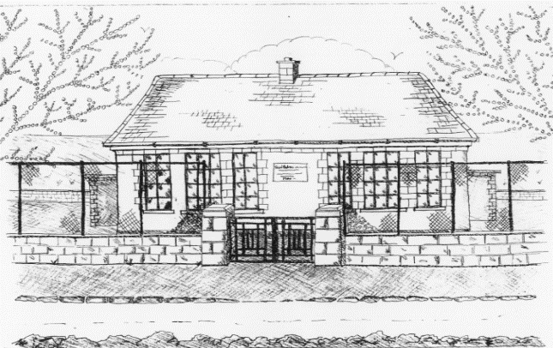
Board of Management,
St. Patrick’s National School,
Glencullen,
Dublin 18.
Tel: (01) 2954255
Email principal@glencullenschool.ie
secretary@glencullenschool.ie
Roll Number: 17507F
www.glencullenschool.ie

Class Allocation Policy/Multi-grade Classes

Background and Rationale

Department of Education staffing schedule, which is available on www.education.ie, identifies that based on our enrolment numbers for September of the previous year it will be necessary to divide one or more classes for the current academic year.

Criteria for splitting classes:

1. Following good practice and direction from the D.E.S. (Circular 19/2019)-
“Posts allocated on the basis of the staffing schedule are specifically for mainstream classes and should be deployed accordingly. School authorities are requested to ensure that the number of pupils in any class is kept as low as possible, taking all relevant contextual factors into account (e.g. classroom accommodation, fluctuating enrolment etc.). However, school authorities should, where possible, use their autonomy under the staffing schedule to implement smaller class sizes for junior classes.”
2. Teacher input - taking special needs & academic inclusiveness into account
3. Maturity and gender balance – equally weighted
4. Parent & pupil input – taking friendships and siblings into account

The criteria for dividing the class will rest ultimately with the Board of Management.

While we realise that it is not the ideal situation to separate a class, please be assured that the children will follow the same curriculum, use the same learning materials, and have the same educational opportunities.

This policy was ratified by the Board of Management on 31st May 2019.

