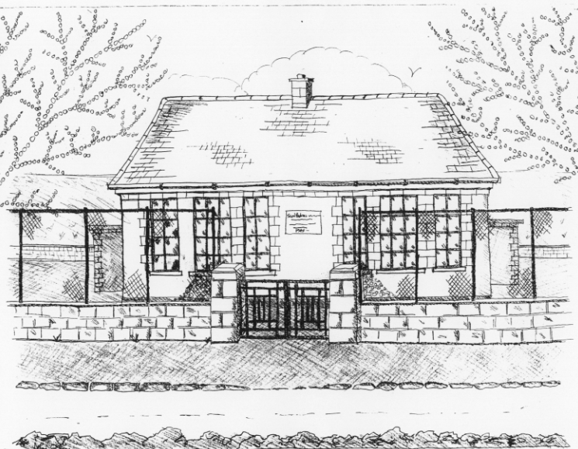 St. Patrick’s NS Booklist 2022-2023

Junior Infants Class

Books to be purchased by Parents

Books to be Bought

Just Phonics 42 Sounds Junior Infants (Educate.ie) [Available in Easons bookstore or on www.schoolbooks.ie]
Operation Maths (At School book & At Home book – PACK) Edco
Grow in Love Junior Infants (Veritas)
All Write Now Junior Infants (Folens)

Copies & Ancillary materials

2 x 15A Project copies (half blank, half lined)
1 x 20pg Display Folder (Poetry)
1 plastic Zip folder A4 (homework)
1 cardboard manila folder (finished worksheets)

Each child will need a pencil case containing the following items;

2 pencils, 1 rubber, 1 sharpener, 1 x 12 pack of twistable crayons , 1 large Pritt Stick Glue, 1 Thin Whiteboard Marker. This pencil case will be left in school.

School Costs

Art & Crafts Fees  Photocopying Fees  Book Rental Scheme for English Reading | €20  €20  €5

- School opens 9.20am on Thursday September 1st 2022
- Junior Infants will finish @ 12.30pm for their first 2 days
- Please pay Art & Craft fees before end of September if possible.
Fees are payable by cash (sealed envelope to school office clearly marked with name), or cheque (payable to St. Patrick’s NS) or via card payment on the Databiz portal.
Databiz instructions & link for new Jr. Infant parents will be emailed to you in early September.

**Please write your child’s name on all books, coats, hats, jumpers/cardigans lunch box, drink container and other belongings.

