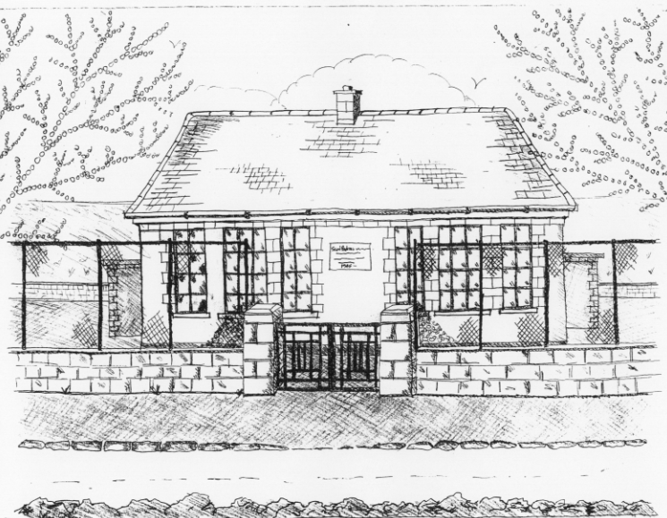 St. Patrick’s NS Booklist 2022-2023

6th Class

Books to be Bought  Spellings For Me (6th Class book)  Léigh sa Bhaile (F) (C.J. Fallon)  Master Your Maths 6 (CJ Fallons)  Planet Maths 6 (Folens)  My Confirmation Year (Veritas)  Abair Liom 6 (Folens)  New Wave English 6 (Prim Ed) | Books to be Kept  English/Irish Dictionary (home)  D Tin Whistle  Bí ag Scriobh Card (if lost purchase in school office for 2euro)  Poetry Folder
Copies & Ancillary materials  Keep  2 Sum Copies 120 page 7mm. Hard Covered Copy  10x 88page page writing copies. USB 2 GB Key  2 x 40 page copies. Calculator  Homework Journal (Fallons)  1 x 40pg Display Folder (Finished Work)  1 large Glue Stick | Keep  Hard Covered Copy (Gaeilge)  USB 2 GB key  Calculator  Geometry set  A2 Card Art Folder

School Costs
Art & Crafts Fees  Photocopying Fees  Book Rental Scheme Fee (please see overleaf for books included) | €15  €15  €25
TOTAL: | €55

- School opens 9.20am on Thursday September 1st 2022
- Please pay Art & Craft fees before end of September if possible.
Fees are payable by cash (sealed envelope to school office clearly marked with name), or cheque (payable to St. Patrick’s NS) or via card payment on the Databiz portal.

Please mark your child’s name clearly on all books, coats, hats cardigans/jumpers and other belongings

School Rental Scheme: 6th class

 | Purchasing Price
SESE  Explorers History  Explorers Geography & Science  Atlas | €13.60  €13.60  €14.00
English  Oxford English Dictionary  Class Novels (estimated 4-5)  Read at Home 6 (CJ FALLON) | €12.80  €9.99 each  €16.95
Gaeilge  Léigh sa Bhaile (F) C.J. Fallon  Focloir Gaeilge  Grammar Le Chéile 6 | €15.95  €20.35  €12.95
Religion  Alive O 8 | €12.45

