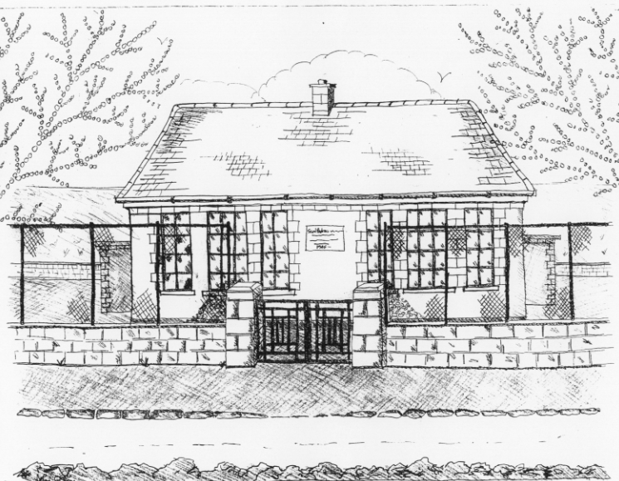 St. Patrick’s NS Booklist 2022-2023

5th Class

Books to be Bought  Léigh sa Bhaile (E) (C.J. Fallon)  Master Your Maths 5 (CJ Fallon)  Planet Maths 5 (Folens)  New Wave English 5 (Prim Ed)  Abair Liom G (Folens | Books to be Kept in school  Poetry Folder
Copies & Ancillary materials  2 Sum Copies 88 Page 7mm Keep2 Sum Copies 88 page 7mm. Hard Covered Copy  6x 88-page page writing copies. USB 2 GB Key  2 x 40 page copies.  1 x B4 handwriting copy  Hard Covered Copy (for Gaeilge)  Calculator (with %sign)  Geometry Set  Homework Journal (Fallons)  1x hard-backed A4 folder with 10xdividers  1 x 40page Display Folder (Finished Work)  1 LARGE Glue Stick | Keep  USB 2 GB key
School Costs
Art & Crafts Fees  Photocopying Fees  Book Rental Scheme Fee (please see overleaf for books included) | €15  €15  €25
TOTAL: | €55

- School opens 9.20am on Thursday September 1st 2022
- Please pay Art & Craft fees before end of September if possible.
Fees are payable by cash (sealed envelope to school office clearly marked with name), or cheque (payable to St. Patrick’s NS) or via card payment on the Databiz portal.

Please mark your child’s name clearly on all books, coats, hats cardigans/jumpers and other belongings

School Book Rental Scheme 5th Class (€25 as above)
 | Purchasing Price
SESE  Explorers History  Explorers Geography & Science  Atlas | €13.60  €13.60  €14.00
English  Word Wizard (Gill Education)  Oxford English Dictionary  Class Novels (estimated 4-5)  Read at Home 5 (CJ Fallon) | €9.95  €9.95  €9.99 each  €15.95
Gaeilge  Léigh sa Bhaile (E) C.J. Fallon)  Focloir Gaeilge  Grammar le Chéile 5 | €15.95  €20.35  €12.95
Religion  Grow in Love 7 | €14.99

