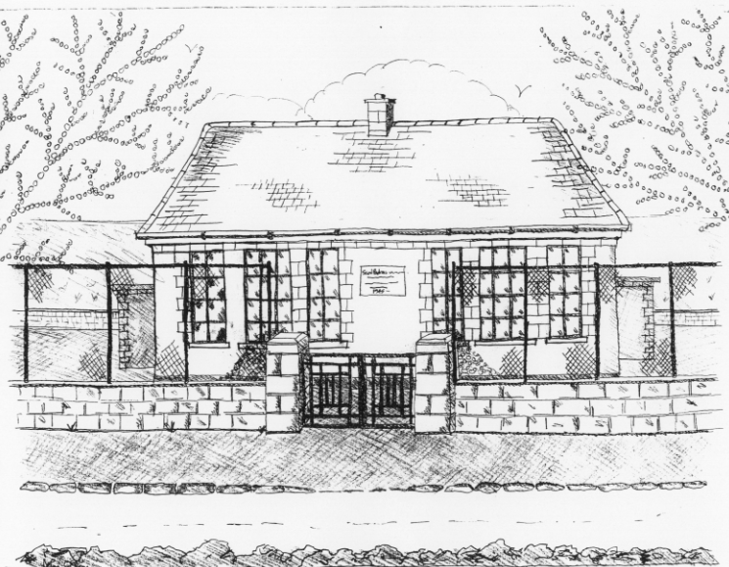 St. Patrick’s NS Booklist 2022-2023

4th Class

Books to be Bought  Léigh sa Bhaile (D) (C.J. Fallon)  Master Your Maths 4 (CJ Fallon)  Planet Maths 4 (Folens)  Abair Liom F (Folens)  New Wave English 4 (Prim Ed) | Books & items to be kept  Graiméar le cheile Rang 3 & 4  (keep from last year!)  D Tin Whistle  Tin Whistle Music Folder
Copies & Ancillary materials
2 Sum Copies 88 Page 7mm
6x 88page page writing copies.
1 x 40 page copies.
2 x handwriting copies B4 Lines
USB 2 GB key
Homework Journal (Fallons)
1 x 40pg Display Folder (Finished Work)
A2 card Art Folder
Calculator
1x ruler
1x whiteboard marker
1x set of twistables/or coloured pencils
2x large glue sticks
Each Child should bring a pencil case to school each day with:
2x pencils, 1xeraser, 1xsharpener
School Costs
Art & Crafts Fees  Photocopying Fees  Book Rental Scheme Fee (please see overleaf for books included)  Friends for Life Workbook (supplemented by B.O.M.) | €15  €15  €15
TOTAL: | €45

- School opens 9.20am on Thursday September 1st 2022
- Please pay Art & Craft fees before end of September if possible.
Fees are payable by cash (sealed envelope to school office clearly marked with name), or cheque (payable to St. Patrick’s NS) or via card payment on the Databiz portal.

Please mark your child’s name clearly on all books, coats, hats cardigans/jumpers and other belongings

School Book Rental Scheme 4th Class (€15 as above)

School Rental Scheme 4th Class | Purchasing Price
SESE  Explorers History 4th Class (Folens)  Explorers Geography & Science 4th Class (Folens)  Atlas | €13.15  €13.15  €14.00
English  Word Wizard (Gill Education)  Oxford English Dictionary & Thesaurus  Class Novels (3/4 )  My Read at Home 4 (CJ Fallon) | €9.95  €12.80  €9.99 each  €15.95
Religion  Grow in Love 4th Class | €12.99

