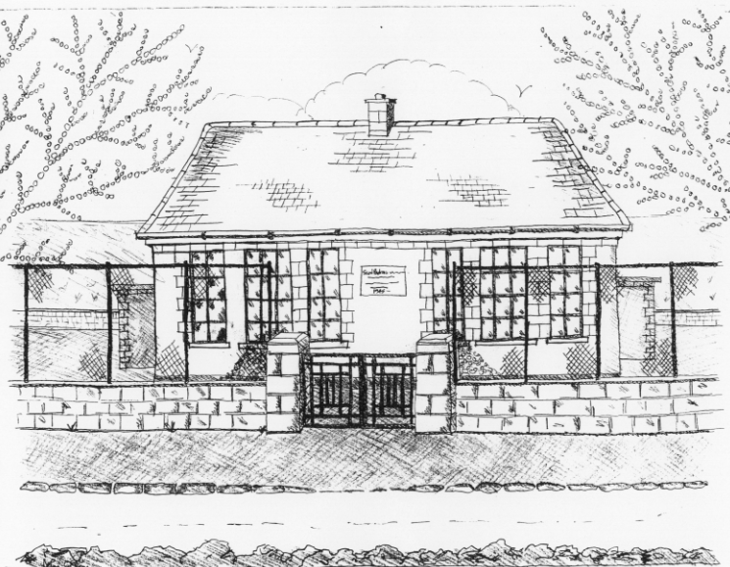 St. Patrick’s NS Booklist 2022-2023
3rd Class

Books to be Bought
Léigh sa Bhaile – Leabhar C (C.J. Fallon)
Master Your Maths 3. (C.J Fallon)
Planet Maths 3 (Folens)
All Write Now 3rd class (Folens) – cursive Level A
D Tin Whistle
New Wave English in Practice 3rd Class (Prim Ed)
Bua na Cainte 3 (Edco)
& Bua na Cainte 3 Leabhar Litrithe (Edco)
Graiméar le cheile Rang 3 & 4 (Edco)

Copies & Ancillary materials
2 x Sum Copies 88 Page 7mm
8 x 88page page writing copies.
2 x 40 page copy

Homework Journal (Fallons)
1 x 10pg Display Folder (Tin whistle music)
2 x Manilla Folder (Finished Work)
2 x Pritt Stick
School Costs
Art & Crafts Fees  Photocopying Fees  Book Rental Scheme Fee (please see overleaf for books included) | €15  €15  €15
TOTAL: | €45

- School opens 9.20am on Thursday September 1st 2022
- Please pay Art & Craft fees before end of September if possible.
Fees are payable by cash (sealed envelope to school office clearly marked with name), or cheque (payable to St. Patrick’s NS) or via card payment on the Databiz portal.

Please mark your child’s name clearly on all books, coats, hats cardigans/jumpers and other belongings

School Book Rental Scheme 3rd Class (€15 as above)
 | Purchasing Price
SESE  History Quest  Geography Quest  Windows of the World Geography  Windows of the World History  Atlas | €11.30  €11.30  €8.95  €8.95  €14.00
English  Class Novels (3 – 4)  Dragons, Jungles & Dinosaurs  Dragons, Jungles & Dinosaurs skills book  Read at Home  Oxford English Dictionary | €7.99 each  €14.95  €9.50  €16.95  €9.95 each
Religion  Grow in Love 3rd Class | €12.99

