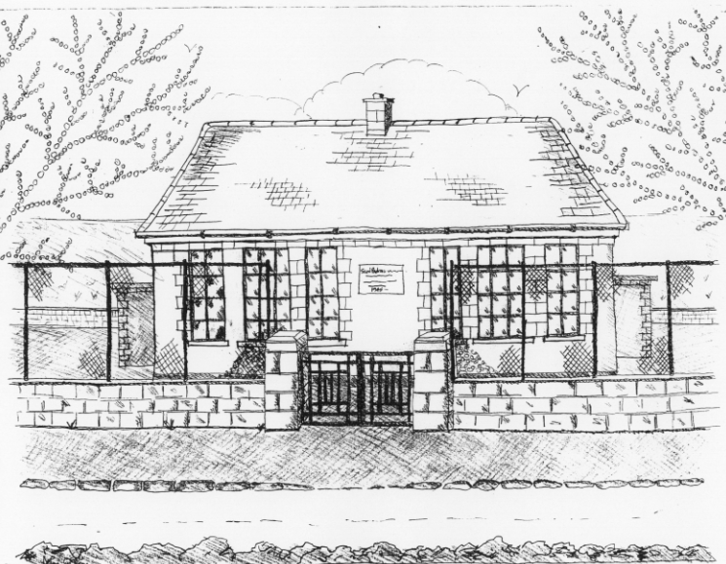 St. Patrick’s NS Booklist 2022-2023

2nd Class
Books to be Bought
Master Your Maths 2. (CJ Fallon)
Operation Maths (At School book & At Home book – PACK) Edco
Grow In Love 2nd Class (Veritas)
All Write Now 2nd class (Folens)
Grammer 2 Pupil Book (Jolly Phonics)
Bua na Cainte 2 (Edco)
Explorers (SESE) (Folens)
Copies & Ancillary Materials
2 Sum Copies 40 Page 10mm
6 x 40page writing copies
Homework Journal (Fallons)
1 x 40pg Display Folder (Finished Work)
1x A2 Card Art Folder
Each child will need a pencil case with the following items.
2 pencils, 1 rubber, 1 x 12 pack twistable colours, 2 large Pritt Stick Glue, 1 Whiteboard Marker

School Costs  Art & Crafts Fees  Photocopying Fees  Book Rental Scheme Fee (please see below for books included) | €15  €15  €10
TOTAL: | €40
- School opens 9.20am on Thursday September 1st 2022
- Please pay Art & Craft fees before end of September if possible.
Fees are payable by cash (sealed envelope to school office clearly marked with name), or cheque (payable to St. Patrick’s NS) or via card payment on the Databiz portal.

Books in our School Book Rental Scheme 2nd Class (€10 as above)
 | Purchasing Price
SESE  History Quest 2  Geography Quest 2 | €9.30  €9.30
English  Class Novels (1 – 2)  Ancillary Readers (approx. 20)  Oxford English Dictionary  Guided Reading Scheme | €9.99 each  €7.99 each  €9.95 each

