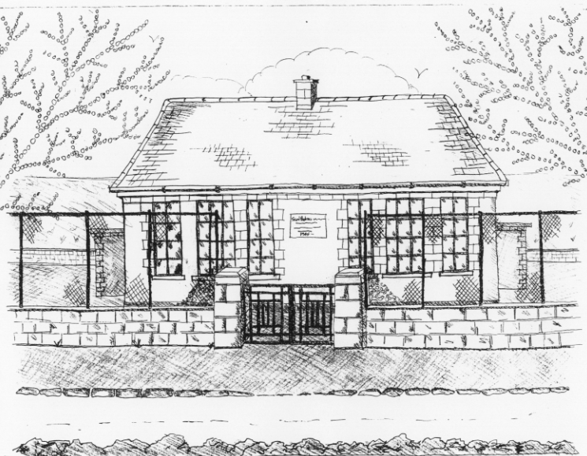 **St. Patrick’s NS Booklist 2022- 2023 **

**1st Class**

|  |
| --- |
| **Books to be Bought**  Master Your Maths 1. (CJ Fallon)  Operation Maths (At School book & At Home book – PACK) Edco  All Write Now 1st class (Folens)  Grow in Love 1st Class Workbook (Veritas)  Jolly Phonics Grammer 1 Pupil book  Bua na Cainte 1 (Edco)  Explorers (SESE) (Folens) |
| **Copies & Ancillary materials**  2Sum Copies 40 Page 10mm  2 X 40 page writing copies  2 x 15A project copies  1 x Blank copies (no lines) .  Homework Journal (Fallons)  1 x 20pg Display Folders (for finished work)  1 x A4 zipped folder (for homework)  1x A5 zipped folder (for reader)  Each child will need a pencil case containing the following;  3 x pencils  1 x rubber  1x sharpener  1x 12 pack twistable crayons(or colouring pencils)  2 x large Pritt stick Glue |

**School Costs**

|  |  |
| --- | --- |
| Art & Crafts Fees  Photocopying Fees  Book Rental Scheme Fee *(please see below for books included)* | **€15**  **€15**  **€20** |
| **TOTAL:** | **€50** |

* School opens 9.20am on Thursday September 1st 2022
* Please pay Art & Craft fees before end of September if possible.

Fees are payable by cash (sealed envelope to school office clearly marked with name), or cheque (payable to St. Patrick’s NS) or via card payment on the *Databiz* portal.

**Books in our School Book Rental Scheme 1st Class (€20 as above)**

|  |  |
| --- | --- |
|  | **Purchasing Price** |
| **English**  Guided readers (approx. 40 per child)  Ancillary Readers (approx. 20 per child)  Whole Class Real Book Reading (approx. 3) | **€4.50 each**  **€7.99 each**  **€7.99 each** |

**Please put your child’s name on all books, coats, hats, jumpers/cardigans, drink container, lunch box and other belongings.**