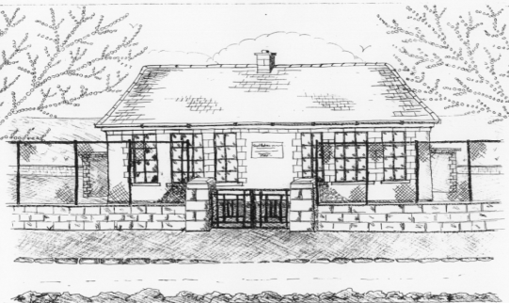
St. Patrick’s National School,
Glencullen,
Dublin 18.
Tel (01) 2954255
Email: secretary@glencullenschool.ie
www.glencullenschool.ie
Roll Number: 17507F

Reminder Letter to Parents RE: Code of Behaviour
Dear Parent(s) / Guardian(s),
Your child has now received 2 cards; you are receiving this reminder letter as stated in our behaviour policy. Please talk to your child and remind him /her of the importance of keeping the following rule / rules:
❑ Behaving in class.
❑ Behaving in yard.
❑ Not deliberately hurting others.
❑ Listening and paying attention.
❑ Having respect for all members of the school community.
❑ Having respect for school property, their own belongings and others.
Teacher’s comments: ______________________________________________ ______________________________________________________________ ______________________________________________________________ ______________________________________________________________

Signed: ________________________ Date:_______________

I have talked to my child about the above rules and he / she promises to try harder.
Signed: ____________________ (Parent / Guardian)

