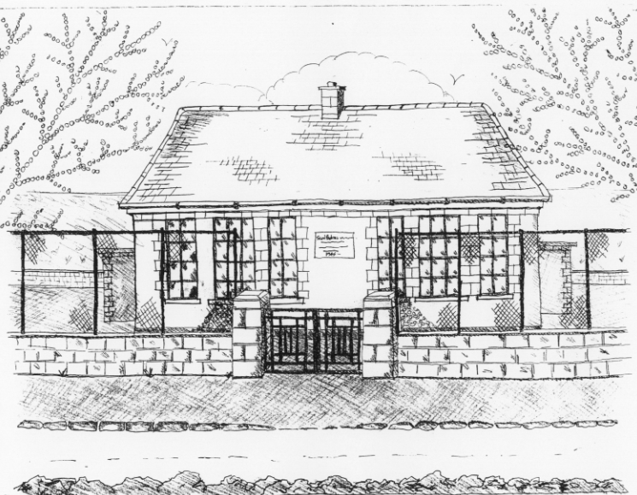 St. Patrick’s NS Booklist 2021-2022

Junior Infants Class

Books to be purchased by Parents

Books to be Bought

Just Phonics 42 Sounds Junior Infants (Educate.ie) [Available in Easons bookstore or on www.schoolbooks.ie]
Planet Maths Junior Infants (Folens)
Planet Maths Junior Infants Number Practice (Folens)
Grow in Love Junior Infants (Veritas)
All Write Now Junior Infants (Folens)

Copies & Ancillary materials

2 x 15A Project copies (half blank, half lined)
1 x 20pg Display Folder (Poetry)
1 plastic Zip folder A4 (homework)
1 cardboard manila folder (finished worksheets)

Each child will need a pencil case containing the following items;

2 pencils, 1 rubber, 1 sharpener, 1 x 12 pack of twistable crayons , 1 large Pritt Stick Glue, 1 Thin Whiteboard Marker. This pencil case will be left in school.

School Costs

Art & Crafts Fees  Photocopying Fees  Book Rental Scheme for English Reading | €20  €20  €5
- A date for the reopening of the School is not available yet.
- Junior Infants usually go home at 12pm for the first few days.
- We will email the date as soon as we know.

**Please write your child’s name on all books, coats, hats, jumpers/cardigans lunch box, drink container and other belongings.

