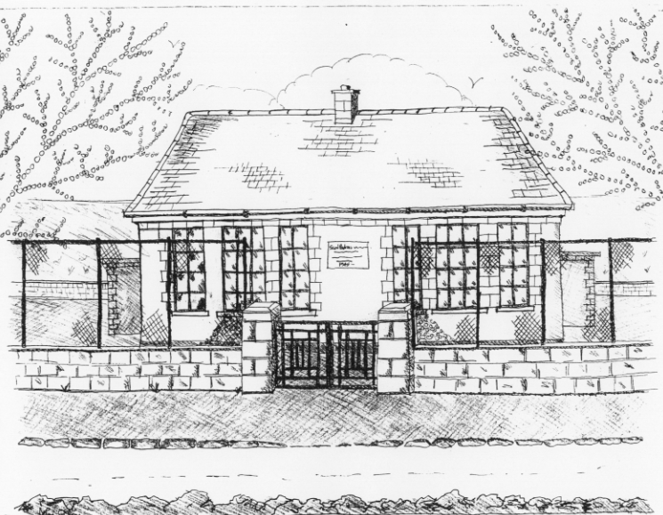
St. Patrick’s National School,
Glencullen,
Dublin 18.
Tel (01) 2954255
Email: secretary@glencullenschool.ie
Roll Number: 17507F

HOLIDAY LIST FOR SCHOOL YEAR 2021– 2022

School Re-opens Wednesday 1st September 2021 at 9.20am.

Mid-Term Break School closes Friday 22nd October at 3pm
Re-opens Monday 1st November

School Closure School closed Friday 10th December

Christmas Holidays School closes on 22nd December at 12.30pm.
Re-opens on Thursday 6th January 2022

Mid-Term Break School closes on Tuesday 22nd Feb. at 3pm
Re-opens on Monday 28th February

St. Patrick’s Day School closed Thursday 17th and Friday 18th March

Easter Holidays* School closes on Friday 8th April at 12.30pm
Re-opens on Monday 25th April

May Bank Holiday School closed on Monday 2nd May

June Bank Holiday School closed on Friday 3rd and Monday 6th June

Summer Holidays School closes on Thursday 30th June at 12.30pm
* Following Circular 34/2011, please note that the Easter holidays may be subject to change should there be any unforeseen closures during the year (such as snow). Under this circular, the Easter break may be reduced by up to 3 days to make up for closures. Please be aware of this when booking holidays.

