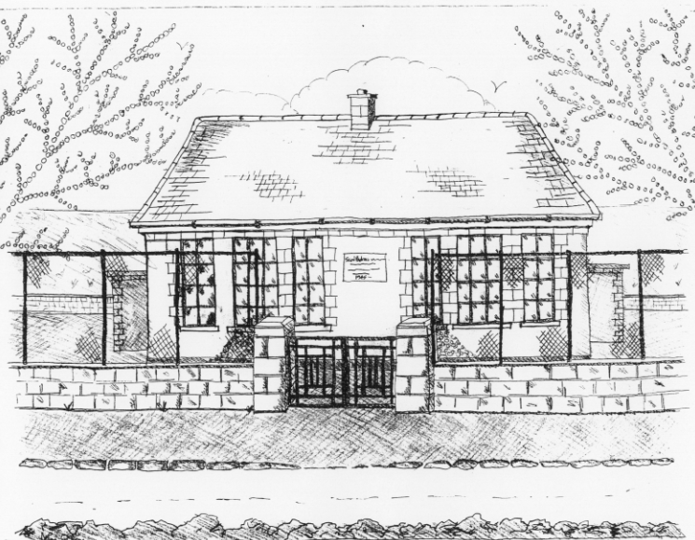 St. Patrick’s NS Booklist 2021-2022

6th Class

Books to be Bought  Spellbound F. (Folens)  Am Don Léamh 6 (Folens)  Master Your Maths 6 (CJ Fallons)  Planet Maths 6 (Folens)  My Confirmation Year (Veritas)  Abair Liom 6 (Folens)  New Wave English 6 (Prim Ed) | Books to be Kept  English/Irish Dictionary (home)  D Tin Whistle  Bí ag Scriobh Card (if lost purchase in office)  Poetry Folder
Copies & Ancillary materials  Keep  2 Sum Copies 88 page 7mm. Hard Covered Copy  10x 88page page writing copies. USB 2 GB Key  2 x 40 page copies. Calculator  Homework Journal (Fallons)  1 x 40pg Display Folder (Finished Work)  1 large Glue Stick | Keep  Hard Covered Copy (Gaeilge)  USB 2 GB key  Calculator  Geometry set  A2 Card Art Folder

School Costs
Art & Crafts Fees  Photocopying Fees  Primary Planet Magazine  Book Rental Scheme Fee (please see overleaf for books included)  Grammar le Cheile | €10  €10  €10 (Supplemented by fundraising)  €25
TOTAL: | €55

Costs can be paid in full or in instalments as suits and online payment will be available in September.
Alternatively, please enclose in an envelope labelled with your child’s name and class and amount enclosed.

Please put your child’s name on all books, coats, hats, jumpers/cardigans and other belongings.

School re-opens on 1st September 2021

School Rental Scheme: 6th class

 | Purchasing Price
SESE  History Quest  Geography Quest  Windows of the World Geography  Windows of the World History  Atlas | €11.90  €11.90  €9.95  €9.95  €14.00
English  Snakes, Eyeballs and Indians Reader (Gill & Macmillan)  Snakes, Eyeballs and Indians Skills Book  Lift off 6  Oxford English Dictionary  Class Novels (estimated 4-5)  Read at Home 6 (CJ FALLON) | €16.95  €9.75  €9.75  €12.80  €9.99 each  €16.95
Gaeilge  Sin É 6  Bun go Barr 6  Focloir Gaeilge | €19.40  €20.35  €12.25
Religion  Alive O 8 | €12.45

