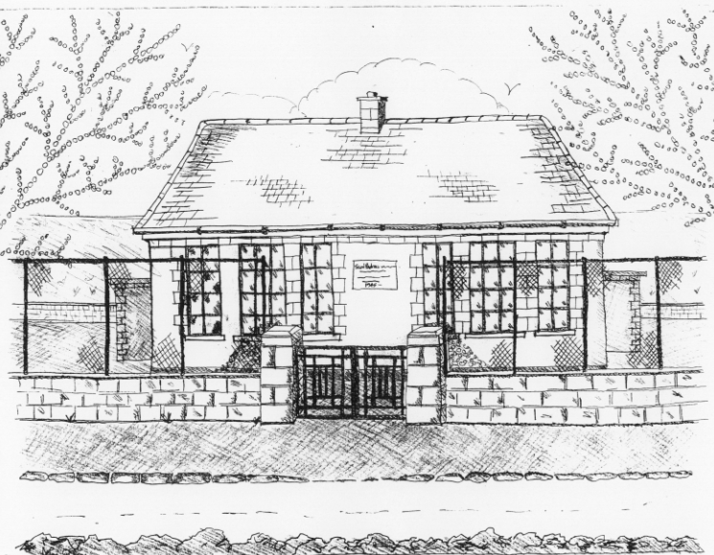 St. Patrick’s NS Booklist 2021-2022

5th Class

Books to be Bought  Spellbound E. (Folens)  Am Don Léamh 5 (Folens)  Master Your Maths 5 (CJ Fallon)  Planet Maths 5 (Folens)  New Wave English 5 (Prim Ed)  Abair Liom G (Folens | Books to be Kept in school  Tin Whistle Music Folder  Poetry Folder
Copies & Ancillary materials  2 Sum Copies 88 Page 7mm Keep2 Sum Copies 88 page 7mm. Hard Covered Copy  6x 88page page writing copies. USB 2 GB Key  2 x 40 page copies.  1 x B4 handwriting copy  Hard Covered Copy (for Gaeilge)  Calculator (with %sign)  Geometry Set  Homework Journal (Fallons)  A2 card Art Folder  1 x 40page Display Folder (Finished Work)  1 LARGE Glue Stick | Keep  USB 2 GB key  D Tin Whistle
School Costs
Art & Crafts Fees  Photocopying Fees  Primary Planet Magazine  Book Rental Scheme Fee (please see overleaf for books included)  Bí ag Scriobh Card can be bought through the school in September €3 | €10  €10  €10 (Supplemented by fundraising)  €25
TOTAL: | €55

Costs can be paid in full or in instalments as suits and online payment will be available in September.
Alternatively, please enclose in an envelope labelled with your child’s name and class and amount enclosed.
Please put your child’s name on all books, coats, hats, jumper/cardigan and other belongings

School re-opens on 1st September 2021

School Book Rental Scheme 5th Class (€25 as above
 | Purchasing Price
SESE  History Quest  Geography Quest  Windows of the World Geography  Windows of the World History  Atlas | €11.90  €11.90  €9.95  €9.95  €14.00
English  Vampires Elephants & Aliens Reader (Gill & Macmillan)  Vampires Elephants & Aliens Skills  Lift off 5  Oxford English Dictionary  Class Novels (estimated 4-5)  Read at Home 5 (CJ Fallon) | €16.95  €9.75  €9.95  €12.80  €9.99 each  €16.95
Gaeilge  Sin E 5  Bun go Barr 5  Focloir Gaeilge  Grammar le Chéile 5 | €18.40  €20.35  €12.95
Religion  Grow in Love 7 | €14.99

