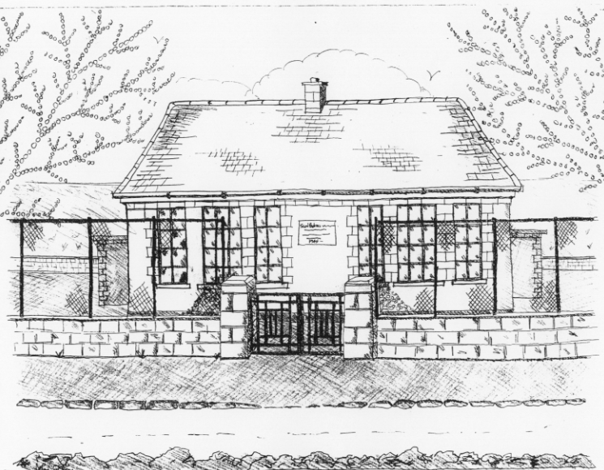 St. Patrick’s NS Booklist 2021-2022

4th Class

Books to be Bought  Spellbound D. (Folens)  Am Don Léamh 4 (Folens)  Master Your Maths 4 (CJ Fallons)  Planet Maths 4 (Folens)  Abair Liom F (Folens)  New Wave English 4 (Prim Ed) | Books to be Kept  D Tin Whistle  Tin Whistle Music Folder  Poetry Folder
Copies & Ancillary materials
2 Sum Copies 88 Page 7mm
6x 88page page writing copies.
1 x 40 page copies.
1 handwriting copy B4 Lines
USB 2 GB key
Homework Journal (Fallons)
1 x 40pg Display Folder (Finished Work)
A2 card Art Folder
Calculator
School Costs
Art & Crafts Fees  Photocopying Fees  Book Rental Scheme Fee (please see overleaf for books included)  Friends for Life Workbook (supplemented by B.O.M.)  Primary Planet | €10  €10  €15  €10
TOTAL: | €45

Costs can be paid in full or in instalments as suits and online payment will be available in September.
Alternatively, please enclose in an envelope labelled with your child’s name and class and amount

Please put your child’s name on books, coats, hats, jumper/cardigan and
Other belongings.

*School re-opens on 1st September 2021

School Book Rental Scheme 4th Class (€15 as above)

School Rental Scheme 4th Class | Purchasing Price
SESE  History Quest  Geography Quest  Windows of the World Geography  Windows of the World History  Atlas | €11.90  €11.90  €9.50  €9.50  €14.00
English  Witches, Spiders & Cowboys  Witches, Spiders & Cowboys Skills Book (Gill & Macmillan)  Oxford English Dictionary & Thesaurus  Class Novels (3/4 )  Read at Home (Fallons) | €15.95  €9.75  €12.80  €9.99 each  €16.95
Religion  Grow in Love 4th Class | €12.99

