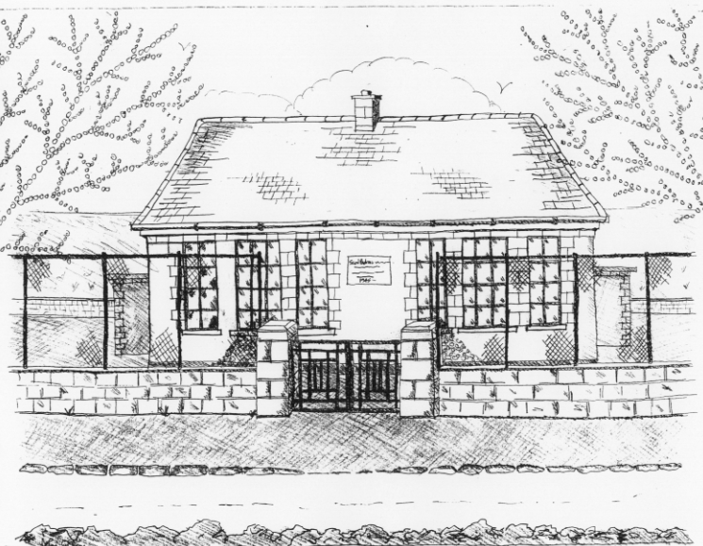 St. Patrick’s NS Booklist 2021-2022
3rd Class

Books to be Bought
Spellbound C. (Folens)
Am Don Léamh 3 (Folens)
Master Your Maths 3. (C.J Fallon)
Planet Maths 3 (Folens)
All Write Now 3rd class (Folens)
D Tin Whistle
New Wave English in Practice 3rd Class (Prim Ed)
Bua na Cainte 3 (Edco)
Graiméar le cheile Rang 3 & 4 (Edco)
Copies & Ancillary materials
2 Sum Copies 88 Page 7mm
8 x 88page page writing copies.
2 x 40 page copy

Homework Journal (Fallons)
1 x 10pg Display Folder (Tin whistle music)
1 x A4 Ring Binder( Self Assessment Learning Folder)
2 x Manilla Folder (Finished Work)
2 x Pritt Stick
School Costs
Art & Crafts Fees  Photocopying Fees  Book Rental Scheme Fee (please see overleaf for books included) | €10  €10  €15
TOTAL: | €35
Costs can be paid in full or in instalments as suits and online payment will be available in September.
Alternatively, please enclose in an envelope labelled with your child’s name and class and amount enclosed.

Please put your child’s name on all books, coats, hats cardigans/jumpers and other belongings

*School re-opens on 1st September 2021

School Book Rental Scheme 3rd Class (€15 as above)
 | Purchasing Price
SESE  History Quest  Geography Quest  Windows of the World Geography  Windows of the World History  Atlas | €11.30  €11.30  €8.95  €8.95  €14.00
English  Class Novels (3 – 4)  Dragons, Jungles & Dinosaurs  Dragons, Jungles & Dinosaurs skills book  Read at Home | €7.99 each  €14.95  €9.50  €16.95
Religion  Grow in Love 3rd Class | €12.99

