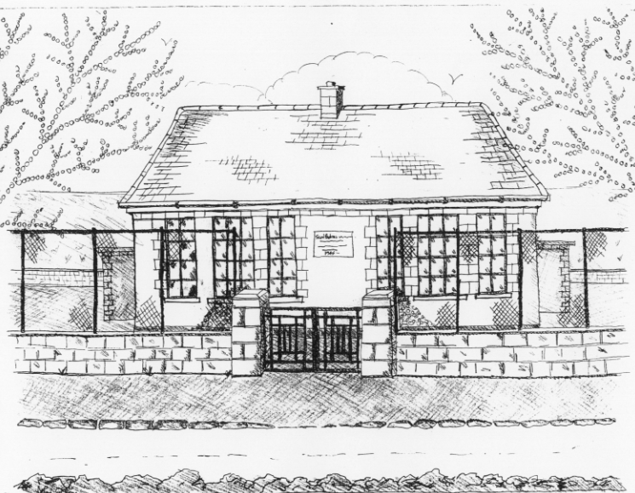 St. Patrick’s NS Booklist 2021-22

2nd Class

Books to be Bought
Master Your Maths 2. (CJ Fallon)
Planet Maths 2 (Folens)
Grow In Love 2nd Class (Veritas)
All Write Now 2nd class (Folens)
Grammer 2 Pupil Book (Jolly Phonics)
Bua na Cainte 2 (Edco)
Copies & Ancillary Materials
2 Sum Copies 40 Page 10mm
6 x 40page writing copies
Homework Journal (Fallons)
1 x 40pg Display Folder (Finished Work)

Each child will need a pencil case with the following items.
2 pencils, 1 rubber, 1 x 12 pack twistable colours, 2 large Pritt Stick Glue, 1 Whiteboard Marker

School Costs  Art & Crafts Fees  Photocopying Fees  Book Rental Scheme Fee (please see below for books included) | €10  €10  €10
TOTAL: | €30

Costs can be paid in full or in instalments as suits and online payment will be available in September.
Alternatively, please enclose in an envelope labelled with your child’s name and class and amount enclosed.
School Book Rental Scheme 2nd Class (€10 as above)
 | Purchasing Price
SESE  History Quest 2  Geography Quest 2 | €9.30  €9.30
English  Class Novels (1 – 2)  Ancillary Readers (approx. 20)  Guided Reading Scheme | €9.99 each  €7.99 each

*School re-opens on 1st September 2021

