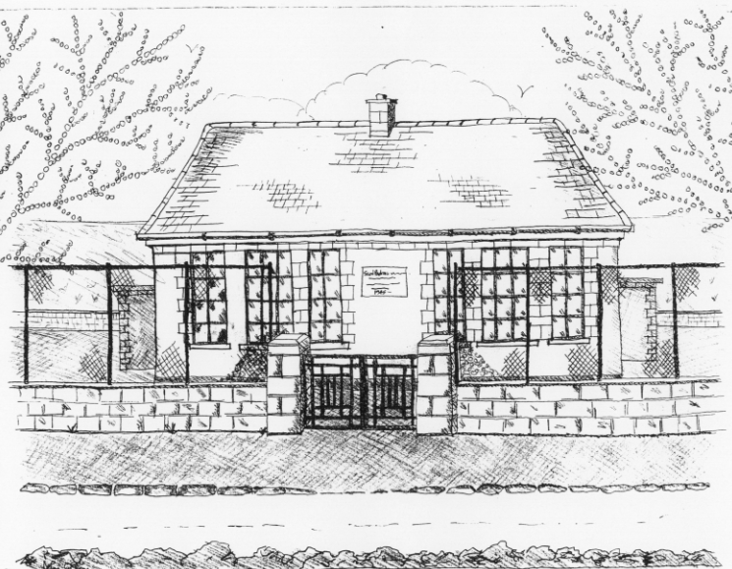 St. Patrick’s NS Booklist 2021- 2022
1st Class

Books to be Bought
Master Your Maths 1. (CJ Fallon)
Planet Maths 1 (Folens)
All Write Now 1st class (Folens)
Grow in Love 1st Class Workbook (Veritas)
Jolly Phonics Grammer 1 Pupil book
Bua na Cainte 1 (Edco)
Copies & Ancillary materials
2 Sum Copies 40 Page 10mm
2 X 40 page writing copies
3 x 15A project copies
1 x Blank copies (no lines) .
Homework Journal (Fallons)
1 x 20pg Display Folders (Self-Assessment Learning Folder)
1 x homework folder

Each child will need a pencil case containing the following;
2 pencils
1 rubber
1x12 pack twistable crayons(or colouring pencils)
1 large Pritt stick Glue

School Costs
Art & Crafts Fees  Photocopying Fees  Book Rental Scheme Fee (please see below for books included) | €10  €10  €20
TOTAL: | €40
Costs can be paid in full or in instalments as suits and online payment will be available in September.
Alternatively, please enclose in an envelope labelled with your child’s name and class and amount enclosed
School Book Rental Scheme 1st Class (€20 as above)
 | Purchasing Price
English  Guided readers (approx. 40 per child)  Ancillary Readers (approx. 20 per child)  Whole Class Real Book Reading (approx. 3) | €4.50 each  €7.99 each  €7.99 each
Please put your child’s name on all books, coats, hats, jumpers/cardigans, drink container, lunch box and other belongings.

*School re-opens on 1st September 2021

