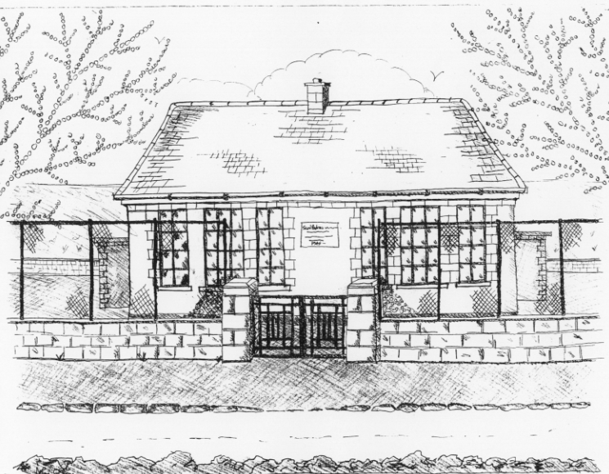
St. Patrick’s National School,
Glencullen,
Dublin 18.
D18 H504
Tel (01) 2954255
Email secretary@glencullenschool.ie
www.glencullenschool.ie
Roll Number: 17507F

ENROLMENT APPLICATION FORM YEAR__________

Class___________
Child’s Name
____________________________________

Address ____________________________________

____________________________________

Date of Birth: ____________________________________

Name of Parent(s) Guardian(s) ____________________________________

____________________________________

Contact Number Mother/Father ____________________________________

e-mail Address: ____________________________________

_____________________________________

Relevant information regarding your child’s health. Has your child got any allergies or medical problems? Yes No
If ‘Yes’ please give details

Has your child ever been referred for a psychological assessment or any other type of assessment (i.e.) Speech and Language, Behavioural, or Developmental?
Yes No
If ‘Yes’ please give details

_________________________________________________________________________________

To the best of my knowledge, the above information is both true and accurate.

Signed_________________________________ Signed_________________________________

Date of Application____________________________

