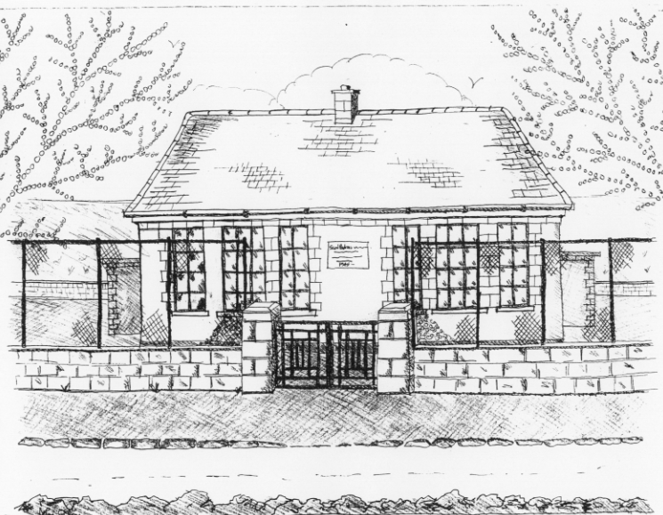
St. Patrick’s National School,
Glencullen,
Dublin 18.
Tel (01) 2954255
Email:
secretary@glencullenschool.ie
www.glencullenschool.ie
Roll Number: 17507F

Autumn Newsletter

Our New Junior Infants
There was a big welcome for our new Junior Infants. Ms. Mc Carthy and all 30 of them are well settled now and they can’t wait to get in the door in the morning!

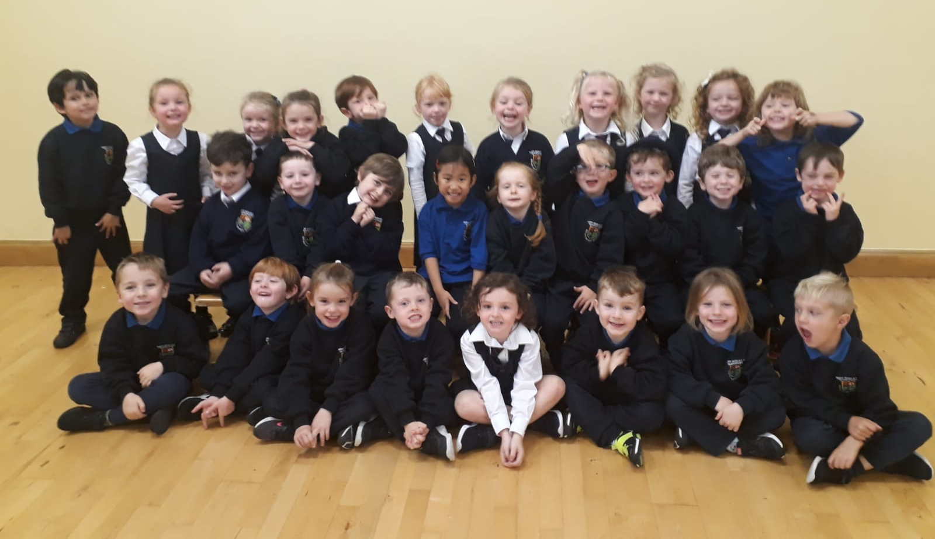

School Swimming
Swimming started on 12th September for 1st and 6th class and they are delighted to be back in the water! Swimming starts for 5th and 2nd class on the 7th November.

G.A.A
Football and Hurling coaching started on Wednesday 12th September. We welcome Gavin Weir, our coach back for his second year.

Cumann na mBunscol Matches
5th and 6th class together have a great football team this year and they have played every match with great skill, perseverance and team-work. They won all their matches and reached the quarter finals. Unfortunately they were beaten by Frances St. CBS on Friday 4th October. We were so proud of all of them and a huge thanks to Peter Keane, Diarmuid Coughlan, Brian Flynn and Gavin Weir for all their support. We had an assembly to congratulate the team and pizzas arrived for the team to enjoy. The team and the school were delighted to hear the news that we are getting a new school team kit very kindly sponsored by Philip Browne and organised by Nicola Coughlan and Norma Browne. We now look forward to the Hurling Competition and our new kit!

Cumann na mBunscol Team 2019-2020

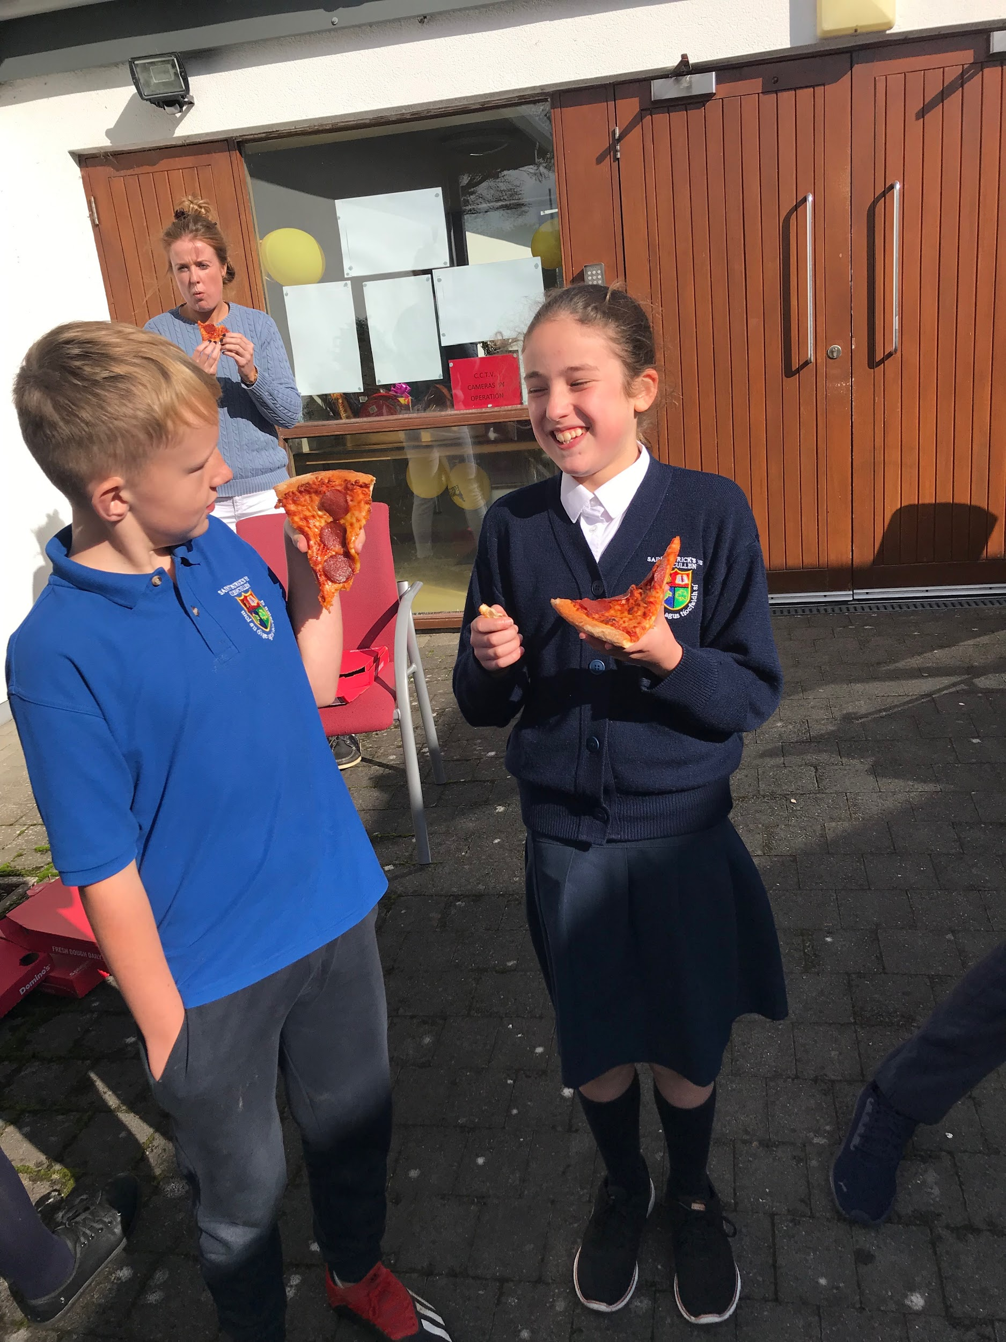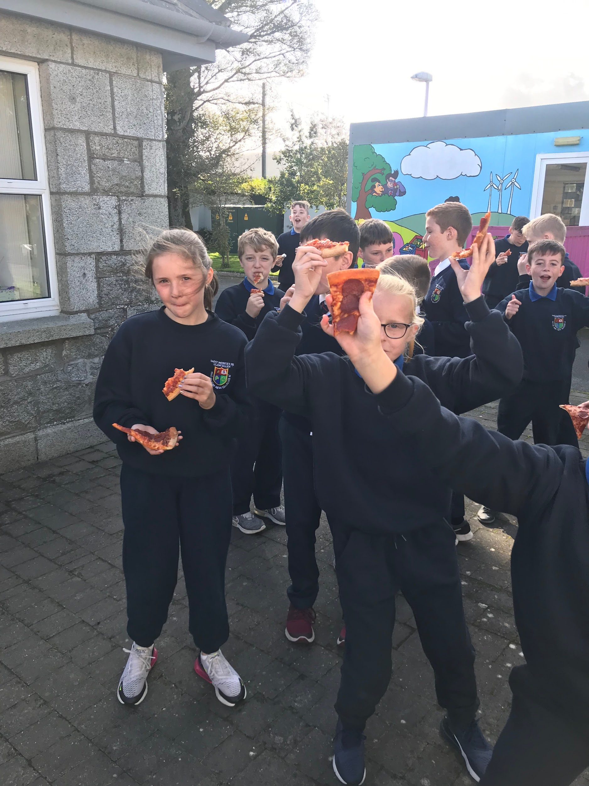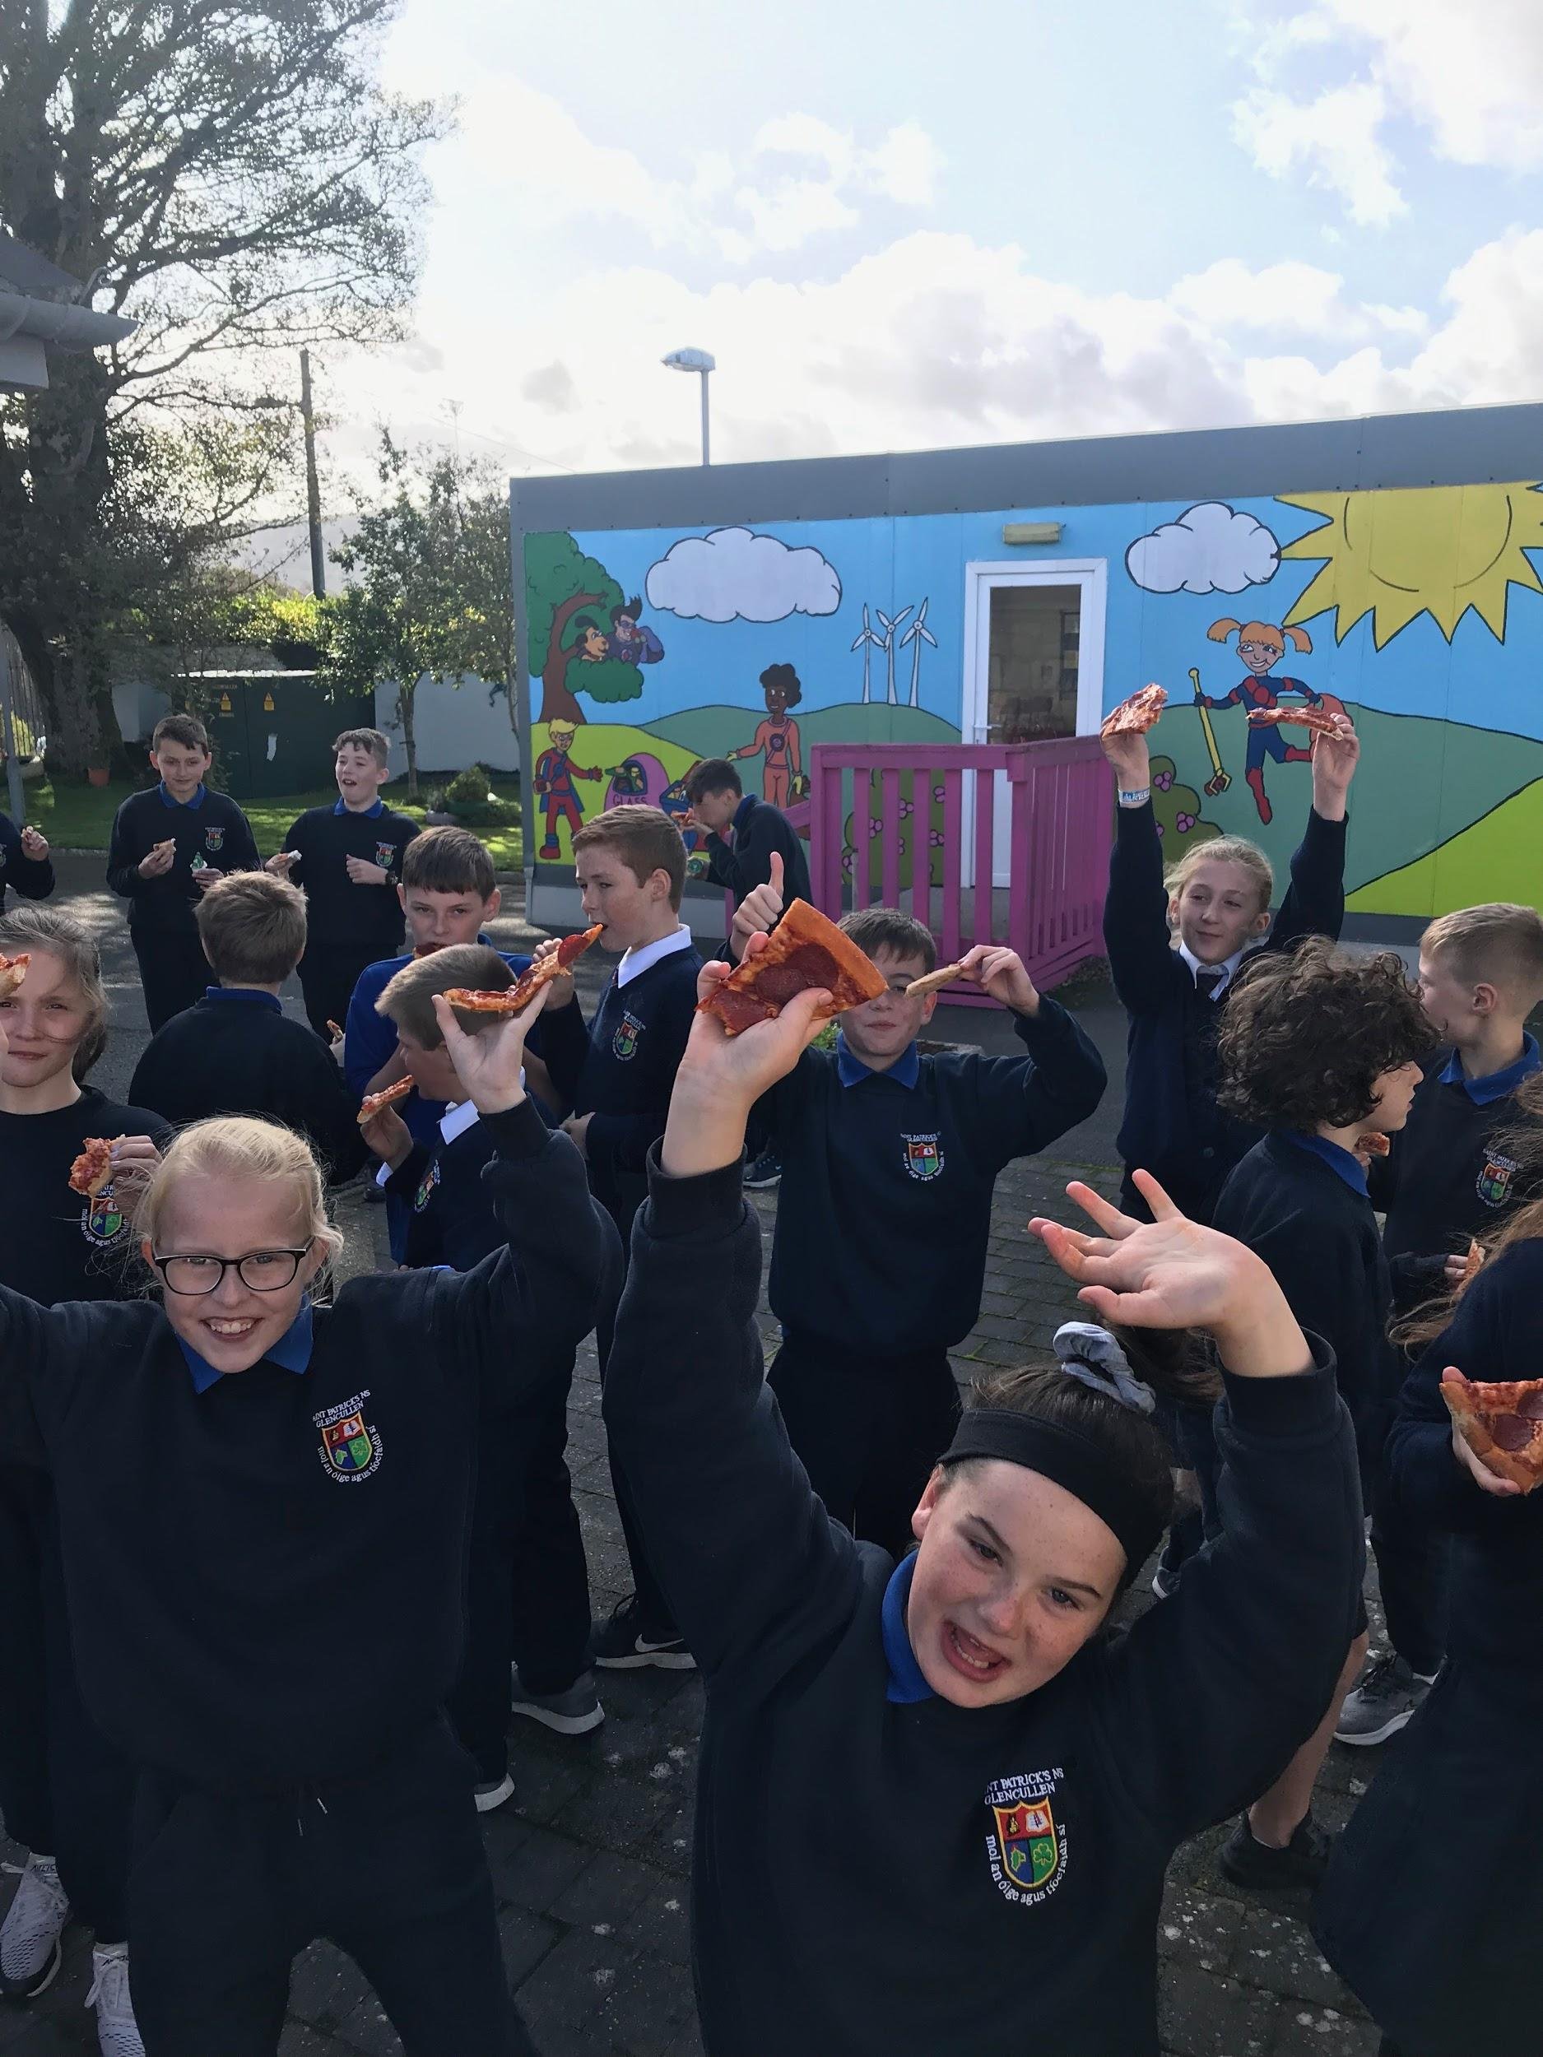

School Walk
The PA Committee organised a fabulous sponsored walk for the school community. We’d like to thank Matthew and Georgina Davy for accommodating all of us at The GAP. We had a great day, and although the weather was dull, there was no rain. We had tea and coffee, juices and treats at the Long Mile. Big Thanks to all who sponsored our walkers and to our PA Committee for organising the tea, coffee and goodies!

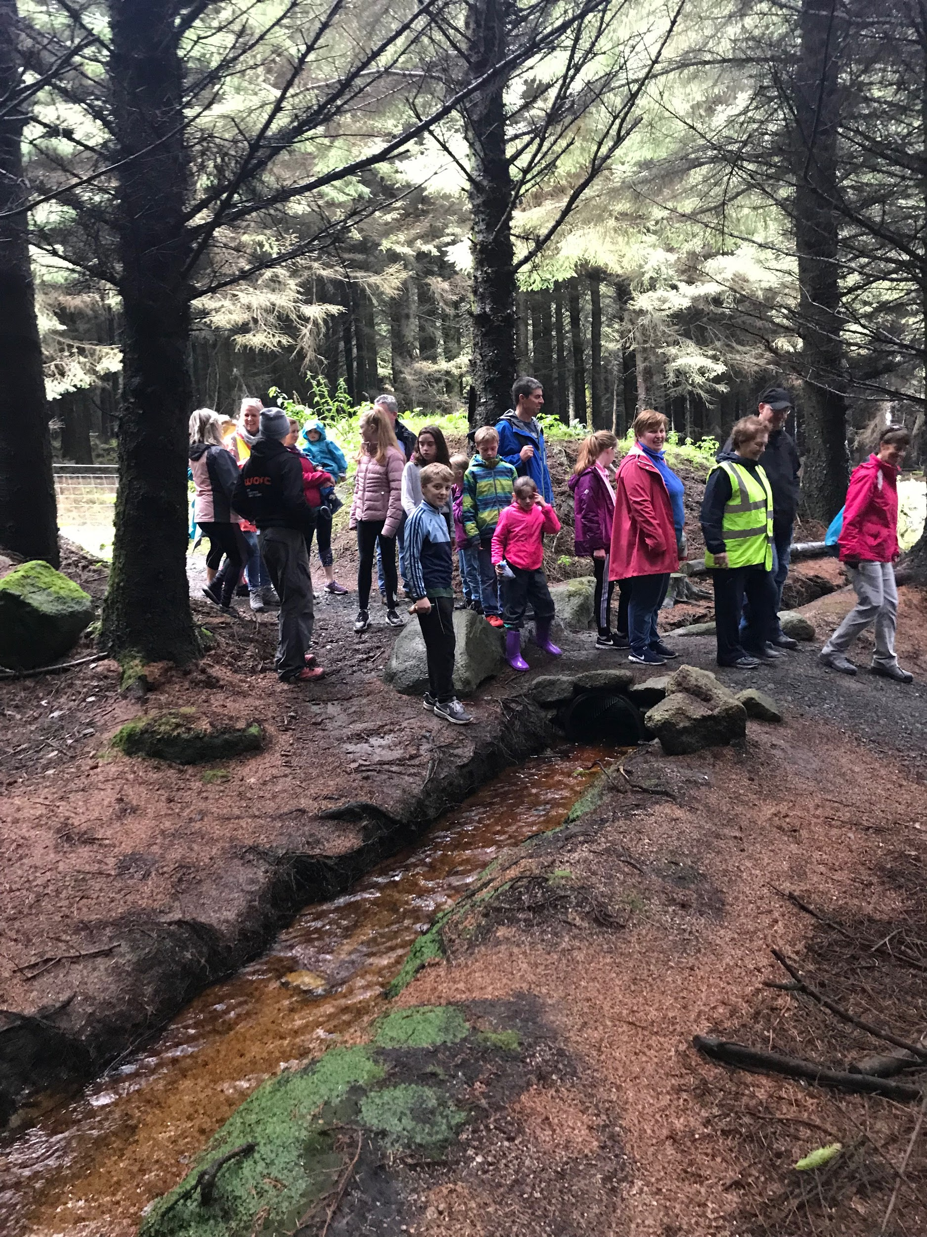

Fighting Words Trip 3rd. Class
Third class enjoyed this writing workshop in Glencree on October 1st. They created characters and a plot and started their book collaboratively which was published by their facilitators. They got to finish them themselves.
So although they started the book together all the endings were totally different! Well done 3rd class.
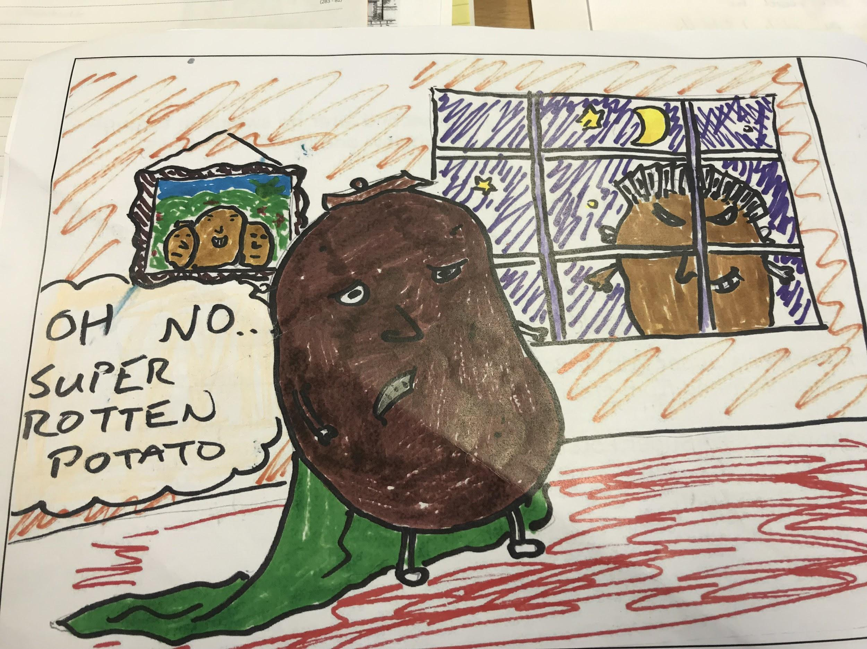

Book Fair 14th -18th October.
All the children and parents will have time to view and browse the books during the week.Thanks to the volunteer parents for organising this event.

MS Readathon
The children from 3rd-6th class will be taking part in the MS Readathon. The MS Readathon encourages children to open a wonderful world of adventure and imagination through reading for a great cause!
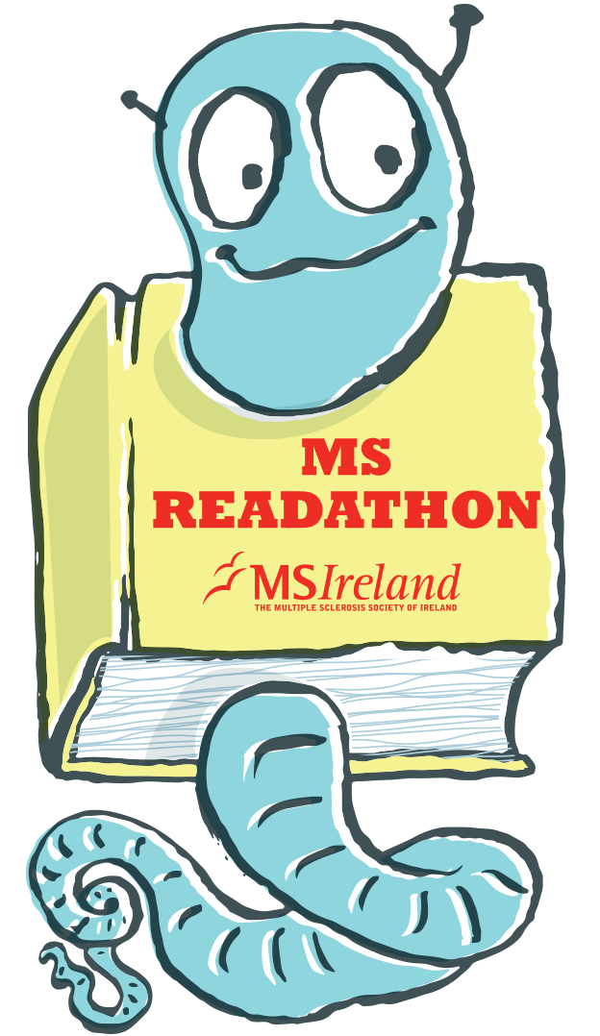

Maths Week
Maths Week shall take place between the 14th & 18th October. This week is a celebration of maths and an opportunity to recognise the importance of maths in our daily lives. Throughout the week, children shall be taking part in Maths trails, quizzes, interactive games, projects, puzzles and activities. Encourage your child to develop his/her maths language and problem solving skills at home and in the community. See www.mathsweek.ie for events taking place in your area. See also www.scoilnet.ie and www.haveyougotmathseyes.com/ for great ideas for spotting maths in the environment and problem solving.
Skip and Hop Workshop 24th October.
This will be going on all day for all classes. The children are enjoying skipping so much we decided to have this workshop for them. Tracksuits to be worn by all on 24th.

Mid-term Break/Halloween Celebration
We will close for the midterm on Friday 25th October at 3p.m. The children are welcome to dress up to celebrate Halloween. However, as a Green School, we encourage you to make your costume rather than buying it. Please ensure that Infants have comfortable runners/shoes on with their costumes for safety.
Nut allergies
Sincere thanks for all of your help in ensuring a safe environment for our pupils with nut allergies and we ask for your continued support. There are no nut products allowed at St. Patrick’s NS, please ensure that you check the ingredients on any items of lunch before your child brings them to school.

Staffing Arrangements commencing 4th November
Due to the drop in our pupil numbers this September, the school has lost a permanent teaching post which takes effect from 30th October until June 2020. We will regain this post for September 2020.
Therefore, from November 4th Ms. Quigley will return to full time teaching as our 2nd SET teacher along with Ms. Shimmins. Please note that she will only be available to meet parents after 3pm or before 9.20 am. Please make an appointment with Betty.

Upcoming Events
Junior Infants Immunisations-5th November
Gymnastics beginning on 4th November for 6 weeks for all classes.

Events for Green Schools
Sustainable Energy Association Workshops for Senior Infants and 4th Class
Some Green School Committee members will be attending an ‘Under the Ocean’ workshop on 28th November

.

