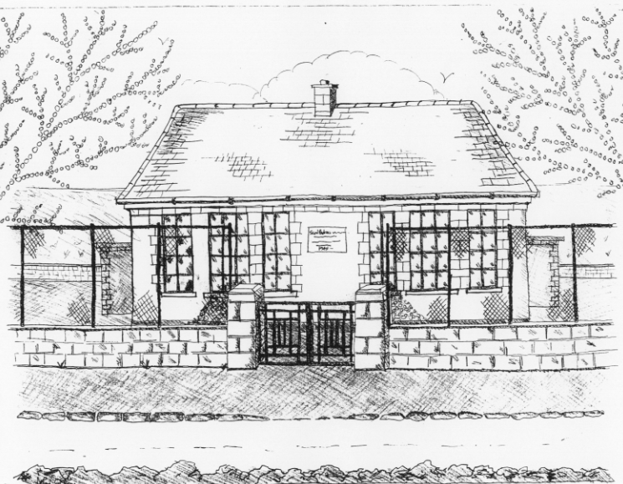

St. Patrick’s National School,
Glencullen,
Dublin 18.
Tel (01) 2954255
Email: secretary@glencullenschool.ie
Website: www.glencullenschool.ie
Roll Number: 17507F

NOVEMBER 2018 NEWSLETTER & UPCOMING EVENTS

New Parents Association Committee
Congratulations to our newly elected Parents Association Committee. They are as follows;

Chairperson: Linda Nolan  Secretary: Deborah Mc Gowan  Treasurer: Marie Acres  NPC Rep: Michelle Coen | Jennie Small Leeann Campbell  Monica Caulfield Eve Mazhandu  Leanne Campbell Celine O’Dowd  Tina Mulvey Joanna Bailey  Sarah O'Malley Lucy Davidson  Karen Rapple Tara Mulryan  Deklin Egan Caroline Mullen

Class Reps
Thank you to our outgoing Class Reps and to those who volunteered for the forthcoming school year;

J. Infants - Martin Browne  S. Infants – Emma Madigan  1st Class – Cait Maguire  2nd Class – Emma Carroll | 3rd Class - Jennie Small  4th Class - Joanna Bailey  5th Class – Gemma Mooney  6th Class - Olive Doyle

Enrolment Applications
Places for next year’s Junior Infant class will be distributed during the next few weeks. First Round offers will be distributed on 16th November from all schools in the parish.

‘The Spirit of Christmas’ Christmas Fair
We are once again delighted to announce that this Christmas we will be holding an even Bigger & Brighter Christmas Fair ‘The Spirt of Christmas’. Join us on Sunday the 2nd December 2018 for this Christmas celebration and fundraiser. In the meantime donations of raffle prizes, bottles & almost new children’s toys will be gratefully received each Tuesday. Parent volunteers will be needed nearer the date. Please let any of our PA committee now if you are available to assist.

Barnardos

Every year, our school participates in a gift giving scheme for the Barnardos Tallaght branch where Christmas presents are bought for boys & girls who attend Barnardos. This is organized by Betty each year and is optional but all donations are very welcome. The list of children’s names for Barnardos is on the Board outside the Office. There are still a few names left. Gifts can be dropped into Betty any morning at 9.30am and closing date for all gifts is the 30th of November. If anyone has any queries or questions please talk to Betty.
We are also collecting nonperishable food that we will make into hampers for Barnardos.

Parent Teacher Meetings

Parent/Teacher meetings shall take place for pupils in 1st-6th class on the 20th & 22^{1st}of November. You can choose your time by completing the form outside your child’s classroom which will be available from Thursday 15th November from 3.00pm. All meetings are 10 mins and we ask respectfully that you maintain this time so that other parents are not left waiting. A list will also be up on Ms. Shimmins’ door. If you have a serious issue that you feel needs more than this time please contact your class teacher to arrange an alternative time and day.

Science Week
We are celebrating Science Week from the 12th - 19th November. This is a national, annual event that celebrates the worlds of science, technology, engineering and mathematics (STEM). We have been doing lots of exciting activities & experiments in school this week and the senior classes will be demonstrating and presenting their science projects to the junior classes on Friday. The children have also been busy with programing Beebots and Lego We-Do 2.0 which were kindly lent to us by Blackrock Education Centre.!

6th class retreat
Our 6th class pupils will participate in a pre-Confirmation retreat on Wednesday 28th November at the Dominican Retreat Centre, Tallaght. We shall attend this retreat with pupils from Our Lady of the Wayside. It will be an opportunity for our pupils to pause and reflect on their lives and their forthcoming Sacrament of Confirmation. Attendance at the retreat has already been paid through the Sacrament fee and the cost of the bus will be covered by the PA committee’s fundraising. The children will wear their school uniform.

