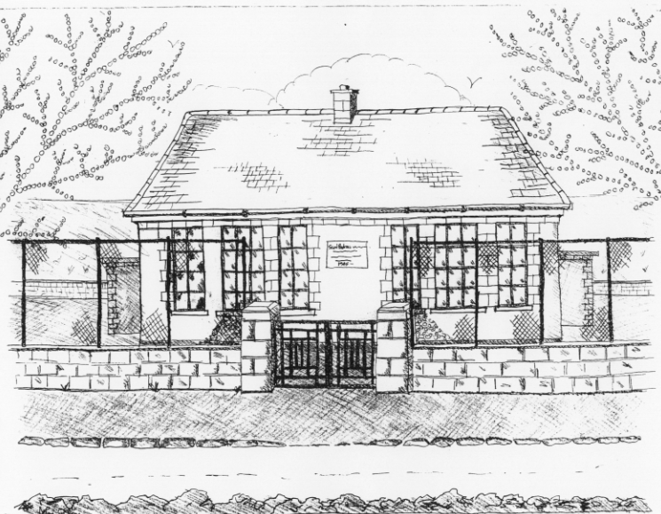
St. Patrick’s National School,
Glencullen,
Dublin 18.
Tel (01) 2954255
Email: principal@glencullenschool.ie
Website: www.glencullenschool.ie
Roll Number: 17507F

DECEMBER NEWS
Christmas Concerts
You are cordially invited to attend our annual Christmas concerts in the Rachel Murphy Hall.
Thursday 20th December at 2.00pm: 3rd ,4th, 5th and 6th class will perform ‘Tír na n-Óg’. (Doors open at 1.45pm)
Friday 21st December 11.15am – Special Double Bill: Junior and Senior Infants will perform ‘Our First Nativity’ and 1st and 2nd class will perform ‘Elves on Strike’ (Doors open at 11.00am)
‘The Spirit of Christmas Fair’
This year’s Christmas Fair was a fabulous success. A huge thank you to the Glencullen community who supported and attended the fair. Congratulations and ENORMOUS thanks to the P.A. committee and all the volunteers whose hard work since September resulted in €7,959 being raised from the Fair. A special thanks to the horses, calf, chickens and sheep and their handlers!

A variety of events have taken place since September apart from ‘The Spirit of Christmas Fair’ which also raised vital funds for the school. A sincere thank you to all in our Parents’ Association who helped to organise each event, and to all the parents for generously supporting these fundraising efforts. A following is a breakdown of the funds raised;
Sponsored Walk - €1,588
Bags to School Collection - €315
Christmas Cards - €597
Christmas Annuals- €59.70

Collection For Barnardos
A sincere thank you to everyone for their generous donations to Barnardos this year. The school community and others in Glencullen and Killegar provided 120 bags of presents for the children, 14 hampers and a variety of large toys and bikes. Thanks to Betty for organising and thanks also to Gerard Mulvey for all the bikes. The staff of Barnardos were, as usual overwhelmed and delighted. Thanks also to 6th class for loading the bus.
