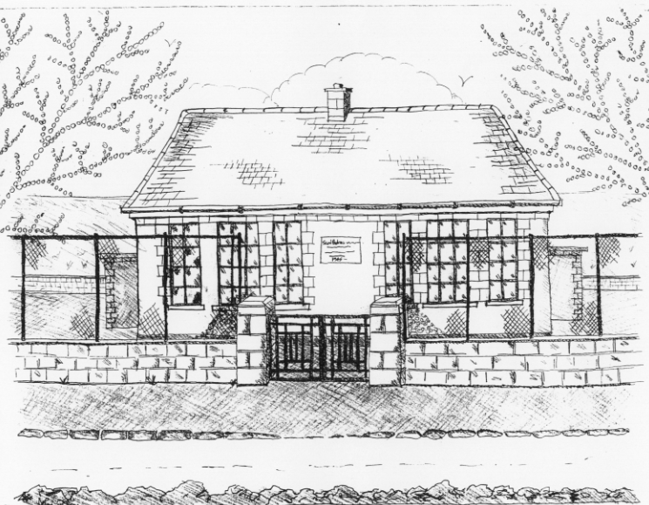
St. Patrick’s National School,
Glencullen,
Dublin 18.
Tel (01) 2954255
Email: secretary@glencullenschool.ie
Roll Number: 17507F

HOLIDAY LIST FOR SCHOOL YEAR 2018– 2019
School Re-opens Thursday 30th August 2018 at 9.20am.

Swimming Term 1: (4th & 1st class) Begins 6th Sept. – 18th Oct.

Swimming Term 2: (5th & 6th class) Begins 25th Oct. – Dec. 13th.

Mid-Term Break School closes Friday 26th October at 3pm
Re-opens Monday 5th Nov.

Parent/Teacher meetings Tuesday 20th & Wednesday 21st November
(1st- 6th class)

School Closure School closed Friday 7th December
Christmas Holidays School closes on 21st December at 12.30pm.
Re-opens on Monday 7th January 2019

Swimming Term 3(Sen. Inf. & 3rd class) Begins 17th January – 7th March

Parent/Teacher meetings Tuesday 5th & Wednesday 6th February.
(Junior/Senior Infants)

Mid-Term Break School closes on Wednesday 20th Feb. at 3pm
Re-opens on Monday 25th February

St. Patrick’s Day School closes Thursday 14th at
3pm and reopens Wednesday 20th March

Easter Holidays* School closes on Friday 12th April at 12.30pm
Re-opens on Monday 29th April

Swimming Term 4 (Jun. Inf. & 2nd Class) Begins 4th April – 30th May

May Bank Holiday School closed on Monday 6th May

June Bank Holiday School closed on Friday 31st May & Monday 3rd June

Summer Holidays School closes on Friday 28th June at 12.30pm

* Following Circular 34/2011, please note that the Easter holidays may be subject to change should there be any unforeseen closures during the year (such as snow). Under this circular, the Easter break may be reduced by up to 3 days to make up for closures. Please be aware of this when booking holidays.

