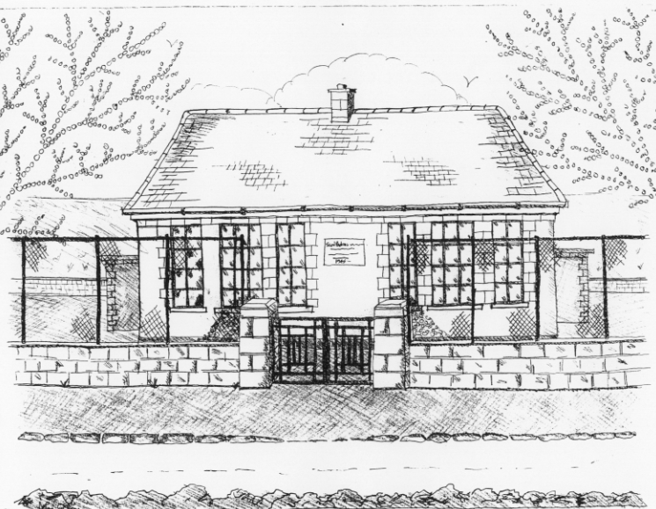 St. Patrick’s NS Booklist 2018-19

5th Class

Books to be Purchased by Parents

Books to be Bought  Spellbound E. (Folens)  Am Don Léamh 5 (Folens)  Master Your Maths 5 (CJ Fallon)  Planet Maths 5 (Folens)  *Due to the new Primary Language Curriculum  5th Class can purchase their Gaeilge Workbook  through the office in September | Books to be Kept in school  Tin Whistle Music Folder  Poetry Folder
Copies & Ancillary materials  2 Sum Copies 88 Page 7mm Keep2 Sum Copies 88 page 7mm. Hard Covered Copy  4x 88page page writing copies. USB 2 GB Key  2 x 40 page copies.  1 x B4 handwriting copy  Hard Covered Copy (for Gaeilge)  Calculator (with %sign)  Geometry Set  Homework Journal (Fallons)  A2 card Art Folder  1 x 20pg Display Folders ( Self Assessment Learning Folder)  1 x 40pg Display Folder (Finished Work and choir music) | Keep  USB 2 GB key  D Tin Whistle

School Costs
Art & Crafts Fees  Photocopying Fees  Primary Planet Magazine  Book Rental Scheme Fee (please see overleaf for books included)  Bí ag Scriobh Card can be bought through the school in September €3 | €10  €10  €10 (Supplemented by fundraising)  €25
TOTAL: | €55
Costs can be paid in full or in instalments as suits.
Please enclose in an envelope labelled with your child’s name and class
and amount

School Book Rental Scheme 5th Class (€25 as above

 | Purchasing Price
SESE  History Quest  Geography Quest  Windows of the World Geography  Windows of the World History  Atlas | €11.90  €11.90  €9.95  €9.95  €14.00
English  Vampires Elephants & Aliens Reader (Gill & Macmillan)  Vampires Elephants & Aliens Skills  Lift off 5  Oxford English Dictionary  Class Novels (estimated 4-5)  Toads, Tricks & Aliens Reader (Carroll Ed. Co.)  Toads, Tricks & Aliens Skills | €16.95  €9.75  €9.95  €12.80  €9.99 each  €16.95  €9.95
Gaeilge  Sin E 5  Bun go Barr 5  Focloir Gaeilge | €18.40  €20.35  €12.95
Religion  Alive O 7 | €14.99

Please put your child’s name on all books, coats, hats, jumper/cardigan and other belongings

