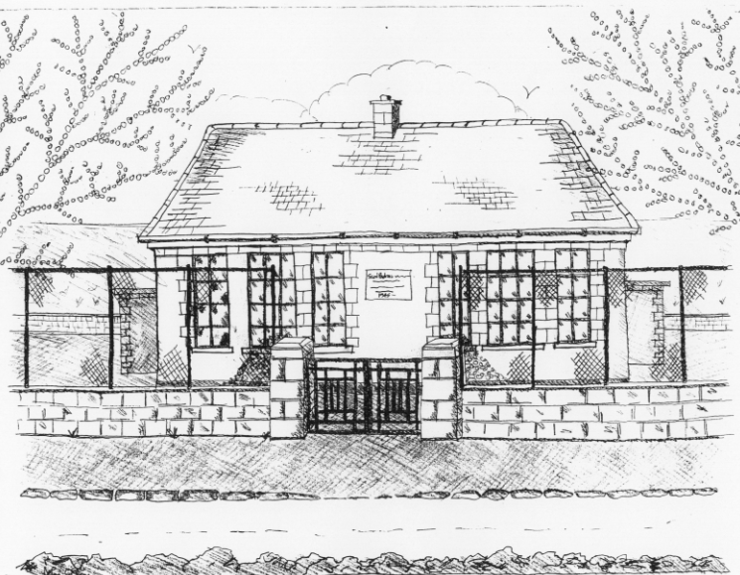 St. Patrick’s NS Booklist 2018 - 2019

1st Class

Books to be Purchased by Parents

Books to be Bought
Master Your Maths 1. (CJ Fallon) *Due to the new primary
Planet Maths 1 (Folens) Language Curriculum, 1st class
All Write Now 1st class (Folens) can purchase their Gaeilge
Grow in Love 1st Class Workbook (Veritas) Workbook through the office
Jolly Phonics Grammer 1 Pupil book in September
Copies & Ancillary materials
2 Sum Copies 40 Page 10mm
3 X 40 page writing copies
3 x 15A project copies
2 x Blank copies (no lines) .
Homework Journal (Fallons)
1 x 20pg Display Folders ( Self Assessment Learning Folder)

Each child will need a pencil case containing the following.
2 pencils, 1 rubber, 1 x 12 pack twistable crayons,(or colouring pencils) I large Pritt Stick Glue.

School Costs

Art & Crafts Fees  Photocopying Fees  Book Rental Scheme Fee (please see below for books included) | €10  €10  €20
TOTAL: | €40

Costs can be paid in full or in instalments as suits.
Please enclose in an envelope labelled with your child’s name and class and amount

School Book Rental Scheme 1st Class (€20 as above)

 | Purchasing Price
English  Guided readers (approx. 40 per child)  Ancillary Readers (approx. 20 per child)  Whole Class Real Book Reading (approx. 3) | €4.50 each  €7.99 each  €7.99 each

Please put your child’s name on all books, coats, hats, jumpers/cardigans and other belongings.

