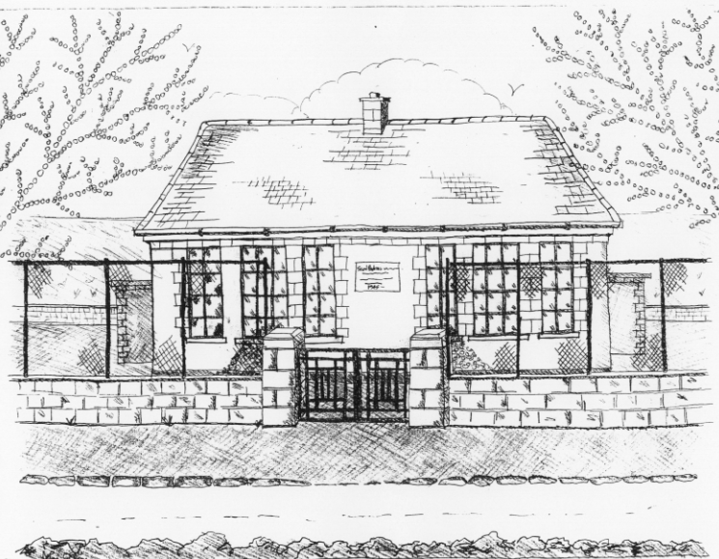
St. Patrick’s National School,
Glencullen,
Dublin 18.
Tel (01) 2954255
Email secretary@glencullenschool.ie
Website: www.glencullenschool.ie
Roll Number: 17507F

JUNE NEWS 2018

Farewell and Au Revoir to some of our Staff
This summer we will have some changes to our staff for various reasons. Ms. Ciara Mc Carthy is taking a second year on career break and we wish her every success in all her adventures. Ms. Alena Scanlan is also taking a career break and we send her every good wish. Ms. Shimmins will remain with us for another year on a fixed term contract and we are delighted she is staying on.

Because of this we will appoint one new teacher on a temporary appointment and please join me in welcoming her/him in September. Interviews will take place in June and we will inform parents as soon as the appointment has been made.

Irish Aid Awards
A huge congratulations to 5th class who reached the National Finals in this year’s Irish Aid Our World Awards. Their project ‘The Plastic Ocean’, encourages everyone in our school and global community to take responsibility for reducing single use plastic and reusing and recycling plastic wherever possible. Ms. Byrne & three pupils attended a fantastic ceremony in the Department of Education where they received an award for reaching the regional finals. Now they look forward to the national event on June 20th in Dublin Castle which the whole class will attend. We are so very proud of our Global Citizens. Congratulations & good luck in the finals!

6th class Graduation
Our 6th class pupils will graduate from St. Patrick’s NS with a special ceremony on Monday 25th June. This will begin with a graduation mass in the hall at 7.30pm followed by a special celebration. All 6th class students, their parents and family members are warmly invited to this night.

Cumann na mBunscol
Despite a valiant effort at this year’s semi-final, our Cumann na mBunscol team were unfortunate not to make it to the Croke Park final this year. Despite a strong start from St. Claires NS, our team made an excellent come-back in the second half with a massive 5 goals & 4 points. We are very proud of each team member and how they never gave up until the whistle blew. Sincere thanks to our coaches Peter Keane & Mr. Coughlan for their continued commitment to our team.

Garda Safety Course
Over the past year 5th class have engaged in a number of workshops with Garda Pat Cullen & Garda Mandy Lowe regarding personal safety & local citizenship. This course will conclude this month and all children will be presented with a certificate. Sincere thanks to both Gardaí in guiding our students.

Junior Infant Open Day
We welcome our new Junior Infants and their parents to our school for a visit on Thursday 14th June. Our current Junior Infants will go home at 1.30pm to facilitate this.

Active Schools & Wellbeing Week
Between the 18th – 27th June we will hold an Active Schools and Wellbeing Week here at St. Patrick’s NS. The goal will be for pupils and parents alike to focus on health, nutrition, physical exercise and mental health throughout the week. We have lots of activities for the children including GAA, Athletics, Netball, Zumba, Meditation, Yoga & Nutrition classes as well as a week-long Olympic team tournament for every child in the school. We also hope to host a daily soccer tournament for 3rd – 6th class.

We will celebrate all the winning achievements of the Active Week at a celebratory ceremony here in our school where all parents are welcome to join us and take photos of the medal winning teams. Details to follow.

First Aid Course for Parents
Following the success of last year’s free First Aid talk, we will once again host a First Aid presentation for parents on Tuesday 12th at 7.30pm. Thanks to parents Vanessa Stonys and Emma Redden for organising this free of charge.

Cake Sale & Raffle
Unfortunately due to poor demand, our recent Bingo night was cancelled. Instead our PA are holding one last Cake Sale and Raffle with some super prizes for kids & adults alike. Raffle tickets can be bought in the school from the 11th June and the cake sale will take place after mass on Sunday 17th in the Glencullen Community Centre (the old library). All donations of cakes would be gratefully received on Friday 15th June or on the morning of the cake sale at 9am in the community hall.

National Parents Council Primary Annual Conference
This year’s NPC annual conference will take place on Saturday 16th June from 10.30am-4pm at the National College of Ireland, Mayor Street, Dublin 1. All parents are welcome to this very interesting gathering of parents from around Ireland entitled ‘Seen & Heard 'The Child's Voice, Making a Difference’ Admission is free but you must register your attendance in advance at http://www.npc.ie/news-post.aspx?contentid=11479.

School Reports
Please be aware that every child will bring home their school report on Friday 15th June. All school reports must include standardised test results but as educators, we urge you to read the whole of the report and not focus solely on the results. We believe your child is so much more than a number on a Maths or Reading test. This year, results will be included on a sheet not on the report, so that you as parents, can decide whether your child should see the result or not. Of course if a parent is concerned about any test result, please make an appointment to speak with your child’s teacher. But please highlight the positive aspects of the report to your child and not focus on the Sten score.

Thank you Parent Committees
Many thanks to all our many parent volunteers this year who actively assisted on the Parent’s Association committee. A special thank you to each of our class reps. Thank you to those who assisted with the Sacraments including the 1st class Reception Committee. Thanks to all those individual volunteers who assisted with various events throughout the year including our coaches for Cumann na mBunscol, Netball, School plays, Science days, school tours and much more. Thank you to those who made copious cups of tea at various receptions throughout the year. Thank you to all who assisted during the long winter of snow. Thank you to everyone who helped to organise and assist at our many fundraising events. Your help and support is invaluable in enriching our children’s education and is always very much appreciated.

Thank you also to our members of the Board of Management who complete this role in a volunteer capacity. We truly appreciate the support & guidance they give to the management of our school.

Thank you Staff
A sincere thanks to each of our staff members who continuously go above and beyond for the pupils in our school. For the many hours of their personal time that they give up to facilitate swimming, football & hurling matches, sacraments, school tours, award ceremonies, fundraising events and much more, I sincerely thank them. I thank all our staff for ongoing professionalism, commitment and dedication to pupils of St. Patrick’s NS. The commitment from both our staff & parent body is what makes our school so special!

Golden Book
As you know we have a special initiative to recognise pupils who demonstrate exceptional skills, talents, academic achievement, acts of selflessness, generosity & kindness in our school. These children are nominated by teachers or peers and are honoured with being included in our Golden Book.

A huge congratulations to all children who were nominated into the Golden Book this year and forthcoming in June. Keep reaching for success and being the very best you can be!

Summer Holidays
School will close for the Summer on Friday 29th at 12.30pm. School will reopen on Thursday 30th August at 9.20am. A full list of closures for 2018-19 will accompany your booklist during June.

Wishing you all a very safe & happy Summer holidays!

