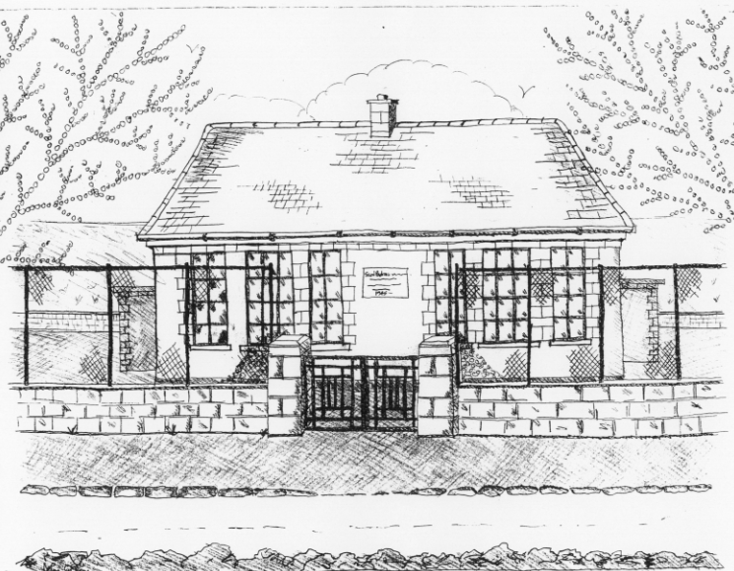
St. Patrick’s National School
Glencullen,
Dublin 18.
Tel (01) 2954255
Email secretary@glencullenschool.ie
Roll Number: 17507F
www.glencullenschool.ie

APRIL NEWS & UPCOMING EVENTS

Easter Cake sale
A sincere thank you to everyone who participated in our Easter cake sale from our organisers to our bakers to everyone who bought the delicious treats. A total of €1114.66 was raised! Thank you everyone!
First Penance
Best wishes to our 2nd class girls and boys who will celebrate the Sacrament of Penance on Tuesday 17th at 7.30pm in St. Patrick’s Church. It will be celebrated with Rev. Fr. Andrew O Sullivan.

Cumann na mBunscol Hurling League
Good luck to our school hurling team! Our next match against Carysfort NS – Venue and Time TBC. All supporters welcome! Many thanks to our coaches Peter Keane and Mr. Coughlan and to all staff for assisting with the supervision.

Gum Shields
A reminder that children are welcome to wear gum shields during any school sports / PE. This is not a school rule but rather an option for parents who are concerned regarding possible damage to teeth.

Morning Yard
A reminder as per our safety & security policy, all children must be supervised by their parent/guardian or a nominated parent/guardian every morning before school begins at 9.20am. To prevent any accidents in the morning, children are not allowed to run around the yard before school begins. No balls or play equipment is allowed in the morning time following a number of accidents to small babies & toddlers. We ask parents to please be vigilant with your child.

Swimming reminder
A new swimming term will begin Thursday 19th April in Meadowbrook pool for Junior Infants and 2nd classes. Pupils have the option to return by bus or to be collected by a parent. However we kindly request that parents choose an option and remain with that option for the term of swimming. We understand that in an emergency it may be necessary to change arrangements. But it is not acceptable to change arrangements weekly without informing the school or the child. Please choose an option and remain with that decision for the duration of the term.

Should your child have a medical condition that prevents them from swimming, please write to the Board of Management requesting a medical exemption.

Vanessa Stonys, Parents Rep for Junior Infants, will be happy to speak to any new parents regarding swimming.

And please remember there is no supervision for siblings at 3pm so if you need to make arrangements with other parents or family members for collection, please do so.

National Spring Clean
This month we are taking part in the National Spring Clean. Already the children and staff are making an extra effort to keep our school clean and tidy. We ask everyone to join us in keeping our environs litter free. Together we can keep our school a beautiful, enjoyable place to learn & play in.

Irish Dancing with Orla Brady
Irish dancing will resume after school on Tuesday 10th April from 2-3 & 3-4pm with Orla Brady.

Bags to School Collection
All bags of donated clothing will be accepted on Wednesday 11th April between 9.00-9.30 at the Rachel Murphy Hall. Bags cannot be collected after this time as they will be collected by the company Bags 2 School that morning. Under no circumstances are bags to be left on school grounds at any time. Many thanks to our PA for organising this.

New Primary Language Curriculum: In-service Training
The new primary language curriculum is in its second phase and all teachers in Ireland must partake in compulsory whole school in-service. We have received word that our training will take place on April 23rd. Therefore our school will be closed on this day.

Irish Aid Award Project: The Plastic Ocean
5th class are partaking in this year’s Irish Aid awards and have decided to focus on Global Goal 14 ‘Life under Water’ and Global Goal 12 ‘Responsible Consumption’. Their project ‘The Plastic Ocean’ examines the effect plastic pollution is having on our seas and marine life. They will be sharing their work on our website and around our school.

As part of their campaign to reduce the use of plastic consumption, 5th class asks you to consider your own use of plastic items and to consider if there is any action you can engage in to change. Using a reusable water bottle or coffee cup can make a massive difference to the quantity of plastic produced and discarded. Similarly, using reusable bags when shopping has helped Ireland’s plastic waste reduce. We have many more ideas which we will share over the week ahead. Watch out for our posters and tips around the school and on our website!

