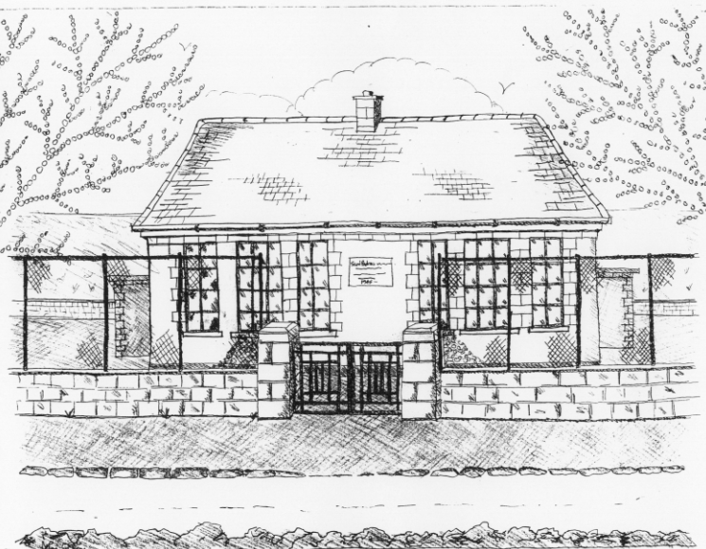
St. Patrick’s National School,
Glencullen,
Dublin 18.
Tel (01) 2954255
Email: secretary@glencullenschool.ie
Website: www.glencullenschool.ie
Roll Number: 17507F

NOVEMBER 2017 NEWSLETTER & UPCOMING EVENTS

New Parents Association Committee
Congratulations to our newly elected Parents Association Committee. They are as follows;

Chairperson: Emma Madigan  Secretary: Deborah Mc Gowan  Treasurer: Linda Nolan  NPC Rep:  Liaison Officer: | Jenny Small  Monica Caulfield  Marie Acres  Leeanne Campbell  Filipa Cardoso  Sarah O'Malley

Class Reps
Thank you to our outgoing Class Reps and to those who volunteered for the forthcoming school year;

J. Infants - Vanessa Stonys  S. Infants – Leeanne Attley  1st Class – Claire Mullen  2nd Class – Karen Mulvey | 3rd Class - Joanna Bailey  4th Class - Breed Reville  5th Class – Emma Reddan  6th Class - Nessa Jordan

Croke Park Finalists!
We are so proud of our Cumann na mBunscol team and their amazing achievement of reaching the final at Croke Park. We are particularly proud of each team members’ perseverance and courage, never giving up once. We hope everyone had a fantastic day at the final and that life long memories were made. Thanks to your fundraising the cost of the pupil’s entry and the cost of the buses were covered. Sincere thank you to the parent volunteers who assisted us.

Enrolment Applications
Places for next year’s Junior Infant class will be distributed during the next few weeks. First Round offers will be distributed on 20th November from all schools in the parish. If you have not already applied for a place for your son or daughter please do so immediately. Application forms are available in the Office.

‘The Spirit of Christmas’ Christmas Fair
We are once again delighted to announce that this Christmas we will be holding an even Bigger & Brighter Christmas Fair ‘The Spirt of Christmas’. Join us on Sunday the 3rd December 2017 for this Christmas celebration and fundraiser. In the meantime donations of raffle prizes, bottles & almost new children’s toys will be gratefully received each Tuesday. Parent volunteers will be needed nearer the date. Please let any of our PA committee now if you are available to assist.

Christmas Cards
Your personally designed Christmas cards can be ordered for purchase by Wednesday 8th November. Sincere thanks to parent Emma Jane Mulvey for organising this fundraiser.

Barnardos
Every year, our school participates in a gift giving scheme for the Barnardos Tallaght branch where Christmas presents are bought for specific underprivileged boys & girls. This is completely optional but all donations are very welcome. The list of children’s names for Barnardos will be put on the Board outside the Office on Monday 13th. Gifts can be dropped into Betty any morning at 9.30am and closing date for all gifts is the 1st of December. Thank you.

Scarf Appeal
A sincere thank you to everyone who donated new scarves to our Scarf Appeal for World Homeless Day. In total we collected 101scarves for men, women and children. All of these have been delivered to the 5 Loaves Homeless shelter in Bray. A huge thanks to our Student Council for organizing this commendable collection.

Bags to School Collection
Our Bags 2 School collection takes place on Wednesday 8th November. Bags of donated clothes can be brought to the hall entrance at 9.20am that morning. Please do not drop clothes in at any other time. Thanks to Monica Caulfield and Linda Nolan for organising this event this year.

Parent Teacher Meetings
Parent/Teacher meetings shall take place for pupils in 1st-6th class on the 21st & 22nd of November. You can choose your time by completing the form outside your child’s classroom which will go up this Friday 17th November 3pm. All meetings are 10 mins and we ask respectfully that you maintain this time so that other parents are not left waiting. Lists will also be up on the SEN teachers’ doors for children attending for Learning Support should you wish to speak to these teachers also. Ms. Byrne will also have a list up for any 5th class parent who wishes to discuss their child’s progress in Maths. If you have a serious issue that you feel needs more than this time please contact your class teacher to arrange an alternative time and day.

Science Week
This year we will celebrate National Science week from the 12th - 19th November. This is a national, annual event that celebrates the fascinating worlds of science, technology, engineering and mathematics (STEM). We have a lot of exciting activities & experiments planned in school. Further information can be found at www.science.ie .

6th class retreat
Our 6th class pupils will participate in a pre-Confirmation retreat on Friday 17th November at the Dominican Retreat Centre, Tallaght. We shall attend this retreat with pupils from Our Lady of the Wayside. It will be an opportunity for our pupils to pause and reflect on their lives and their forthcoming Sacrament of Confirmation. Attendance at the retreat has already been paid through the Sacrament fee and the cost of the bus will be covered by the PA committee’s fundraising.

Fighting Words
3rd class will visit the Fighting Words Centre in Glencree on Wednesday 15th November. Here the children will engage in a creative writing workshop and will co-create their own books. More information about the centres in Ireland can be found at http://www.fightingwords.ie/. This trip is funded by the PA’s fundraising and we thank everyone for this.

Sacrament Masses
A reminder to our sacrament classes that the next ‘Do This in Memory’ mass takes place on Sunday 12th November while the 6th class Confirmation preparation mass takes place on Sunday 19th November. Both masses take place in St. Patrick’s Church at 10am.

