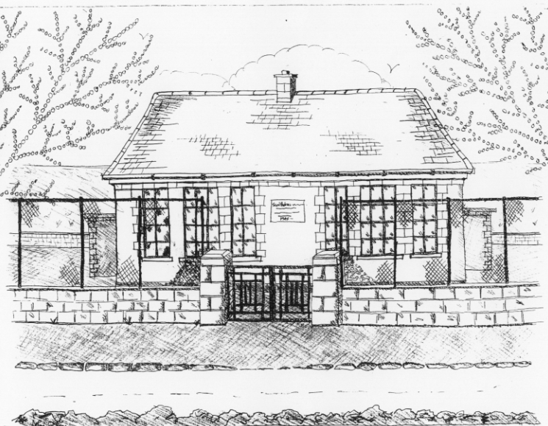
St. Patrick’s National School
Glencullen,
Dublin 18.
Tel (01) 2954255
Email secretary@glencullenschool.ie
www.glencullenschool.ie
Roll Number: 17507F

St. Patrick’s N.S. School Policy on Homework.
This policy was devised in 2011. It has since been reviewed in 2015 & 2017.
Homework is given as a means of revising and consolidating the work done in school. We would advise you to check your child’s work and remain in regular contact with the child’s teacher by signing homework as necessary.
We believe the purpose of homework to be the following;

- To reinforce, review and practise skills & content knowledge covered in the classroom
- To give the child confidence in completing tasks that use newly acquired skills in the classroom and develop their own learning decisions
- To develop skills of independent learning, problem solving, time management, organisation, task completion, study skills, responsibility & resilience in our students
- To allow parents to be an active partner in their child's homework and to offer one to one support where necessary. Parents can follow how their child is progressing and spend time discussing their personal learning.
- To allow teachers to assess a pupil's progress when working independently of class support
- To encourage creativity, research skills and differentiated learning experiences through project work
- Reading is acknowledged as a very important aspect of all learning. Reading regularly at home from the early years cultivates a time for discussion, for sharing ideas, for improving fluency as well as deepening vocabulary & comprehension skills and developing children’s opinions.

The following points should also be noted with regards to homework.
- Set aside a quiet regular time for homework.
- The child should be sitting comfortably at the table.
- Encourage your child to keep books and copies clean and tidy.
- If your child is working independently, be available to help and show interest in what is being done. Praise your child’s efforts at every opportunity.
- If your child is persistently having problems with homework, contact the class teacher and discuss the difficulties.
- Homework Journals should be signed each night by parent or guardian. If for any reason homework cannot be done, let the class teacher know by writing a short note.
- Do not allow children to watch T.V while doing homework.
- If when working with your child you feel yourself becoming impatient, stop. Take a break. Homework should not be stressful for either parent or child.
While homework is given with the average child in the class in mind, obviously some children will get it completed more quickly than others. Remember that work completed quickly and carelessly is not work completed properly.
When considering the amount of time spent on homework, one must not include time spent on doing another unrelated activity e.g. wandering off to play. Time spent depends on the child’s concentration, ability and application.
Here follows the recommended homework times which should operate in normal circumstances and keeping the above guidelines in mind.
- Junior & Senior infants – 15 mins max
- 1st & 2nd Class – up to 25 min max
- 3rd & 4th Class – up to 35 mins max
- 5th & 6th Class – up to 45 mins max
Please stop when your child reaches the maximum time limit and record in journal for his/her teacher to see.

2017 Whole School Homework review
Following an extensive review of our homework practices in 2017 with feedback from pupils, parents and staff, a number of changes were brought about including the following;
- Homework will be delivered weekly.
- Quantity of homework was reduced in all classes.
- Homework will be reduced in December and June to facilitate busy lives and good weather.
- Senior class Projects will not be given parallel to regular homework. Instead written work will be removed during project/research homework. Again nightly reading should continue especially with older pupils.
- Parental requests for parental support with Gaeilge and senior Maths will be provided
A copy of the final outcome letter is included in Appendix A. A copy of all data from all surveys conducted during this extensive review is kept on file.
We have a policy of giving homework from Monday – Thursday. Weekends are homework free provided homework has been completed on Monday to Thursday.

Ratified By: ______________ Date:___________________

