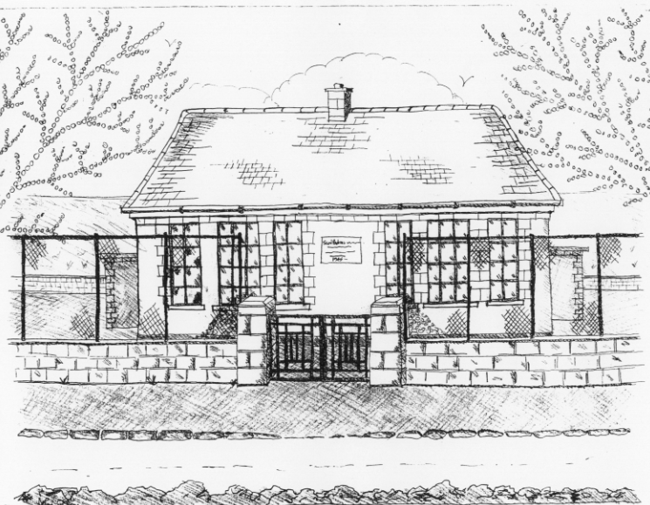
St. Patrick’s National School,
Glencullen,
Dublin 18.
Tel (01) 2954255
Email secretary@glencullenschool.ie
www.glencullenschool.ie
Roll Number: 17507F

ACTION PLAN FOR SNOW
Drawn up November 2009 following consultation with Parent’s Association committee and the Board of Management. Reviewed by the Parents Association and Board of Management every year, including November 2017.
Preparation for heavy snowfall
- Ensure there are sufficient text bundles in the Text-a-parent service for at least 5 messages per family. Update list early September each year.
- Ensure there is sufficient salt in external container in October of each year. If not, order from DLR county council. Ensure there is tape for cordoning off dangerous areas; kept in office.
- Draw up a list of local volunteers to clear snow each year. Send note out in November highlighting need for volunteers to be available at 8.30am on a day where there is heavy snowfall. Caretaker to coordinate volunteers on morning of such event.
- Letter to go out to families in November reminding of safety precautions and procedures that should be taken. (see Appendix A)
- On day of snow, Principal to contact Chairperson of BOM before 8.30am to discuss situation and to make decision. When making a decision, the Gardai, AA Roadwatch and local residents of Glencullen will be contacted to get a complete picture of the severity of weather in Glencullen and surrounding roads.
- If closing, parents to be contacted before 9am. Staff to be contacted before 9am. A minimum of two teaching staff is needed to open the school for insurance reasons.
- Contact DLR county council regarding time for gritting the roads.
- P. Keane (parent) to be contacted immediately if heating is not working.
- I. Maddison (parent) to be contacted immediately if electricity is not working.
- Eircom to be contacted if phone lines are down.
- Rolla to be taken slightly later (11am) on a serious snow day to allow children to get to school.
- If snow is too heavy to clear by hand, M. Davy (local member of community) and D. Doyle (parent) to be contacted to come with tractor or jcb to clear snow. Insurance company to be contacted.
- In the event of an emergency closure during the day due to severe snowfall, Parents will be contacted via the text-a-parent service and staff will remain with children until all are collected. If electricity and mobile phone service is not working, neighbouring schools will be contacted via the emergency mobile to send out the message through the Text-a-Parent service.
School closure will be the last resort. Every effort will be made to keep the school open at all times but the safety and welfare of the pupils, staff and parents will be paramount in making any decision.
St. Patrick’s National School
Glencullen,
Dublin 18.
Tel (01) 2954255
Email secretary@glencullenschool.ie
www.glencullenschool.ie
Roll Number: 17507F

6th November 2017
SNOW COMMUNICATION GUIDELINES

Dear Parents,
Following consultation with the Parents Association Committee and the Board of Management, we wish to advise you of best practice should we experience any heavy snowfall this year.
Please note the following;
- On the morning of a snowfall, please be aware of any weather or traffic reports on local radio or news stations. Each area will be different so please use your own discretion regarding travelling on national roads.
- Please drive carefully over the next few months to and from school. Remember Glencullen can be a couple of degrees colder than lower levels increasing the risk of frost, ice and snow.
- Volunteers are needed to clear snow at 8.30am on the morning of a snowfall. Current volunteers include Ovis Stonys & Anthony Pluck. If there are any other volunteers, please contact Betty this week with your name and contact number.
- Please take great precautions walking around the school building. Pathways will be cleared and salted but we advise that you remain on these paths and walk carefully.
- If carparks are inaccessible due to heavy snow, volunteers will assist children being dropped off at front of school. This will be a rolling system as cars cannot park on the main road. Details will be send via text on the morning.
- The rolla will be called a little later on the day of a snowfall (11am) to allow parents extra time to get their children to school.
- If there is a need to close the school according to our Critical Incident and Health & Safety Procedures, the Chairperson will strive to make this decision before 9am and all parents will be contacted by 9am via the Text-a-Parent service. It is your responsibility to let the Office know if your mobile number has changed over the year.
- All children will receive a snow booklet of work this month, should it be necessary to close the school or if your child is unable to make the journey to school when it is open. This work is age appropriate and should be completed under parent supervision. Should the school be closed for an excessive length of time, additional work will be posted on our website www.glencullenschool.ie. Please note that in the event of excessive closures, the school may have to open during a later holiday period.
School closure will be the last resort and only in case of extreme circumstances. Every effort will be made to keep the school open at all times but the safety and welfare of the pupils, staff and parents will be paramount in making any decision.
Yours sincerely,
K. Byrne V. Stonys B. Murray
Principal Chairperson (Parents Association) Chairperson (BOM)

