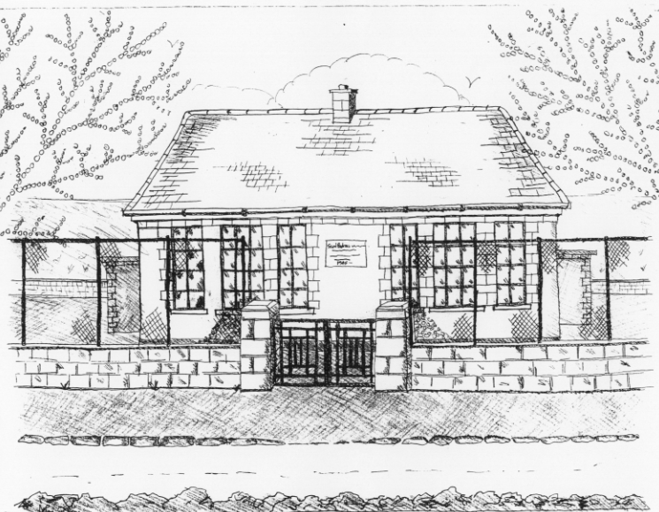
St. Patrick’s National School
Glencullen,
Dublin 18.
Tel (01) 2954255
Email secretary@glencullenschool.ie
Website: www.glencullenschool.ie
Roll Number: 17507F

SEPTEMBER BACK TO SCHOOL NEWS AND UPDATES

Private and Confidential Information: If any of your details have changed since last year’s Private & Confidential form (mobile number, address, email, etc.) please inform Betty immediately. It is most important that you include an emergency contact number that is operable, in the event of an accident or illness.

Illness & medication: If your child requires medication during school hours, you are required to write to the BOM and you must sign a Disclaimer Form indemnifying the school of any responsibility. Any medication including cough sweets, inhalers & cough bottles must be labelled and stored in the Medication Box in the Office. A child who is unable to administer his/her own medication should have the medication administered by a parent. Please speak to our principal directly about any recently diagnosed serious illness including anaphylaxis, epilepsy or asthma.

Sick children in school: please be assured that betty will always contact a parent should a child have a temperature, vomit, have a head injury or any other serious injury. Please ensure your emergency contact number is active.
It is not advisable to send sick children to school. As always in our school, there is no supervision indoors during yard time if your child has an illness such as cough, cold, sore throat etc. We do not have the staff numbers to provide this supervision. All children who are well enough to attend school will play outdoors at break times. Exceptions to this practise will be made for broken bones or return from a long hospitalisation.

AED/Defibrillator: Remember we have a defibrillator on site & it is located at the entrance to our school hall.

Pupil Absence: Under the Education Welfare Act 2000, children must not be absent from school for 20 days or more. We understand that children may be ill or a family emergency can occur. Therefore it is imperative that you send a note in explaining all absences. This will be kept on file should there be a query from the NEWB Welfare Officer. It is our policy here, to send you a reminder letter when your child has missed 12 days or more. This is for your information and is standard for all children. If you are taking your child out on holidays during term time, it is courteous to let us know beforehand in writing.

School Uniform: Our School Uniform policy is outlined on our website. Pupils from 1st-6th class should wear their full school uniform every day except on PE & swimming days when they wear the school tracksuit. Personal t-shirts and coloured tracksuits are not acceptable as part of the school uniform. Please label all children’s clothing to avoid unnecessary stress. Junior & Senior Infant pupils are permitted to wear his/her school tracksuit every day if parents wish.

Healthy Lunch: We have a Healthy Lunch policy here at St. Patrick’s NS. Children are encouraged to bring a nourishing sensible lunch which can include fruit, yoghurt, sandwiches, milk, etc. Sweets, crisps & chewing gum are prohibited. No nut products of any kind are permitted due to a number of children with serious nut allergies.

Payment of money: All money owed to the Office (photocopying, art & craft, book rental, swimming, etc.) should be placed in an envelope labelled with your child’s name and class teacher. Payment can be in cash or by cheque. If any family is having financial difficulty with any of these payments, please speak to the Principal in confidence.

Car park: As always in both car parks, please park sensibly and safely (reverse into spaces) and do not block the pedestrian entrance gate. Please follow the carpark map as designed by our PA. School grounds open at 9.00am with school beginning at 9.20am. Children must be supervised by parents/guardians until 9.20am. Please do not enter school grounds before the pedestrian gates are open at 9.00am.

Voluntary Contributions: At St. Patrick’s NS we run a Voluntary Contribution scheme to assist us in meeting the extensive shortfall between departmental grants and the running costs of the school. Letters will follow shortly detailing how you can make your donation to our school. We thank all families sincerely for the continuing support of this financial deficit.

Swimming: Swimming will re-commence in Meadowbrook Pool on Thursday 7th September for 4th & 6th class. Fees are due by September 30th. As a requisite of the curriculum, all children attend swimming unless they have a medical condition whereby parents must write to the Board of Management requesting an exemption. If a child is unable to attend one weeks swimming due to minor illness, they will accompany the class to the pool by bus and will be supervised by their teacher.

Dogs & smoking: Please be aware that dogs are not allowed on school premises. Also by law, smoking and vaping is illegal in school grounds.

Parent Communication: Following the success of our digital communication last year, we will continue to email newsletters, upcoming tours, PA events etc. This will help us reduce stationery costs in the office, be environmentally friendly and will bring information to parents’ fingertips instantly. Should you fail to receive emails over the next few weeks, please contact the Office immediately.

Cumann na mBunscol: Once again our school will take part in the Cumann na mBunscol Football League this September. Information will follow shortly to parents of 5th & 6th class.

Afterschools Activities: registration will take place this Friday at 2pm in the hall. Activities will include Zumba, Irish dancing, Stretch n Grow and Guitar.

New Staff: I want to take this opportunity to welcome Ms. Amy Lane who joins us in a permanent position, teaching Senior Infants this year. Welcome also to Ms. Adriana Lally who joins us in a substitute position teaching 2nd class in place of Ms. Scanlan who begins her maternity leave. And finally welcome to Ms. Chloe Shimmins who joins our staff for one year as our Special Education Teacher.

I hope you will join me in making our new staff feel very welcome in our school.

