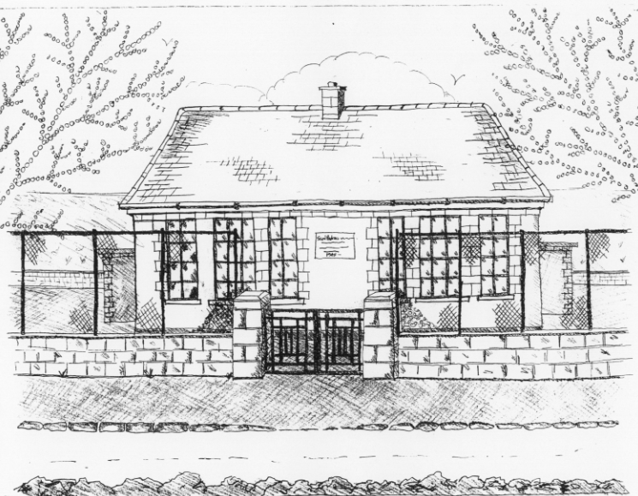
St. Patrick’s National School,
Glencullen,
Dublin 18.
Tel (01) 2954255
Email secretary@glencullenschool.ie
Website: www.glencullenschool.ie
Roll Number: 17507F

MAY 2017 NEWS & UPCOMING EVENTS

Green Schools; 7th Green flag for Global Citizenship; Energy
Huge congratulations to all our pupils on winning their 7th Green flag for Global Citizenship; Energy. As far as we are aware, we are the only school in our parish to have 7 flags. This achievement has come after 3 years of work and examination of global issues including our Walk for Water, Irish Aid Our World Projects, Energy Elimination Day, Trocaire Lenten campaign, Barnardos Christmas Gifts, Tidy Schools Competition, National Spring Clean Day and much more. This work was expertly led by our Green Schools Pupil Committee; Sinead, Felix, Luisa, Jack, Jodie, Mark, Eva & Simon. Sincere thanks to Ms. Casey for guiding us through the process and to all staff for their additional hard work! We hope to raise our flag at the end of June as part of our end of year celebrations!

Irish Aid Awards
Congratulations to 5th class who have reached the Regional finals of the Irish Aid Awards 2017. We have been shortlisted to 15 schools in the Leinster region and 3 representatives will go along to the Award ceremony. This will take place on Tuesday 16th May in the Dept. of Education in Dublin where the Minister for Foreign Affairs along with other dignitaries will view our project ‘Towards a Sustainable Future’ before the award ceremony. Three projects will be then chosen to go on to the National Finals. We wish our boys and girls the very best of luck and congratulate them on such a wonderful achievement!

New Primary Language Curriculum : In-service Training & School closure
A reminder that we are closed on May 29th as our staff must partake in compulsory whole school in-service of the new primary language curriculum.

Cake Sale thank you
Thank you to everyone involved in our Easter Cake Sale including our excellent PA committee and their parent volunteers, to all our brilliant bakers and to those who spent their money on some delicious treats. A total of €1472.50 was raised for our school.

An extra special thank you to our PA Committee who organised a surprise Easter Egg hunt for all the boys and girls. What a lovely way to end the term!

Bags2School
Sincere thanks to all who brought in bags for this fundraiser raising €306.45 for our school. Many thanks to Seona Leonard and her team for organising!

Cumann na mBunscol Hurling League
Congratulations to our wonderful hurling team who have won all their matches so far in the opening round of this year’s league. Our next match takes place Thursday 4th May in Marley Park and will hopefully lead us to Croke Park.

First Holy Communions
Our First Holy Communion will take place on Saturday 13th May at 11am in St. Patrick’s Church, Glencullen followed by a Communion reception in the Rachel Murphy Hall. Many thanks to Ms. Casey, Mary Allen, Ms. Scanlan, Betty O’ Connor, our school choir, all of our staff, the Do This in Memory Committee & the First Class parents Reception committee for all their support in preparing for this special day. All of our staff here send special wishes to each of our Communicants on receiving this special sacrament.

School tours
We have lots of exciting and educational school tours coming up this month. Senior Infants are off to Airfield Estate while 4th will visit Baltinglass Adventure Centre for lots of outdoor & adventure pursuits. All other classes will have their tours in June. Thank you to the PA fundraising for subsidising these trips.
Please send in all outstanding money for these trips over the next two weeks.

Tidy Schools
Our school was evaluated for the Tidy Schools competition on the last week before Easter and our Green Schools Committee were interviewed on the work we continue to do in striving to keep our school clean. We now anxiously await the results of our evaluation. Fingers crossed!

National Children’s Choir
Congratulations to our amazing choir who sang at the National Children’s Choir in the Tallaght Basketball Arena. We are so proud of their outstanding performance. A special thank you to Ruth Fitzsimon for guiding the choir to this special day. We hope we will see many of these children on the international stage in the future!

Good luck to the four children who will represent our school in the National Concert Hall later this year.
Netball
Thanks to parent Norma Browne from the Irish Netball Association, pupils in 5th & 6th class are currently enjoying a 6 week netball programme free of charge. These classes can wear their tracksuits on Mondays for the next 6 weeks.

Athletics
Athletics will begin on Monday 8th May for 1st-6th class with Grace O Rourke from the Dundrum Athletics Club. This is funded by the money raised at fundraising events throughout the year. All children can wear their tracksuits on Mondays for the rest of this school year.

Homework survey results
A letter has gone to all families explaining the results of our homework review and outlining a suggested pilot for homework for the next 5 weeks. We hope it will allow parents more freedom in guiding a more individualised support programme for their children.

School Garden
Our school garden is looking particularly beautiful in this sunny weather thanks to Denis and the children. The children will now be planting potatoes and other vegetables in the beds. Our garden is a special place for learning we all enjoy our time there.

Children are of course allowed to visit the garden after school under the strict supervision of their parents/guardians. Any child or adult who is found to be vandalising the garden, jumping on tables, climbing fences or any other dangerous behaviour will be asked to leave the garden and not return. If damage to the garden repeatedly occurs, we will have to close the garden to all visitors outside class time. Therefore please treat our beautiful garden with respect and enjoy it!

