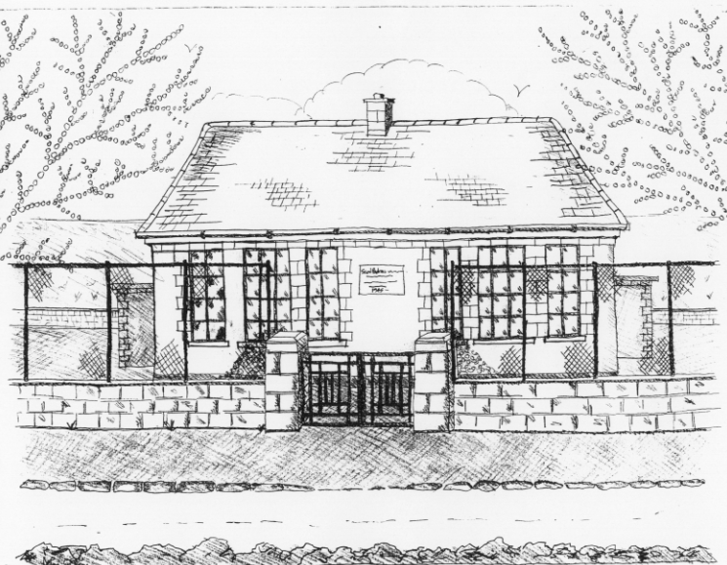
St. Patrick’s National School,
Glencullen,
Dublin 18.
Tel (01) 2954255
Email secretary@glencullenschool.ie
Website: www.glencullenschool.ie
Roll Number: 17507F

JUNE NEWS 2017

Farewell and Au Revoir to some of our Staff
This summer we will have some changes to our staff for various reasons. Ms. Linda Russell will return to her school, St. Marys & St. Gerards NS fulltime in September and we thank her for the wonderful years as shared Learning Support teacher in our school. We also say farewell to Ms. Brenda Doyle who leaves her position as Resource teacher this Summer and after four excellent years, we will truly miss her.

Ms. Ciara Mc Carthy is taking a one year career break and we wish her every success in all her adventures. And as most of you know, Ms. Alena Scanlan leaves us at the end of June on maternity leave. I’m sure you will join us in wishing her and her husband every good wish on the arrival of their second child.

Because of this we will welcome three new teachers in September. Interviews will take place in June and we will inform parents as soon as appointments have been made. For this reason, class allocation will be not be released to parents until the last week of June/first week of July.

School Closure
To facilitate the Bank Holiday weekend our school will close on Thursday 1st June at 3pm and reopen Wednesday 7th June at 9.20am.
Irish Aid Awards
A huge congratulations to 5th class who reached the Regional Finals in this year’s Irish Aid Awards. Their project ‘Let’s Make a Sustainable Future’, encourages everyone in our school and global community to take responsibility for our own roles in creating a sustainable future for all people. Ms. Scanlan & three pupils attended a fantastic ceremony in the Department of education where they received a Special Distinction Award. We are so very proud of our Global Citizens. Congratulations!

6th class Graduation
Our 6th class pupils will graduate from St. Patrick’s NS with a special ceremony on Monday 26th June. This will begin with a graduation mass in the hall at 7.30pm followed by a special celebration. All 6th class students, their parents and family members are warmly invited to this night.

School Tours
We have a number of school tours taking place in June. Junior Infants are heading up to the Pine Forest Art Centre on the 13th June while 5th class go on their tour to Larchill Adventure Centre on the 9th . 1st class will visit Lullymore Farm on June 15th. 2nd class are off to UCD on 16th June and our 3rd class on the 22nd. And finally 6th class will go to Glasnevin Cemetery, St. Patrick’s Cathedral and the Viking Splash on the 28th. Thank you to all the fundraising efforts which subsidise the costs of all buses.

Tidy Schools Award
Congratulations everyone on our recent Award of Distinction in the Tidy Schools programme. Sincere thank you to our coordinator Ms. Skelly, our litter pickers, our 6th class gardening committee, Denis Mulvey, and Betty O’ Connor for all the work they continue to do maintaining our beautiful grounds.

Cumann na mBunscol
Despite a valiant effort at this year’s semi-final, our Cumann na mBunscol team were unfortunate not to make it to the Croke Park final this year. We are very proud of each team member and how they never gave up until the whistle blew. Sincere thanks to our coaches Peter Keane, Jason Sinclair & Mr. Coughlan for their continued commitment to our team.

National Children’s Choir
Congratulations to Felix Jordan, Grace O Dwyer, James Roe, Ava Cannon and Sean Murray who recently represented our school by performing in the National Children’s Choir in the National Concert Hall. They delivered a stunning performance and we are very proud of each of them.

Bingo Night
A very sincere thank you to everyone who supported our Bingo night on Sunday 28th. There were lots of lucky winners in both the Bingo and the raffle. A special thank you to Tony Mc Mahon in Johnny Foxes for his excellent support and to our wonderful PA committee who organised the whole event. A total of €1545 was raised for our school.

Garda Safety Course
Over the past year 5th class have engaged in a number of workshops with Garda Pat Cullen & Garda Mandy Lowe regarding personal safety & local citizenship. This course will conclude this month and all children will be presented with a certificate. Sincere thanks to both Gardaí in guiding our students.

Junior Infant Open Day
We welcome our new Junior Infants and their parents to our school for a visit on Thursday 15th June. Our current Junior Infants will go home at 1.30pm to facilitate this.

Uniform Swap
Thank you to Deirdre Mc Cabe who is organising a Uniform Swap on Monday 26th June between 2-3pm in the school hall. We shall also offer our new Junior Infants coming in, an opportunity to purchase second hand uniforms on the 15th. Please keep any uniform items that are in good condition & clean that could be donated to this swap.

Green Schools; 7th Green flag for Global Citizenship; Energy
Ms. Casey and representatives of our Green School committee collected our Green Flag from a special ceremony in the Helix on Wednesday 23rd. Now we would like to celebrate with you all by raising our flag on Friday 23rd June at a special ceremony in our school. Details to follow.

Active Schools & Wellbeing Week
Between the 19th – 23rd June we will hold an Active Schools and Wellbeing Week here at St. Patrick’s NS. The goal will be for pupils and parents alike to focus on health, nutrition, physical exercise and mental health throughout the week. We have lots of activities for the children including GAA, Athletics, Netball, Zumba, Meditation, Yoga & Nutrition classes as well as a week-long Olympic team tournament for every child in the school. We also hope to host a daily soccer tournament for 3rd – 6th class.

As we are engaging in a week long activity event as part of our Active Flag application, there will be no Sports Day in the field this year. Instead we invite parents to join 1st -6th class in running a mile at the Stars of Erin pitch on Friday 23rd. This is a culmination of our ‘Daily Mile’ programme which the children have been taking part in all year. We will leave the school at 9.30am, run one mile of the pitch and then return.

We will celebrate all the winning achievements of the Active Week on Friday 23rd at a celebratory ceremony here in our school where all parents are welcome to join us and take photos of the medal winning teams.

First Aid Course for 6th class & parents
Thanks to fundraising this year, we are in a position to provide a First Aid workshop for 6th class before they leave us this year. This will take place in school hours and will be facilitated by First Aid trainer Pat Reid. We hope this valuable skill will stand to our young people in the future.

Following the success of last year’s free First Aid talk, we will once again host a First Aid presentation for parents on Tuesday 13th at 7.30pm. Thanks to parents Vanessa Stonys and Emma Redden for organising this free of charge.

National Parents Council Primary Annual Conference
This year’s NPC annual conference will take place on Saturday 10th June from 10.30am-4pm at the National College of Ireland, Mayor Street, Dublin 1. All parents are welcome to this very interesting gathering of parents from around Ireland entitled ‘Shaping the Future!’ Admission is free but you must register your attendance in advance at http://www.npc.ie/register_conference_2017.aspx or call 01 8874034.

School Reports
Please be aware that every child will bring home their school report on Friday 16th June. All school reports must include standardised test results but as educators, we urge you to read the whole of the report and not focus solely on the results. We believe your child is so much more than a number on a Maths or Reading test. Of course if a parent is concerned about any test result, please make an appointment to speak with your child’s teacher. But please highlight the positive aspects of the report to your child and not focus on the Sten score.

Thank you Parent Committees
Many thanks to all our many parent volunteers this year who actively assisted on the Parent’s Association committee and also on the IT committee. A special thank you to each of our class reps. Thank you to those who assisted with the Sacraments including the 1st class Reception Committee. Thanks to all those individual volunteers who assisted with various events throughout the year including our coaches for Cumann na mBunscol, Choir, Netball, School plays, Science days, Art days, Poetry recitals, school tours and much more. Thank you to those who made copious cups of tea at various receptions throughout the year. Thank you to everyone who helped to organise and assist at our many fundraising events. Your help and support is invaluable in enriching our children’s education and is always very much appreciated.

Thank you Staff
A sincere thanks to each of our staff members who continuously go above and beyond for the pupils in our school. For the many hours of their personal time that they give up to facilitate swimming, football & hurling matches, sacraments, school tours, award ceremonies, fundraising events and much more, I sincerely thank them. I thank all our staff for ongoing professionalism, commitment and dedication to pupils of St. Patrick’s NS. The commitment from both our staff & parent body is what makes our school so special!

Golden Book
As you know we have a special initiative to recognise pupils who demonstrate exceptional skills, talents, academic achievement, acts of selflessness, generosity & kindness in our school. These children are nominated by teachers or peers and are honoured with being included in our Golden Book.

A huge congratulations to all children who were nominated into the Golden Book this year and forthcoming in June. Keep reaching for success and being the very best you can be!

Summer Holidays
School will close for the Summer on Friday 30th at 12.30pm. School will reopen on Wednesday 30th August at 9.20am. A full list of closures for 2017 -18 will accompany your booklist during June.

Wishing you all a very safe & happy Summer holidays!

