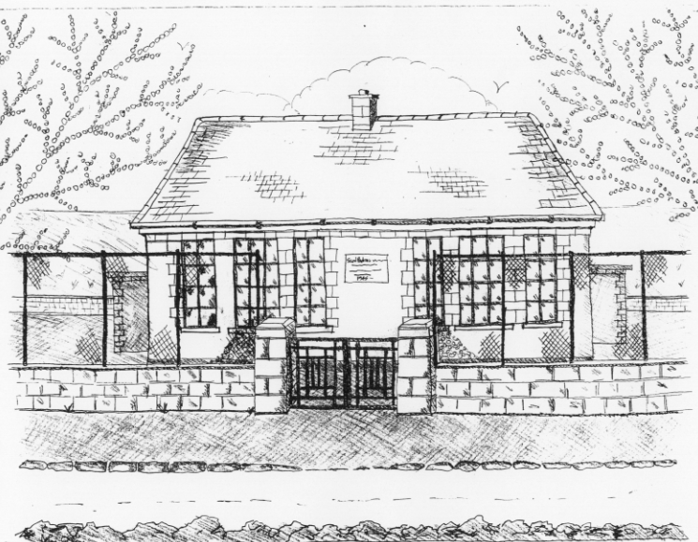
St. Patrick’s National School
Glencullen,
Dublin 18.
Tel (01) 2954255
Email secretary@glencullenschool.ie
Roll Number: 17507F
www.glencullenschool.ie

MARCH NEWS & UPCOMING EVENTS

Confirmation
Best wishes to our 6th class boys and girls who will celebrate their Sacrament of Confirmation on Friday 31st March. It will be celebrated with Monsignor Enda Lloyd and Rev. Fr. Andrew O Sullivan.

First Penance
Best wishes to our 1st class girls and boys who will celebrate the Sacrament of Penance on Wednesday 22nd at 7.30pm in St. Patrick’s Church. It will be celebrated with Rev. Fr. Andrew O Sullivan.

World Book Day
We celebrated World Book Day on Thursday 2nd March. This is the biggest global celebration of books and a wonderful promotion of the enjoyment of reading. Please use this day as an opportunity to enjoy a good book with your child!

Write a Book Project
Congratulations to all our budding authors in 2nd, 3rd, 4th & 6th class who took part in this year’s Write a Book project. We are celebrating all of their successes at a special assembly today where each author will share their story with children from other classes. In particular we would like to congratulate the Winners and Highly Commended authors who are as follows;

2nd | 3rd | 4th | 6th
Winner  Adam Greenlee | Winner  Tim Swan | Winner  Mark Grenham | Winner  Sabastine Pennington
Highly Commended  Donnacha Brock  Harry Mc Geown  Lulu Fitzsimons | Highly Commended  Adam Coughlan  Ella Mulvey  Simon O Flynn | Highly Commended  Alai Gill  Lucie Reddan  Maressa Vard | Highly Commended  Grace O Dwyer  Oonagh Mc Carthy  Sarah Fitzsimon

Seachtain na Gaeilge
Beidh Seachtain an Gaeilge againn 13^{ú} – 17ú de Márta. During this week, we encourage everyone to make an effort to ‘bí ag caint as Gaeilge’. Lots of activities will take place this week including dramaíocht Gaeilge, scéalta, Tráth na gCeist, amhrain, filíocht, cluichí agus ceilí. Thanks to Orla Brady, we will have a day of Irish dancing on Monday 13th. Everyone will be ready with their cúpla focail on St. Patrick’s Day!

Garden
Please note our garden is closed at the moment due to tree trimming. A red tape has been put across the entrance to highlight this to all. Please do not pass the tape.

Car Park Safety
Once again both car parks are beginning to get quite dangerous with high speeds, poor parking and adults dropping children at the gate.

Can parents please advise childminders, grandparents and others who may be collecting your child, the correct procedure for parking and leaving the Church carpark. A number of small children are still wandering through the carpark daily looking for their parents and we are very concerned there will be a serious accident. Please collect all young children from the school yard or school gate for their personal safety.

Our PA will host a Car Park Safety Week in both car parks from Monday 13th. Parent volunteers are needed from all classes to assist for 10 minutes each morning. The PA will send out a letter regarding this and reminder maps on how to park. We will be asking the Gardai to do spot checks on safe driving and parking during this week.

Trocaire Boxes
A Trocaire Box was sent to each family at the beginning of Lent. These boxes must be returned to the school on Wednesday 29th March as they are being collected.

School Closures
We will close on Friday 17th March to celebrate St. Patrick’s Day and we will reopen on Tuesday 21st March.

Bags to School Collection
Just to let you know in advance, our next Bags 2 School collection takes place on Wednesday26th April. You may like to use the Easter holidays to gather up unwanted clothing, shoes, teddies and more. Thanks to Shona Leonard for organizing this event.

Cake Sale
Our annual Easter Cake sale will take place on Friday 7th April at 12.30pm. More information will follow from our PA. But for now, get your oven mitts out and the icing bag piped as we look forward to a delicious end to our second term!

