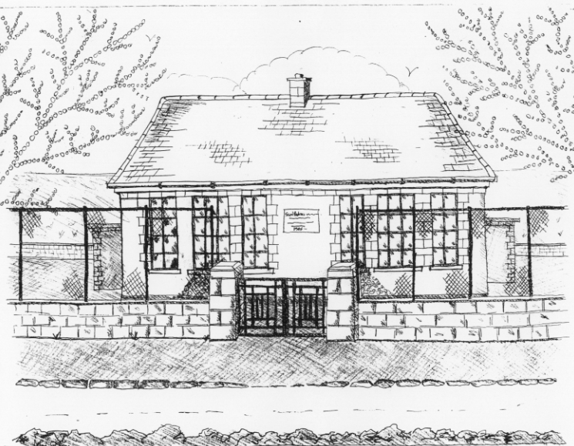
St. Patrick’s National School,
Glencullen,
Dublin 18.
Tel (01) 2954255
Email: secretary@glencullenschool.ie
www.glencullenschool.ie
Roll Number: 17507F

FEBRUARY NEWS & UPCOMING EVENTS

Cyberweek 6th- 10th February
This year to coincide with Safer Internet Day, our pupils IT committee have organised a Cyberweek. This week will include coding activities, digital skills lessons, Stay Safe lessons on Cyberbullying, pupil competitions and more. 3rd & 4th will participate in an Internet Safety workshop with parent and Microsoft volunteer Emma Vard, focusing on the safe use of the internet, cyberbullying & appropriate disclosure via technology. 5th class will have a Cyberbullying talk from the community Gardai while 6th class will complete cyberbullying lessons from the Webwise programme.

It is a timely reminder for parents to review internet safety procedures in the home. We recommend that parents examine the Parents section of http://www.webwise.ie/ for tips while family Internet Safety supports for parents can be found at http://www.saferinternetday.ie/parents/.
Cyberbullying is part of the Bullying programme for 3rd – 6th class and parents can see these lessons and resources at http://www.staysafe.ie/parents.htm.

Our NPC rep Linda Nolan is currently organising a course for Parents on this topic and as soon as we have details we let you all know.

P/T meetings
Parent/Teacher meetings for Junior & Senior Infant classes will take place next week from the 14th & 15th February. Parents can choose a time that suits them by completing the form outside the classrooms from Friday 3rd after 2pm. School will close as normal for infants from 2pm each day and we politely ask parents to arrange supervision for children and younger siblings while they attend their meeting.

Voluntary Contribution
Can we remind anyone who has forgotten to drop in their voluntary contribution for this school year that it is not too late. We sincerely thank those who have already donated this year. Receipts were sent out to all those who paid by cheque or cash for the tax year 2016. We kindly ask all those who donated €250 or more to complete the Tax cert included with your receipt and return to the Office as this will increase your contribution to us.

Midterm break
School will be closed on Thursday 23rd and Friday 24th February for midterm break. Enjoy the break!

Ash Wednesday
Mass will take place on Wednesday 1st March at 10am in St. Patrick’s Church for those wishing to receive ashes.

Service of Light & Confirmation
Service of Light for Confirmation candidates will take place on Monday 6th February 7.30pm in St. Mary’s Church. Confirmation will take place in the same church on Friday 31st March at 11.00am. We wish all our Confirmants every good wish as they take this next step in their Catholic faith.

Trocaire Boxes
A Trocaire Box will be sent to each family at the beginning of Lent. These boxes must be returned to the school on Wednesday 29th March as they are being collected.

Homework Review
At St. Patrick’s NS we are continuously reviewing and evaluating our educational practice. Currently we are examining homework and we would greatly welcome the views of parents and students. A survey will be emailed to all parents while pupils from 3rd to 6th class have completed a questionnaire. Once we have collated the views of staff, parents and pupils we evaluate and plan for any changes necessary and we will share this information with all parents.

