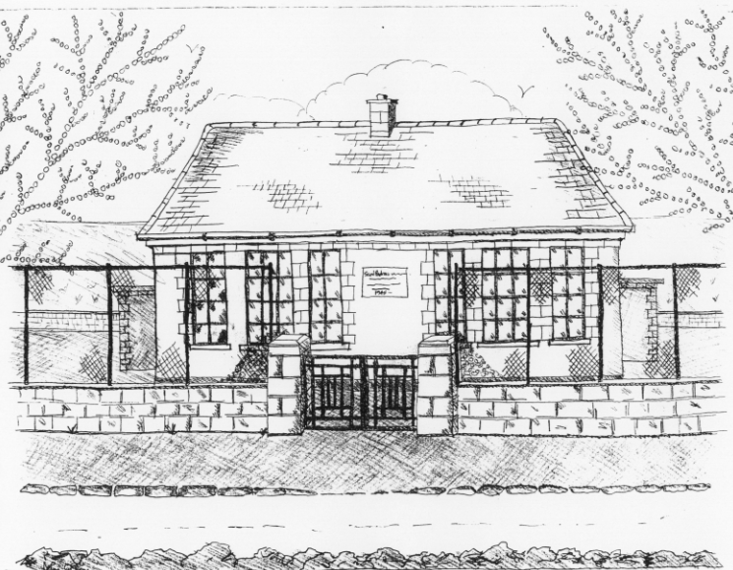
St. Patrick’s National School,
Glencullen,
Dublin 18.
Tel (01) 2954255
Email secretary@glencullenschool.ie
Website: www.glencullenschool.ie
Roll Number: 17507F

UPCOMING EVENTS JANUARY 2017

Happy New Year everyone from all the staff at St. Patrick’s NS!

Jingle & Mingle
A huge thank you to everyone involved in making our Christmas Fair 'Jingle & Mingle' a huge success. €5301 was raised for the school.
Thank you to everyone who organised, volunteered, baked, cleaned & spent money!! A special thanks to those who generously donated to our raffle & cake sale.

Christmas Cards
Thank you to all who bought Christmas cards in this year’s fundraiser. A total of €648 was raised for the school while lots of families received beautiful designs from our pupils.

Swimming
A new swimming term will begin in Meadowbrook pool on 19th January for Senior Infants & 4th class. Pupils have the option to return by bus or to be collected by a parent. However we kindly request that parents choose an option and remain with that option for the term of swimming. We understand that in an emergency it may be necessary to change arrangements. But it is not acceptable to change arrangements weekly without informing the school or the child. Please choose an option and remain with that decision for the duration of the term.

Should your child have a medical condition that prevents them from swimming, please write to the Board of Management requesting an exemption. Our swimming policy is available on www.glencullenschool.ie

And please remember there is no supervision for siblings at 3pm so if you need to make arrangements with other parents or family members for collection, please do so.

Winter Weather
Please take care driving to school each morning as often the hill from Kilternan is not gritted. Please take care walking around the school grounds – every effort is made to cordon off icy areas but remain vigilant. Children on school grounds before 9.20am should be supervised by their parents/guardians. Thank you to those who have adhered to this advice.

Credit Union
Our Credit Union Savings scheme will be up and running again after the holiday break from Thursday 19th. It is a great opportunity to teach and encourage children to save. If any parent wishes to join please enquire at the office. As part of our participation in the scheme, we received a donation of €500 from Dundrum Credit Union which we gratefully appreciate! Congratulations to Luisa Farrell and Grainne Davis on wining to small prizes in the Credit Union pupil members raffle.

Child Protection Reminder
As the New Year begins, we wish to remind all families that we have a firm Child Protection Policy in place which can be accessed on our website or in the front foyer. This also includes having Child Protection as an ongoing issue on all Board of Management and Staff meeting agendas. Should a parent or child ever have a concern surrounding a Child Protection issue, please speak with Ms. Byrne who is our Designated Liaison Person. Should Ms. Byrne be unavailable, Ms. Quigley is our Deputy Designated Liaison person.

Catholic Schools Week
Catholic Schools Week 2015 will begin on 29th January. The theme for this week is “Catholic Schools: Communities of Faith, Knowledge and Service” and gives everyone involved in Catholic education the opportunity to acknowledge and celebrate the contribution that our Catholic schools make to Irish life. Catholic schools support the work of parents in teaching their children about Jesus’ love for them. Parents are encouraged to take time to reflect on what it means to have your child as part of a Catholic school community and to consider how you can support the work being done in your child’s Catholic school. Any parent wishing to examine the programme for Catholic Schools Week can find it at https://www.ncea.org/NCEA/Proclaim/Catholic_Schools_Week/School_Choice_Week.aspx

Positivity & Friendship Week
From the 23rd January we will be holding our annual Positivity Week in school for all in our school community. The purpose of this focus on positivity is to provide some balance to the pervasive news of political gloom and media coverage of international disasters, terrorism etc. Often children are too aware of such serious issues and can sense the effects of adult stress and worry. The basic idea is to get everyone to laugh a little more and generally be nice to one another. We will have lots of fun activities for the children throughout the week. We ask parents to join us in instilling some positivity into our pupils and overall school community.

Gymnastics
As part of our PE programme, gymnastics will begin Monday 16th January in school with Olympian Gymnastics for every class. Classes will take place for 6 weeks and are free of charge thanks to PA fundraising. All children can wear their tracksuit on Mondays.

Rugby Training
Following last year’s successful rugby training programme with Leinster Rugby, we have been offered a free 6 week programme for 4th-6th class pupils in tag rugby. This will take place as part of the PE programme in school hours every Tuesday for 6 weeks and is in association with De La Salle Rugby Club.

