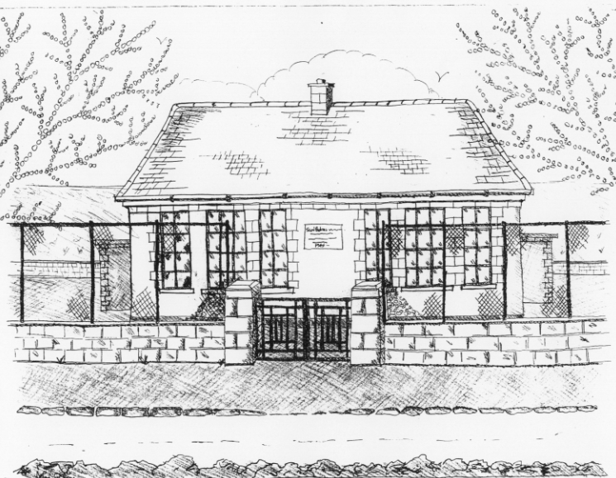
St. Patrick’s National School,
Glencullen,
Dublin 18.
Tel (01) 2954255
Email secretary@glencullenschool.ie
Website: www.glencullenschool.ie
Roll Number: 17507F

DECEMBER NEWSLETTER & UPCOMING EVENTS

Jingle & Mingle
Sunday 4th December 10.45am

Our Jingle & Mingle event preparation is in full swing thanks to our hardworking elves. All raffle tickets sold must have the stubs returned by Friday to be part of the sellers competition. Raffle tickets will also be sold on the day. Baking can be dropped off on Saturday between 11-1pm. Anybody available to volunteer on the Saturday or Sunday please contact Vanessa Stonys 0872675439. But please be advised that no children are allowed on premises during Saturday’s organisational day.

Sincere thanks to our PA Committee for their hard work on this event. Looking forward to seeing you all at our wonderful fair!

Christmas Presents for staff

Every year we remind you that there is no need for parents to buy Christmas gifts for teachers and staff. Your kindness and generosity is very evident throughout the year in your support of fundraising events and this is more than enough. I know each teacher would love a homemade card from a child (where possible) but presents are not necessary. We thank you for your thoughtfulness.

Christmas Concerts

We are delighted to invite you to our annual Christmas concerts. This year 3rd, 4th, 5th & 6th class will perform Hosanna Rocks on Wednesday 21st at 2pm in the Rachel Murphy Hall. This will be followed on Thursday 22nd with our Infant pupils performing Ralph the Reindeer and 1st & 2nd class performing Elves on Strike, all from 11.15am. Thank you to all our teachers and SNAs for helping the children to put on such wonderful shows!

Feast of the Immaculate Conception

Pupils from 1st-6th class will attend mass on Thursday 8th December at 11am in St. Patrick’s Church to celebrate the Feast of the Immaculate Conception. All welcome.

School Closure

A reminder that school is closed Friday 9th December.

Barnardos
A sincere thank you to everyone for their generous donations to Barnardos this year. This year St. Patrick’s NS school community hope to provide 128 children’s gifts, 16 hampers and a variety of large toys & bikes. All gifts & donations of food need to be in by Friday 2nd at the latest. Many children will be having a happy Christmas thanks to you!

Sincere thanks to Betty O Connor for organising this every year.

Swimming

Swimming will commence on the 19th January 2016 for Senior Infants & 4th class pupils. Forms will go out after Christmas and fees should be returned to the office by the 19th January.

Sacrament Masses
A reminder to our sacrament classes that the next ‘Do This in Memory’ mass takes place on Sunday 11th December while the 6th class Confirmation preparation mass takes place on Sunday 18th December. Both masses take place in St. Patrick’s Church at 10am.

ICT Pupils Committee

Congratulations to the new members of our pupil’s IT Committee;

Sarah Fitzsimon  Kelliann Coughlan | Harry Owens  Craig Doyle  Mark Grenham

Our first event that we are taking part in is the international Hour of Code. This is where pupils learn how to code using simple games. Coding encourages problem solving & logistical thinking and is considered an essential 21st century skill. Our IT committee will now get busy preparing to hsot this event across the school!

Christmas Holidays

School will close for the Christmas holidays on Thursday 22nd December at 12.30pm and reopen on January 9th.

From all of the staff here at St. Patrick’s NS we wish each of you a very happy and peaceful Christmas. Best wishes for 2017!

