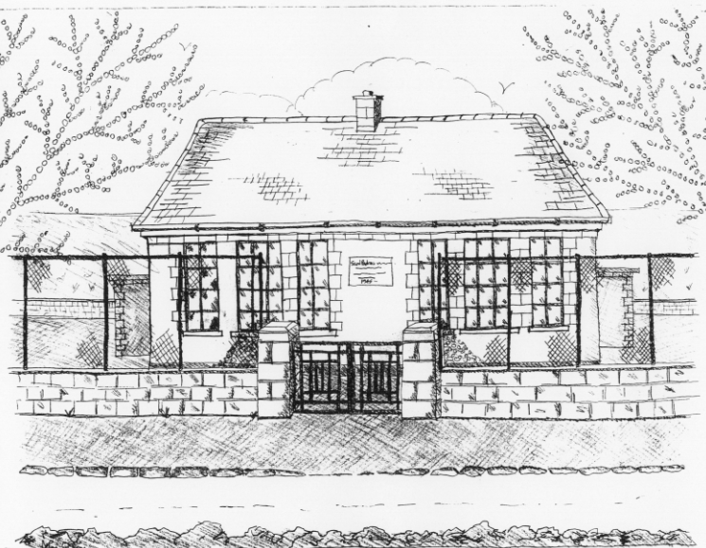
St. Patrick’s National School,
Glencullen,
Dublin 18.
Tel (01) 2954255
Email: secretary@glencullenschool.ie
Website: www.glencullenschool.ie
Roll Number: 17507F

NOVEMBER 2016 NEWSLETTER & UPCOMING EVENTS

New Parents Association Committee
Congratulations to our newly elected Parents Association Committee. They are as follows;

Chairperson: Vanessa Stonys  Secretary: Shona Leonard O'Toole  Treasurer: Emma Redden  NPC Rep: Linda Nolan  Liaison Officer: Emma Campbell | Michelle Cohen  Deirdre McCabe  Sally Mc Sweeney  Leeanne Attley  Emma Madigan

Class Reps
Thank you to our outgoing Class Reps and to those who volunteered for the forthcoming school year;

J. Infants - Gemma Mooney  S. Infants – Leeanne Campbell  1st Class - Mary Lou Craig  2nd Class - Joanna Bailey | 3rd Class - Clare Longmore  4th Class - Helen Fisher  5th Class - Sarah O' Malley  6th Class - Marian Sinclair

Croke Park, Here we come!
We are so proud of our Cumann na mBunscol team and their amazing achievement of reaching the final at Croke Park. We hope everyone has a fantastic day at the final and that life long memories are made. Thanks to your fundraising the cost of the pupil’s entry and the cost of the buses will be covered.

Enrolment Applications
Places for next year’s Junior Infant class will be distributed during the next few weeks. First Round offers will be distributed on 18th November from all schools in the parish. If you have not already applied for a place for your son or daughter please do so immediately. Application forms are available in the Office.

Jingle & Mingle
We are once again delighted to announce that this Christmas we will be holding an even Bigger & Brighter Christmas Mingle & Jingle. Join us on Sunday the 4th December 2016 for this Christmas celebration and fundraiser. In the meantime donations of raffle prizes, bottles, children’s books & toys will be gratefully received each Tuesday. Thank you to Pat Dawson who is printing the raffle tickets for us free of charge. Parent volunteers will be needed nearer the date.

Barnardos
Every year, our school participates in a gift giving scheme for the Barnardos Tallaght branch where Christmas presents are bought for specific underprivileged boys & girls. This is completely optional but all donations are very welcome. The list of children’s names for Barnardos will be put on the Board outside the Office on Wednesday 9th. Gifts can be dropped into Betty any morning at 9.30am and closing date for all gifts is the 2nd of December. Thank you.

Sock Appeal
A sincere thank you to everyone who donated new socks to our Sock Appeal for World Homeless Day. In total we collected 113 packs of socks, 21 coats, 7 jumpers, 5 sets of shoes/boots and a collection of hats, scarves & gloves. All of these have been delivered to the 5 Loaves Homeless shelter in Bray. A huge thanks to our Student Council for organizing this commendable collection.

Bags to School Collection
Our Bags 2 School collection takes place on Wednesday 9th November. Bags of donated clothes can be brought to the hall entrance at 9.20am. Please do not drop clothes in at any other time. Thanks to Shona Leonard for organizing this event this year.

Parent Teacher Meetings
Parent/Teacher meetings shall take place for pupils in 1st-6th class on the 22nd & 23rd of November. You can choose your time by completing the form outside your child’s classroom which will go up this Friday 18th November 3pm. All meetings are 10 mins and we ask respectfully that you maintain this time so that other parents are not left waiting. If you have a serious issue that you feel needs more than this time please contact your class teacher to arrange an alternative time and day.

Science Week
This year we will celebrate National Science week from the 13th - 20th November. This is a national, annual event that celebrates the fascinating worlds of science, technology, engineering and mathematics (STEM). We have a lot of exciting activities & experiments planned in school. Further information can be found at www.science.ie .

6th class retreat
Our 6th class pupils will participate in a pre-Confirmation retreat on Friday 11th November at the Dominican Retreat Centre, Tallaght. We shall attend this retreat with pupils from Our Lady of the Wayside, Holy Trinity and St. Mary’s NS. It will be an opportunity for our pupils to pause and reflect om their lives and their forthcoming Sacrament of Confirmation. Attendance at the retreat costs €10 but the cost of the bus will be covered by the PA committee’s fundraising.

Fighting Words
5th class will visit the new Fighting Words Centre in Glencree on Wednesday 16th November. Here the children will engage in a creative writing workshop and will co-create their own books. More information about the centres in Ireland can be found at http://www.fightingwords.ie/. This trip is funded by the PA’s fundraising and we thank everyone for this.

National Children’s Choir Local Rehearsal
Our wonderful NCC choir have been rehearsing hard in school this term. On Tuesday 15th November they will attend a local rehearsal in Gaelscoil Taobh na Coille with pupils from that school and Holy Trinity. This will take place during school hours and transport by bus will be covered by PA fundraising. We hope the pupils of 5th & 6th class have a wonderful day of music and singing!

Sacrament Masses
A reminder to our sacrament classes that the next ‘Do This in Memory’ mass takes place on Sunday 13th November while the 6th class Confirmation preparation mass takes place on Sunday 27th November. Both masses take place in St. Patrick’s Church at 10am.

Sam Maguire
On Wednesday 30th November, the Sam Maguire Cup will come to St. Patrick’s NS. This is a great occasion for our school and the locality of Glencullen to celebrate the Dublin team’s win in the All Ireland Football Championship. We would like to invite you and your family to come see the Sam Maguire in the Rachel Murphy Hall. There will be an opportunity to take photos of the cup and to hopefully meet one or two of the Dublin players. A time will be confirmed nearer this date. We will also celebrate our own Cumann na mBunscol team’s achievement in reaching Croke Park on this momentous day.

