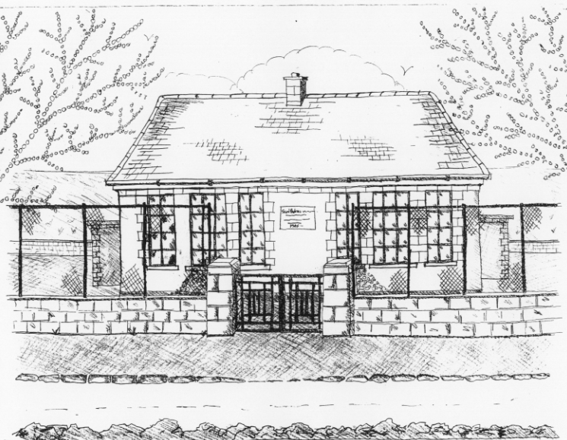
St. Patrick’s National School,
Glencullen,
Dublin 18.
Tel (01) 2954255
Email secretary@glencullenschool.ie
www.glencullenschool.ie
Roll Number: 17507F

OCTOBER NEWSLETTER & UPCOMING EVENTS

PA AGM
Reminder that our PA AGM takes place Monday 3rd October at 8pm. We actively encourage all families to send at least one parent for this meeting which illustrates the importance of parent support & volunteerism in our daily school life. Please consider if you could offer some time to joining our PA Committee as we are only as strong as our parent support. The meeting will take place in the 6th class room with a glass of wine or cup of tea afterwards to thank you for your ongoing support.

Sincere thanks to our outgoing PA Committee who have worked tirelessly throughout the year for our school and our children.
Junior Infant Meeting
A meeting for Junior Infant Parents will take place on Monday 3rd October at 7.15pm. This will give parents an opportunity to learn about the Junior Infant programme for the year ahead and to ask Ms. Mc Carthy any questions you may have about homework & class life.
This meeting will take place in the Junior Infant classroom.

Road Safety Week
As Irish Road Safety Week begins, we once again urge parents, child minders & visitors to our school to please slow down when driving near our school especially in our carparks. Our students will shortly begin a Carpark Safety Campaign urging adults to slow down, park carefully & remain alert to small children around car areas.

Cumann na mBunscol Matches
Congratulations to our Cumann na mBunscol team who are making excellent progress through this year’s league. A special thank you to fathers Peter Keane, Jason Sinclair & teacher Mr. Coughlan for training the team and accompanying the team to their matches. Thank you also to our staff who take time after school to accompany the teams & cheer them on. I hope the whole school will come and support some of their future matches as we continue our journey!

World Teacher’s Day
October 5th is World Teacher’s Day where countries and communities around the world celebrate teachers and all that they do. I am very proud of the calibre of staff we have working here at St. Patrick’s NS and I thank each of them for all that they do for the education, welfare and care of each child.

World Homeless Day
World Homeless Day takes place on Monday 10th and is a timely reminder to examine social issues within our own country and locality with our children. Simply reminding young children what a wonderful home they have can bring about awareness of housing issues while the older children will explore in more detail the various definitions of homelessness through Focus Ireland’s programme No Place Like Home. Our Student Council will discuss and examine if we can do a collection of clothing items here in the school for the homeless.

Nut allergies
Sincere thanks for all of your help in ensuring a safe environment for our pupils with severe nut allergies and I ask that you simply continue this support. There are no nut products allowed at St. Patrick’s NS.

Student Council
Congratulations to our newly elected members of the Student Council. They are Lennon Gill, Regan O Hanlon, Sabastine Pennington (all 6th classs), Matthew O Flynn (5th class), Alai gill (4th class) and Louis Featherstone (3rd class). Our council will give a student voice to issues that arise throughout the year and may offer insightful suggestions form the student body.

Maths Week
Maths Week shall take place between the 15th & 23rd October. This week is a celebration of maths and an opportunity to recognise the importance of maths in our daily lives. Throughout the week, children shall be taking part in Maths trails, quizzes, interactive games, projects, puzzles and activities. Encourage your child to develop his/her maths language and problem solving skills at home and in the community. See www.mathsweek.ie for events taking place in your area. For assistance with new topics in maths check out www.mathsisfun.com while www.haveyougotmathseyes.com/ gives great ideas for spotting maths in the environment.

Music in the Classroom
2nd & 3rd class will attend ‘Music in the Classroom’ in the National Concert Hall on Monday 3rd October. Thanks to PA fundraising for covering the cost of this trip.

Fighting Words
4th class will visit the new Fighting Words Centre in Glencree on Tuesday 18th October. Here the children will engage in a creative writing workshop and will co-create their own books. More information about the centres in Ireland can be found at http://www.fightingwords.ie/. This trip is funded by the PA’s fundraising and we thank everyone for this.

Mid term break/Halloween Celebration
We will close on Friday 28th October at standard closing hours for a week long mid-term break. As always on this day, children are allowed to dress up to celebrate the Halloween tradition. However, as a Green School, we encourage you to make your costume rather than shop buying it. This is not compulsory nor a competition just some Glencullen fun!! Of course please keep all ‘weaponry’ at home along with ‘high heel shoes’. Please remember due to severe nut allergies within the school that nuts are not allowed as a snack on this day.

