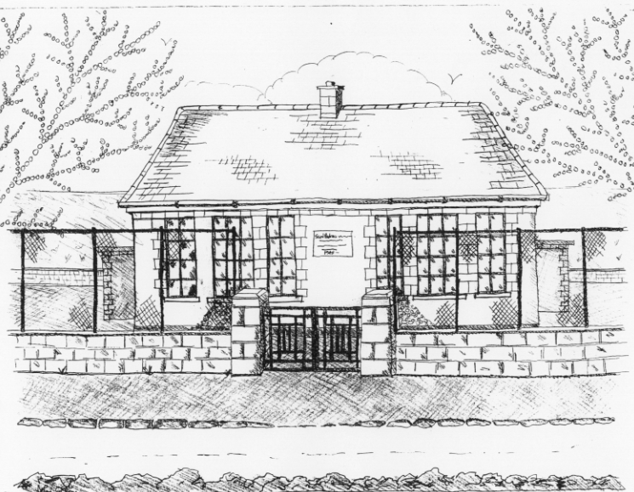
St. Patrick’s National School,
Glencullen,
Dublin 18.
Tel (01) 2954255
Email secretary@glencullenschool.ie
Website: www.glencullenschool.ie
Roll Number: 17507F

DECEMBER NEWSLETTER & UPCOMING EVENTS

Jingle & Mingle
Sunday 6th December 11-1pm

Our Jingle & Mingle event preparation is in full swing thanks to our hardworking elves. Raffle prizes can be dropped into the Office or to Patricia Campbell. Raffle tickets will be sold on the day but also this Wed, Thurs & Fri at the Office from 9.20-9.40am. Baking can be dropped off on Saturday between 5-7pm. Anybody available to volunteer on the Saturday or Sunday please contact Vanessa Stonys 0872675439. But please be advised that no children are allowed on premises during Saturday’s organizational day.

Christmas Presents for staff

Every year we remind you that there is no need for parents to buy Christmas gifts for teachers and staff. Your kindness and generosity is very evident throughout the year in your support of fundraising events and this is more than enough. I know each teacher would love a homemade card from a child (where possible) but presents are not necessary. We thank you for your thoughtfulness.

Christmas Concerts

We are delighted to invite you to our annual Christmas concerts. This year 2nd, 3rd and 4th class will perform a special moonlit concert on Monday 21st evening at 7.30pm in the Rachel Murphy Hall. This will be followed on Tuesday 22nd with our junior pupils – to 1st class performing the Nativity story from 11.15am.
The Senior pupils will continue to perform in their annual show later in the year.

School Closure

A reminder that school is closed this Monday 7th December.

Feast of the Immaculate Conception

Pupils from 1st-6th class will attend mass on Tuesday 8th December at 10am in St. Patrick’s Church to celebrate the Feast of the Immaculate Conception. All welcome.

Sam Maguire Visit

Exciting news!! The Sam Maguire Cup will be visiting St. Patrick’s NS on Tuesday 8th December at 11.15am. To celebrate this momentous visit, all children can wear their Dubs colours into school on that day. Parents and community members are welcome to come see the cup on this day too. But please be aware it will only be here for half an hour so be on time if you wish to see it!

Barnardos
A sincere thank you to everyone for their generous donations to Barnardos this year. This year St. Patrick’s NS school community hope to provide 120 children’s gifts, 16 hampers and a variety of large toys & bikes. All gifts & donations of food need to be in by Friday 4th at the latest. Many children will be having a happy Christmas thanks to you!
Sincere thanks to Betty O Connor for organising this every year.

Swimming

Swimming will commence on the 7th January 2016 for 2nd , 3rd & 4th class pupils. Forms will go out after Christmas and fees should be returned to the office by the 13th January.

Strictly St. Patrick’s

As you’ve already heard we are hosting a huge fundraiser for our school on February 12th. Our PA committee are looking for the twinkle toes amongst you who would like to take part in the dancing. Having taken part for the Stars of Erin last year, I can highly recommend it as a really fun event and well worth volunteering your time for. If you would like to take part, or if you know anyone outside of the school who would like to join in, please ring Vanessa on 0872675439.

ICT Pupils Committee

Congratulations to the new members of our pupil’s IT Committee;

Holly Gilmer  Amy Hill  Sarah Fitzsimon | James Ruane  Romy Featherstone  Jack Keane | Noah Sinclair  Ruby Swan  Joe Daly

Our first event that we are taking part in is the international Hour of Code. This is where pupils learn how to code using simple games. Coding encourages problem solving & logistical thinking and is considered an essential 21st century skill.

On Thursday 10th December our pupils committee will work with 3rd, 4th, 5th & 6th class on a special Star Wars themed coding activity. They hope also to get into 1st & 2nd class and teach them a fe small steps in computer programming.

Golden Book

As you know we have a special initiative to recognise pupils who demonstrate exceptional skills, talents, academic achievement, acts of selflessness, generosity & kindness in our school. These children are nominated by teachers or peers and are honoured with being included in our Golden Book.
This month’s honourees are;
- Layla Duffy 1st class
- Liam Campbell 6th class
- Mark Grenham 3rd class

Christmas Holidays

School will close for the Christmas holidays on Tuesday 22nd December at 12.30pm and reopen on January 6th. As the 6th of January is a Holy Day of Obligation, we will attend mass in St. Patrick’s Church on this day.

From all of the staff here at St. Patrick’s NS we wish each of you a very happy and peaceful Christmas. Best wishes for 2016!

