March/ April Edition

A Sprinkle of St. Patrick’s

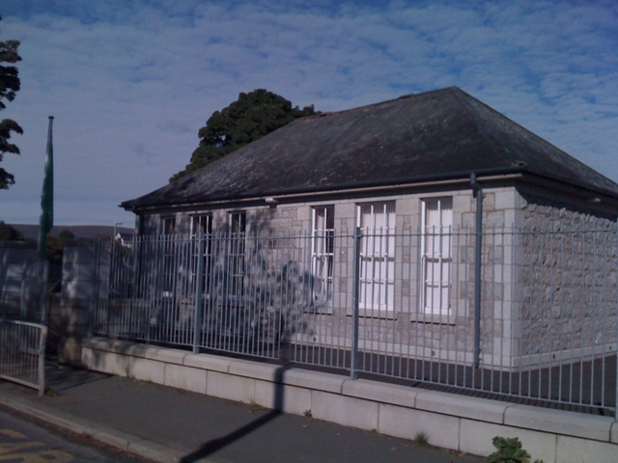

INSIDE:
School news!!!
- Conformation
- World book day
- Irish aid
- 1916
- Strictly St. Patricks
- Snow
- Internet safety day
- Monthly competition
- Seact ná galige
- Our magazine team

Glencullen online school magazine
Hello welcome back to a sprinkle of St. Patrick’s. This is our march edition. A sprinkle of St. Patrick’s is our online school magazine. Last month we had lots of activities and things going on around our school. This month we have EVEN MORE!!! So keep reading to see what’s going on down here in Glencullen.
Conformation:
On the 26th of February our class made our Confirmation. We made it with Holy Trinity N.S. Mons. Lorcain O’Brien and Father Andrew were confirming us. Both schools looked very nice in their uniforms and it was a lovely ceremony. Our class took many photos when the ceremony had ended and one special photo with the whole class and Mons. Lorcan O’Brien standing on the altar. We would like to thank the choir for their amazing singing at the church. After the ceremony many people had parties, also a few of our class went to the Royal Marine Hotel in Dun Laoghaire. And of course none of this would have happened without the help and preparation from Ms Casey our teacher, Nicola our class SNA, our secretary Betty and our Principal Ms. Byrne. We all had a wonderful day.

World book day 2016:
I hope your World Book Day was fun because St. Patricks N.S had a great time. To start of the day 5th class went down and read some books to the junior infants, 4th class went and read to the senior infants. 2nd 3rd, 4th & 5th class also had some DEAR time while some of the other classes did some reading aloud. 5th class also made some book marks. Then when everything quietened down in the evening 6th and 5th class joined together and had a book table quiz. Well done to the winners Emma Mooney, Siún Handley, Riona Moulton, and Ben O Dwyer. And at the end of the day all the students got a book token, I hope you all had a great World Book Day and were curled up with one of your favourite books

Irish aid:

Don’t forget about our monthly competition. This month’s topic is “Music”. You can enter a drawing, poem, story, song, etc. The Entry box is in the Foyer

Prizes:
Homework pass
Your entry gets published in the magazine!!!

Irish Aid is a great programme that helps countries that need more homes, more water, education, food and lots more. It can save people’s lives. They have come up with 17 Global Goals for you to work on and hopefully be achieved by 2030 to improve the lives of people around the world. They are No poverty, No hunger, Good education, Good health, Gender Equality, Climate Action and lots more. Ireland has 9 key partner countries to help - they are Lesotho, Mozambique, Sierra Leon, Tanzania, Vietnam, Ethiopia, Malawi, Uganda and Zambia. 5th class has done a project to try and spread the word about The Global Goals and to communicate with other people what they can do. It is called ‘Spread the Word & take Action’. We did this by making posters showing what you can do to help, for example: buying fair-trade, saving energy, saving water, recycling and only using what you need. We also have been doing other things to make people aware. We made an art sculpture called ‘The Global Goal Tree for Life’ which we made out of litter. We wrote a song called ‘One World One Future’ and made a music video. We also made a video outlining the Global Goals in our own words. We have been making some leaflets to hand out at school and posters to put up at school. We have learned from the Irish Aid that there are a lot more countries and people than we thought who need our help, and you need to stop for a moment to think about everything you have and that there are people out there who would be grateful to be us. So please, help us do this and save people’s lives.
If you would like to join the fight in achieving the 17 Global Goals, have a look at our website www.glencullenschool.ie for ideas and photos of our fun project!
1916:
As you know, we have just celebrated our 1916 Proclamation Day. Proclamation day was amazing down here at St Patrick’s. Every family created an Ancestry project finding family members back as far as 1916. We then had a Treasure Hun using these projects.
On proclamation Day we had a ceili in the hall for the whole school. That afternoon, parents and community members joined us in reading the 1916 proclamation and our own Proclamation for a New Generation. Each class shared what they had learned and we heard about the Handley family’s Ancestry project. We had our 1916 art competition winners revealed. We had loads of trophies to hand out. It was such a turn out. Finally Riona and Marco helped raise our Tricolor. All the parents then came to view our art work and our projects. Wow what an amazing day!
Strictly St. Patricks:
Our first ever Strictly St. Patricks got off to a great start even though they were beginner dancers!
Mr. Coughlan, Mr. Terry and many more were competing for the top spot. There was a variety of dances like the Quickstep, Charleston and many more. It was a great night. Deirdre McCabe & Eoin Roe came in 3rd place who danced the salsa, Rachel Simpson & Brian Murray came in 2nd who danced the Quickstep and in a phenomenal 1st place was Sharon Vard & Adrian Grenham with an amazing twist. Choreography was up to perfection. The judges were amazed by what skill the dancers had. With lifts, twists and tricks the audience was amazed. And the dancers should be really proud of themselves. On top of that they raised over €31,000. Can’t wait till next year!!
Snow
What a surprise we got on Friday 4th March when Glencullen woke up to a Winter wonderland! While this is great fun for our girls & boys, it can be a lot of work to get the school open. Thanks to our caretaker Denis and parent Trevor Hamilton who cleared paths around the school. And once the roads got gritted, traffic started moving more safely. Thank you to everyone for the patience and understanding in our efforts to get children to school safely.
Internet safety day:
This year on Internet Safety day, the I.T. committee Noah Sinclair, Holly Gilmer, Sarah Fitzsimon, Ruby Swan, Romy Featherstone, Joe Daly, James Ruane and Jack Keane all spoke to the Junior classes with tips on staying safe online. As part of the Webwise campaign we took a Super Selfie photo, but remembered that we have to keep safe on the internet, so we wore masks to disguise ourselves.
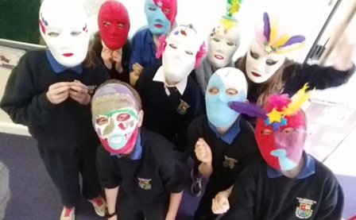
We also had Emma Vard, a parent from Microsoft, come in and talk to 3rd & 4th class .As well as that Garda Pat and Garda Mandy gave 5th & 6th class a workshop about cyber bullying.
The I.T. committee spoke to 2nd & 3rd class about the Granny Rule which means before you post something up online you should think if you would want your granny to see it.
We told them if you are being cyber bullied you should stop, block and tell. We also told them that before you post something online you should think: T for is it true, H for is it helpful, I for is it inspiring for is it necessary and K for is it kind.
Best of all, the it committee got interviewed and appeared on RTE News2day!!! Reporter Gill Stedman and her camera crew, spent the morning in our school filming all the great work our committee had organised. It was so exciting!

This month’s Competition winners:
As you know we just started our new competition. Here are our March winners:
It was very difficult to choose only three winners because every entry was brilliant, but we made our decision and here they are. In 5th class we have Sabastine Pennington, in 1st we have Caroline Jordan and in Junior Infants we have Emma Veale. Congratulations!!
This month sadly nobody from 3rd or 4th class entered our competition. We hope to see you next month. On the bright side we did have plenty more entries.
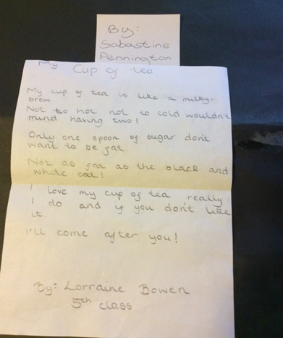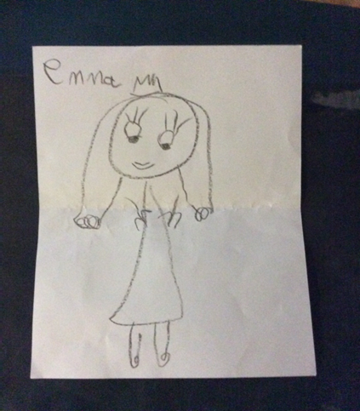

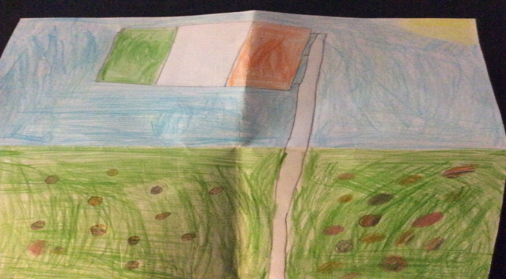

And here are the winners of April’s competition:
In 1st class we have Saorise Handley, in 5th class we have Regan O Hanlon and in senior infants we have Ava Plant.
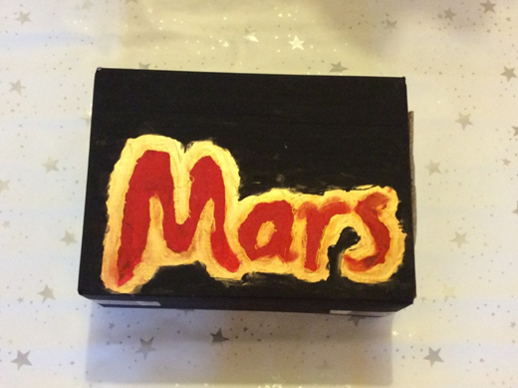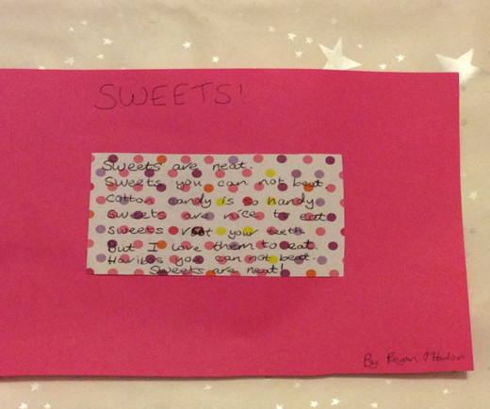

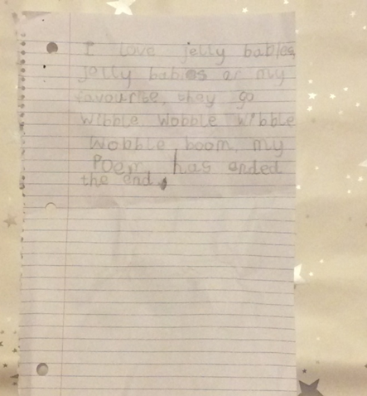

Seachtain na Gaelige

Tá Seachtain na Gaelige ag teacht.

Beidh ceílí againn agus beidh spraoi againn.

Tá muid ag foghlaim an Staicín eorna agus Balla Luimnigh.

Beimíd ag canadh Oró sé do Bheath Bhaile.

Bhi a lan craic againn..

Seachtain na Gaelige was really fun. We learned the ceili and sang
loads of irish songs including Oró sé do Bheatha Bhaile! The teachers even
nominated people for speaking the most irish and they won an
Easter egg. We had soooooo much fun!!!

Thank you so much for reading and make sure to read next month’s magazine to find out what’s happening in St.Patricks NS Glencullen!!!! (Also known as the best school ever!!!!!!!!)

In the Community

[Event Name]
[You can add a description and key information about event here.]

[Event Name]
[You can add a description and key information about event here.]

Our magazine team:
Reporters:
- Ciara Doyle
- Lilly-May Craig
- Sarah Fitzsimons
- Amy Hill
- Ella O’ Donohue
- Kelly-Ann Coughlan
- Brady Walsh
- Oonagh Mc Carthy

Photographer:
- Sarah Fitzsimons
Editor:
- Holly Gilmer

Along with the amazing help of our superb principal MS BYRNE!!!
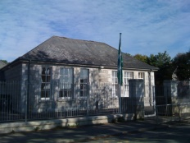 THANK YOU!!!!! 