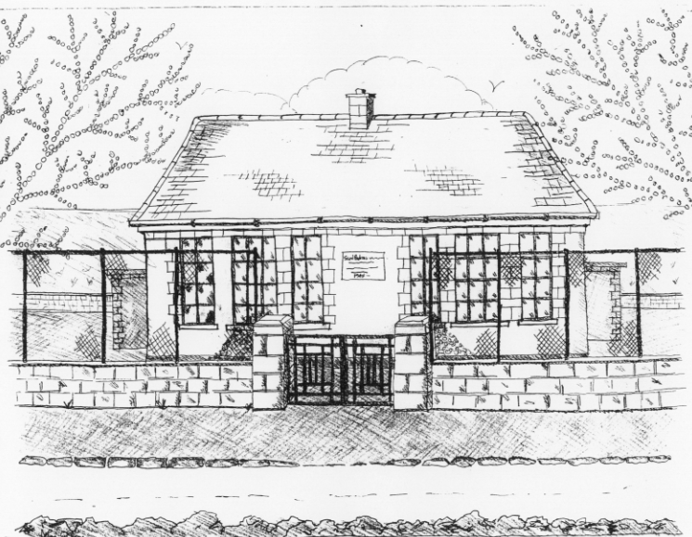 St. Patrick’s NS Booklist 2018-19

6th Class

Books to be Purchased by Parents

Books to be Bought  Spellbound F. (Folens)  Am Don Léamh 6 (Folens)  Master Your Maths 6 (CJ Fallons)  Planet Maths 6 (Folens)  My Confirmation Year (Veritas)  *Due to the new primary Language Curriculum  6th class can purchase their Gaeilge Workbook  through the office in September | Books to be Kept  English/Irish Dictionary (home)  D Tin Whistle  Bí ag Scriobh Card (if lost purchase in office)  Poetry Folder  1 x 20page Display Folder (Self Assessment Learning Folder)
Copies & Ancillary materials  Keep  2 Sum Copies 88 page 7mm. Hard Covered Copy  10x 88page page writing copies. USB 2 GB Key  2 x 40 page copies. Calculator  Homework Journal (Fallons)  1 x 40pg Display Folder (Finished Work & Choir Music) | Keep  Hard Covered Copy (Gaeilge)  USB 2 GB key  Calculator  Geometry set  A2 Card Art Folder

School Costs
Art & Crafts Fees  Photocopying Fees  Primary Planet Magazine  Book Rental Scheme Fee (please see overleaf for books included) | €10  €10  €10 (Supplemented by fundraising)  €25
TOTAL: | €55

Costs can be paid in full or in instalments as suits.
Please enclose in an envelope labelled with your child’s name and class and amount

Please put your child’s name on all books, coats, hats, jumpers/cardigans and other belongings.

School Rental Scheme: 6th class

 | Purchasing Price
SESE  History Quest  Geography Quest  Windows of the World Geography  Windows of the World History  Atlas | €11.90  €11.90  €9.95  €9.95  €14.00
English  Snakes, Eyeballs and Indians Reader (Gill & Macmillan)  Snakes, Eyeballs and Indians Skills Book  Lift off 6  Oxford English Dictionary  Class Novels (estimated 4-5)  Ghosts Secrets & Thieves Reader (Carroll Ed. Co.)  Ghosts Secrets & Thieves Skills Book | €16.95  €9.75  €9.75  €12.80  €9.99 each  €16.95  €9.95
Gaeilge  Sin É 6  Bun go Barr 6  Focloir Gaeilge | €19.40  €20.35  €12.25
Religion  Alive O 8 | €12.45

