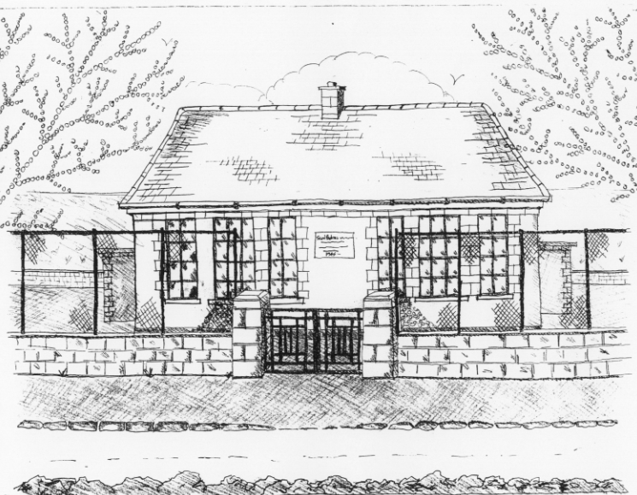 St. Patrick’s NS Booklist 2018-19

4th Class

Books to be Purchased by Parents

Books to be Bought  Spellbound D. (Folens)  Am Don Léamh 4 (Folens)  Master Your Maths 4 (CJ Fallons)  Planet Maths 4 (Folens)  *Due to the new primary Language Curriculum  4th class can purchase their Gaeilge Workbook  through the office in September | Books to be Kept  D Tin Whistle  Tin Whistle Music Folder  Poetry Folder  Self Assessment Learning Folder
Copies & Ancillary materials
2 Sum Copies 88 Page 7mm
6x 88page page writing copies.
1 x 40 page copies.
1 handwriting copy B4 Lines
USB 2 GB key
Homework Journal (Fallons)
1 x 20pg Display Folder (SESE)
1 x 40pg Display Folder (Finished Work)
A2 card Art Folder
Calculator

School Costs

Art & Crafts Fees  Photocopying Fees  Book Rental Scheme Fee (please see overleaf for books included)  Friends for Life Workbook (supplemented by B.O.M.)  Primary Planet | €10  €10  €15  €10
TOTAL: | €45

Costs can be paid in full or in instalments as suits.
Please enclose in an envelope labelled with your child’s name and class and amount

- Please put your child’s name on books, coats, hats, jumper/cardigan and
Other belongings.

School Book Rental Scheme 4th Class (€15 as above)

School Rental Scheme 4th Class | Purchasing Price
SESE  History Quest  Geography Quest  Windows of the World Geography  Windows of the World History  Atlas | €11.90  €11.90  €9.50  €9.50  €14.00
English  Giants, Fishbones & Chocolate  Giants, Fishbones & Chocolate Skills Book (Carroll Ed. Co.)  Witches, Spiders & Cowboys  Witches, Spiders & Cowboys Skills Book (Gill & Macmillan)  Oxford English Dictionary & Thesaurus  Class Novels (3/4 ) | €14.95  €9.75  €15.95  €9.75  €12.80  €9.99 each
Religion  Grow in Love 4th Class | €12.99

