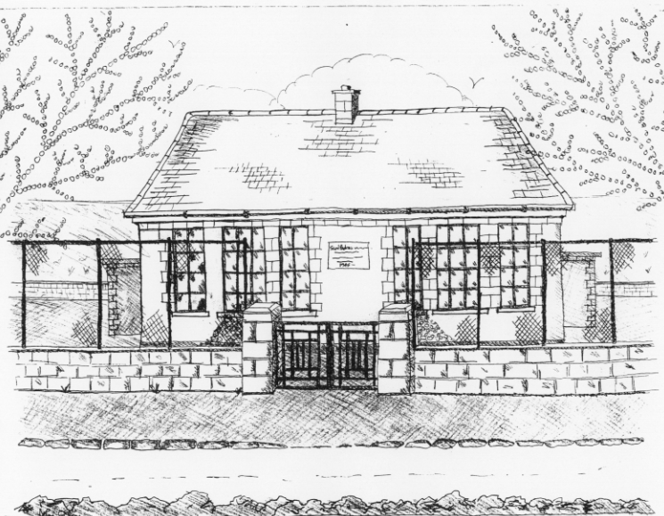 St. Patrick’s NS Booklist 2018-19

2nd Class

Books to be Purchased by Parents

Books to be Bought
The Green Genie Combined Reading and Activity (Folens)
Master Your Maths 2. (CJ Fallon) * Due to the new Primary Language
Planet Maths 2 (Folens) Curriculum, 2nd class can purchase
Grow In Love 2nd Class (Veritas) their Gaeilge workbook through the
All Write Now 2nd class (Folens) office in September

Copies & Ancillary materials
2 Sum Copies 40 Page 10mm
8 x 40page writing copies
Homework Journal (Fallons)
*2 x 20pg Display Folders ( Self Assessment Learning Folder) *Keep from 1st class
1 x 40pg Display Folder (Finished Work)

Each child will need a pencil case with the following items.
2 pencils, 1 rubber, 1 x 12 pack twistable colours, 1 large Pritt Stick Glue.

School Costs

Art & Crafts Fees  Photocopying Fees  Book Rental Scheme Fee (please see below for books included) | €10  €10  €10
TOTAL: | €30

Costs can be paid in full or in instalments as suits.
Please enclose in an envelope labelled with your child’s name and class and amount

School Book Rental Scheme 2nd Class (€10 as above)

 | Purchasing Price
SESE  History Quest 2  Geography Quest 2 | €9.30  €9.30
English  Class Novels (1 – 2)  Ancillary Readers (approx. 20) | €9.99 each  €7.99 each

