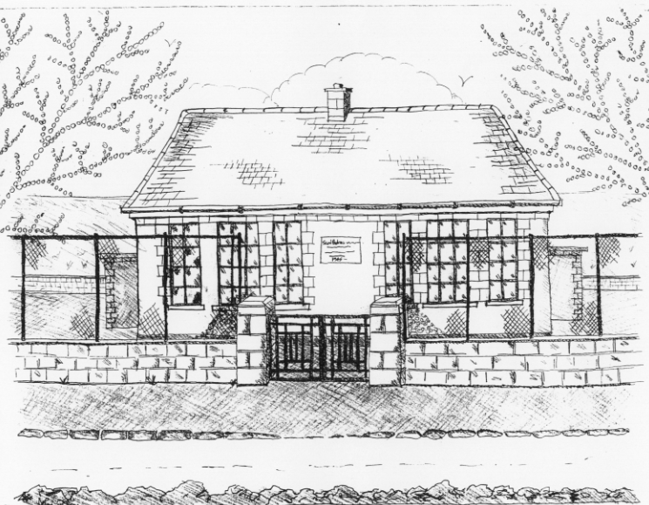
St. Patrick’s National School,
Glencullen,
Dublin 18.
Tel (01) 2954255
Email secretary@glencullenschool.ie
Website: www.glencullenschool.ie
Roll Number: 17507F

MAY 2018 NEWS & UPCOMING EVENTS

Irish Aid Awards
Congratulations to 5th class who have reached the Regional finals of the Irish Aid Awards 2017. We have been shortlisted to 15 schools in the Leinster region and 3 representatives will go along to the Award ceremony. This will take place on Tuesday 15th May in the Dept. of Education in Dublin where the Minister for Foreign Affairs along with other dignitaries will view our project ‘The Plastic Ocean’ before the awards ceremony. Three projects will be then chosen to go on to the National Finals. We wish our boys and girls the very best of luck and congratulate them on such a wonderful achievement!

Bags2School
Sincere thanks to all who brought in bags for this fundraiser raising €247.68 for our school. Many thanks to our PA for organising!

Cumann na mBunscol Hurling League
Congratulations to our wonderful hurling team who are now through to the semi-final of this year’s Shield competition. Our next match takes place after mid term and will hopefully lead us to Croke Park.

First Holy Communions
Our First Holy Communion will take place on Saturday 5th May at 11am in St. Patrick’s Church, Glencullen followed by a Communion reception in the Rachel Murphy Hall. Many thanks to Ms.Lally, Betty O’ Connor, our school choir, the Do This in Memory Committee & the First Class parents Reception committee for all their support in preparing for this special day. All of our staff here send special wishes to each of our Communicants on receiving this special sacrament.

Credit Union
Congratulations to Lauren Mooney winner of a €150 voucher for Joe Daly’s Bikes as part of the regular Savers scheme. We will have a second voucher at the end of June for all who regularly save with our credit union.

A very sincere thank you to all our volunteers this year. We are always looking for new volunteers and will especially need some new people for next year. If you could give up a 20 minutes on a Thursday morning on a rotational basis, please give your name to Betty or parent Helen Fisher. Many thanks.

School Tours
We have a number of school tours taking place in June. They are as follows;
- Junior Infants are heading up to the Pine Forest Art Centre on the 11th June
- Senior Infants are off to Airfield Estate on the 27th June
- 1st class will visit Lullymore Farm on June 6th
- 2nd class are off to Russborough House June 8th
- 3rd class are heading to Squirrel Scramble 23rd May
- 4th class will visit the Croke Park Tour & Epic Famine Museum 18th June
- 5th class go on their tour to Larchill Adventure Centre 18th June
- 6th class to be confirmed with Mr. Coughlan
Thank you to the PA fundraising for subsidising these trips.

Letters regarding each trip will go out over the week to individual classes.

School Garden
Our school garden is looking particularly beautiful in this sunny weather thanks to Denis and the children. The children will now be planting vegetables in the beds and plants in other areas. Each class has responsibility for a particular area while simultaneously using the garden during other lessons as a place of tranquillity. Our garden is a special place for learning and we all enjoy our time there.

Children are of course allowed to visit the garden after school under the strict supervision of their parents/guardians. Any child or adult who is found to be vandalising the garden, jumping on tables, climbing fences or any other dangerous behaviour will be asked to leave the garden and not return. If damage to the garden repeatedly occurs, we will have to close the garden to all visitors outside class time. Therefore please treat our beautiful garden with respect and enjoy it!

Treehouse Montessori: Breakfast Club & after School Drop off 2018-19
Treehouse Montessori is opening up a Montessori playschool in Glencullen Community Centre this September 2018, from 9-1pm. They will be providing a Breakfast Club from 8-9.20am for any pupils in St. Patrick’s NS who wishes to attend. The cost is €5 per morning. They will also be operating an After School Drop In service from 2-6pm at €7 per hour (including a hot meal).Please contact Elaine Dunne at 0831852426 for more information.

