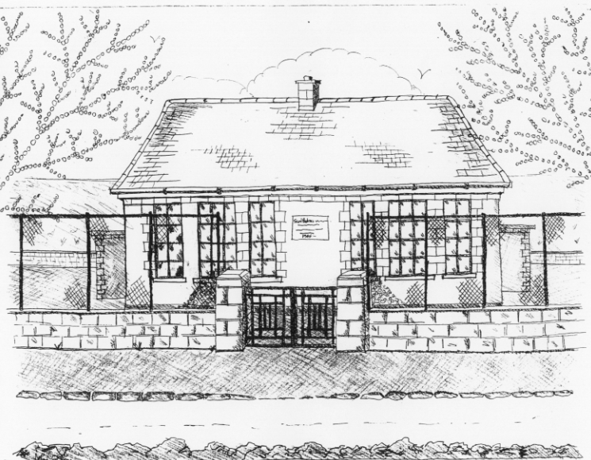
St. Patrick’s National School
Glencullen,
Dublin 18.
Tel (01) 2954255
Email secretary@glencullenschool.ie
Roll Number: 17507F
www.glencullenschool.ie

MARCH NEWS & UPCOMING EVENTS

Child Safeguarding Statement
There are new Child Protection Procedures now in place for all primary & post primary schools. These new procedures give direction and guidance to schools authorities and to school personnel in relation to meeting their new statutory obligations under the Children First Act, 2015 and in the continued implementation of the best practice (non-statutory) guidance set out in Children First National Guidance 2017. You can access these procedures at www.education.ie.

Our Board of Management are currently devising our Child Safeguarding Statement in consultation with our staff, Parents Association & Student Council. This includes a risk assessment on the possible risks of harm to children in school. This statement will be completed and published on our website by 11th March.

World Book Day
World Book Day took place on Thursday 1st March. This is the biggest global celebration of books and a wonderful promotion of the enjoyment of reading. Please use this day as an opportunity to enjoy a good book with your child!

The Little Book of Big Imagination
Congratulations to all our budding authors in 3rd, 4th, 5th & 6th class who took part in this year’s writing project in becoming a published author. We are celebrating all of their successes at a special assembly where each author will share their story with children from other classes. A sincere thank you to Ms. Quigley, Ms. O Brien & Mr. Coughlan who put a huge amount of work into these young writers. Their anthology of short stories ‘The Little Book of Big Imagination’ will be on sale from Monday at €10 per copy. This is not a fundraiser but a unique opportunity to inspire & support our budding writers in seeing their work published and appreciated.

Seachtain na Gaeilge
Beidh Seachtain an Gaeilge againn 12^{ú} – 16ú de Márta. During this week, we encourage everyone to make an effort to ‘bí ag caint as Gaeilge’. Lots of activities will take place this week including dramaíocht Gaeilge, scéalta, Tráth na gCeist, amhrain, filíocht, cluichí agus ceilí. Everyone will be ready with their cúpla focail on St. Patrick’s Day!

Bingo Night
Our PA would like to invite you all to join us for a fantastic night of fun & frolics at our latest fundraiser for our school, Bingo. Join us on March 15th at 7.30pm in Johnny Foxes pub and bring your friends!!

Trocaire Boxes
A Trocaire Box was sent to each family at the beginning of Lent. These boxes must be returned to the school on Thursday 15th March as they are being collected.

Car Park Safety
Can parents please advise childminders, grandparents and others who may be collecting your child, the correct procedure for parking and leaving the Church carpark. A number of small children are still wandering through the carpark daily looking for their parents and we are very concerned there will be a serious accident. Please collect all young children from the school yard or school gate for their personal safety. Our Student Council have commented on children walking behind moving cars and will be speaking to all classes about child safety in the carparks.

Cumann na mBunscol Hurling League
This year’s hurling league begins on March 15th. We are inviting students from 5th & 6th class who currently play hurling or camogie to come and join our team. There will be 3 initial matches followed by a knock out phase. Many thanks to our coaches Peter Keane and Mr. Coughlan for their time and support in coaching our team and thanks to our staff who offer supervision.

Bags to School Collection
Just to let you know in advance, our next Bags 2 School collection takes place on Wednesday 11th April. You may like to use the Easter holidays to gather up unwanted clothing, shoes, teddies and more. Thanks to our PA for organizing this event.

Cake Sale
Our annual Easter Cake sale will take place on Friday 23rd March at 12.30pm. More information will follow from our PA. But for now, get your oven mitts out and the icing bag piped as we look forward to a delicious end to our second term!

New Primary Language Curriculum: In-service Training
The new primary language curriculum is in its second phase and all teachers in Ireland must partake in compulsory whole school in-service. We have received word that our training will take place on April 23rd. Therefore our school will be closed on this day.

School Closures
As we are closing on Friday 16th March to facilitate compulsory staff training in new Child Protection measures, we will reopen on Tuesday 20th March following the Bank Holiday.

We will close at 12.30pm on Friday 23rd March for the Easter holidays and reopen 9th April.

Wishing you all a lovely Easter break.

