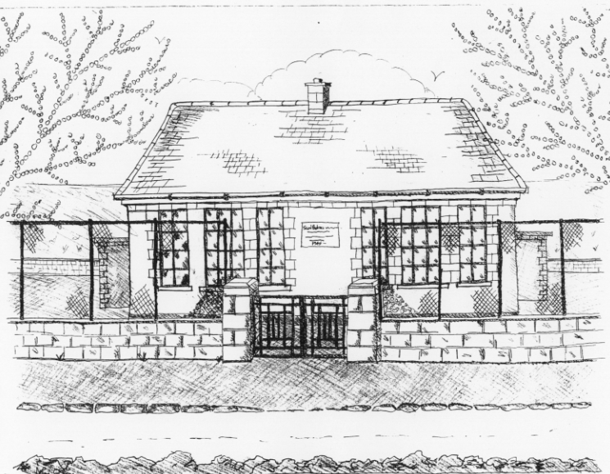
St. Patrick’s National School,
Glencullen,
Dublin 18.
Tel (01) 2954255
Email secretary@glencullenschool.ie
Website: www.glencullenschool.ie
Roll Number: 17507F

DECEMBER NEWSLETTER & UPCOMING EVENTS

‘The Spirit Of Christmas’ Fair
Sunday 3rd December 10.45am

Our Christmas fair preparation is in full swing thanks to our hardworking elves. All raffle tickets sold must have the stubs returned by Friday to be part of the sellers competition. Raffle tickets will also be sold on the day. Baking can be dropped off on Saturday between 10-3pm. Anybody available to volunteer on the Saturday or Sunday please contact Emma Madigan 0879384036 . But please be advised that no children are allowed on premises during Saturday’s preparation day.

This year, thanks to parents Eoin & Ann Roe we will have a live crib. Along with the many stalls will be a disco, café and Games Room. And Santa Claus himself will arrive at 10.45am with lovely carols from 5th & 6th class!

Sincere thanks to our PA Committee for their hard work on this event. Looking forward to seeing you all at our wonderful fair!

Christmas Presents for staff

Every year we remind you that there is no need for parents to buy Christmas gifts for teachers and staff. Your kindness and generosity is very evident throughout the year in your support of fundraising events and this is more than enough. I know each teacher would love a homemade card from a child (where possible) but presents are not necessary. We thank you for your thoughtfulness.

Christmas Concerts

We are delighted to invite you to our annual Christmas concerts. This year 3rd, 4th, 5th & 6th class will perform ‘Super Star’ on Thursday 21st at 2pm in the Rachel Murphy Hall. This will be followed on Friday 22nd with our Infant pupils performing ‘ABC Nativity’ and 1st & 2nd class’ performing ‘Hey Ewe!’, all from 11.15am in the Rachel Murphy Hall. Thank you to all our teachers and SNAs for helping the children to put on such wonderful shows!

School Closure

A reminder that school is closed Friday 8th December.

Barnardos
A sincere thank you to everyone for their generous donations to Barnardos this year. This year St. Patrick’s NS school community hope to provide 110 children’s gifts, 15 hampers and a variety of large toys & bikes. All gifts & donations of food need to be in by Friday 1st at the latest. Many children will be having a happy Christmas thanks to you!

Sincere thanks to Betty O Connor for organising this every year.

Book Fair
Thank you to everyone who supported our Book Fair in October. The school can now claim €1622 in books from Scholastic for our school!

Dundrum Carol Singing for Laura Lynn

On December 11th our 6th class will sing some Christmas carols at Dundrum shopping centre to raise money for Laura Lynn hospice. It is wonderful to see the children doing such a kind & charitable gesture for other children who are so unwell at Christmas. If you would like to hear them, pop down between 11-12.30pm.

Swimming

Swimming will commence on the 18th January 2018 for Senior Infants & 3rd class pupils. Forms will go out after Christmas and fees should be returned to the office by the 18th January.

Sacrament Masses

A reminder to our sacrament classes that the next ‘Do This in Memory’ mass takes place on Sunday 16th December while the 6th class Confirmation preparation mass takes place on Sunday 17th December. Both masses take place in St. Patrick’s Church at 10am.

Youth Club

Parent Lindsey Harris is hoping to get a youth club up and running in January on Friday nights at the Stars of Erin clubhouse. Age group will be 10+!

She is looking for some local parents or siblings over 18years of age to volunteer sometime to meet get it off the ground and she also wants to get a committee of kids together

Contact Lindsey through Facebook :GlencullenYouthclub https://www.facebook.com/Dublinmountainscommunitycentre/
Or email theglencullenyouthclub@gmail.com
Call, Text or Whats App : 0867743106

Promotion of school

At our annual PA AGM in October, we shared the BOM plans to actively promote our school this year in a bid to promote enrolments to increase to an 8 teacher school, thus eventually removing the split class.

You can help us do this by promoting our school with neighbours, friends and family, sharing news and events from our facebook page ‘St. Patrick’s NS Glencullen’, retweeting from our school Twitter account and directing interested parties to our website. A key message we are trying to deliver is that we are only 5 mins drive from Kilternan as there is an impression that we are very high up the mountains.

Thank you in advance for this. Our goal to grow to an 8 teacher school (203 pupils) would remove the split class, something we know parents are eager for.

Christmas Holidays

School will close for the Christmas holidays on Friday 22nd December at 12.30pm and reopen on January 8th.

From all of the staff here at St. Patrick’s NS we wish each of you a very happy and peaceful Christmas. Best wishes for 2018!

