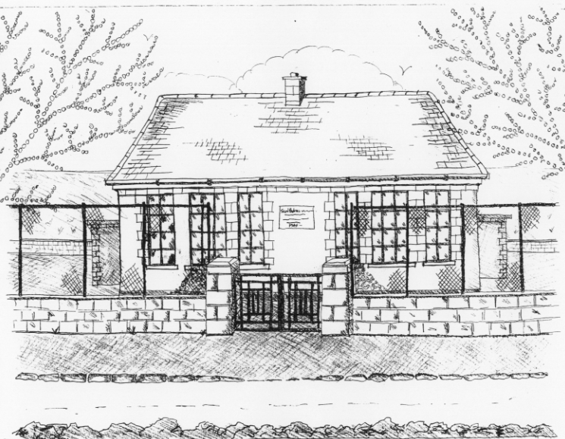
St. Patrick’s National School,
Glencullen,
Dublin 18.
Tel (01) 2954255
Email secretary@glencullenschool.ie
www.glencullenschool.ie
Roll Number: 17507F

OCTOBER NEWSLETTER & UPCOMING EVENTS

PA AGM
Reminder that our PA AGM takes place Wednesday 4th October at 8pm. We actively encourage all families to send at least one parent for this meeting which illustrates the importance of parent support & volunteerism in our daily school life. Please consider if you could offer some time to joining our PA Committee as we are only as strong as our parent support. The meeting will take place in the 5th class room with a glass of wine or cup of tea afterwards to thank you for your ongoing support.

Sincere thanks to our outgoing PA Committee who have worked tirelessly throughout the year for our school and our children.

BOM Father Nominee
A reminder that we will need a new father nominee on the BOM this year. All expressions of interest should be in the Office by Oct. 2nd for a decision to be made at the PA AGM. If there is more than one nominee a ballot will take place across the whole school community. A letter explaining this process was emailed and sent home in hard copy.

Junior Infant Meeting
A meeting for Junior Infant Parents will take place on Wednesday 4th October at 7.30pm. This will give parents an opportunity to learn about the Junior Infant programme for the year ahead and to ask Ms. Skelly any questions you may have about homework & class life.
This meeting will take place in the Junior Infant classroom.

Road Safety Week
As Irish Road Safety Week begins, we once again urge parents, child minders & visitors to our school to please slow down when driving near our school especially in our carparks. Our students will shortly begin a Carpark Safety Campaign urging adults to slow down, park carefully & remain alert to small children around car areas. Please adhere to our lollipop man by walking in front of him & not behind him. This teaches young children how to safely cross the road.

Cumann na mBunscol Matches
Well done to our Cumann na mBunscol team who are persevering through this year’s league. A special thank you to father Peter Keane & teacher Mr. Coughlan for training the team and accompanying the team to their matches. Thank you also to our staff who take time after school to accompany the teams & cheer them on. I hope the whole school will come and support some of their future matches as we continue our journey!

World Teacher’s Day
October 5th is World Teacher’s Day where countries and communities around the world celebrate teachers and all that they do. I am very proud of the calibre of staff we have working here at St. Patrick’s NS and I thank each of them for all that they do for the education, welfare and care of each child.

World Homeless Day of Action
World Homeless Day takes place on Tuesday 10th and is a timely reminder to examine social issues within our own country and locality with our children. Simply reminding young children what a wonderful home they have can bring about awareness of housing issues while the older children will explore in more detail the various definitions of homelessness through Focus Ireland’s programme No Place Like Home. Some of our senior pupils will take action by writing to our Ministers for Children and Housing respectively. Our Student Council have decided to do a collection of scarves here in the school for the homeless in WH5Loaves.

Nut allergies
Sincere thanks for all of your help in ensuring a safe environment for our pupils with severe nut allergies and I ask that you simply continue this support. There are no nut products allowed at St. Patrick’s NS.

Student Council
Congratulations to our newly elected members of the Student Council. They Romy Featherstone, Rachel Hamilton, Isobel O Malley (all 6th classs), Zara Mulhall (5th class), Nadia Kennedy (4th class) and Sean O Flynn (3rd class). Our council will give a student voice to issues that arise throughout the year and may offer insightful suggestions form the student body.

Book Fair
Our bi-annual Book Fair returns this month with an opportunity for children to purchase new books. The Scholastic Book Fair will arrive at Glencullen on the 16th October where children will be brought by their teachers to peruse the books. Tuesday 17th & Thursday 19th shall be the sales day where children can bring in money to buy books themselves. A time will be allocated between 9.20-10 am for parents to come in and make purchases themselves. The school receives 60% book return of all books sold. Therefore it is a wonderful opportunity not only for your child to get a new book but also for the classes to get new books for their libraries!

Niall De Burca, Storyteller
As part of our celebration of books, we have invited celebrated storyteller and performer Niall de Burca to come to perform for the children on Tuesday 17th. We hope to reignite their love of story and reading and we thank the PA for the fundraising that covers the cost of this event.

Maths Week
Maths Week shall take place between the 14th & 22nd October. This week is a celebration of maths and an opportunity to recognise the importance of maths in our daily lives. Throughout the week, children shall be taking part in Maths trails, quizzes, interactive games, projects, puzzles and activities. Encourage your child to develop his/her maths language and problem solving skills at home and in the community. See www.mathsweek.ie for events taking place in your area. For assistance with new topics in maths check out www.mathsisfun.com while www.haveyougotmathseyes.com/ gives great ideas for spotting maths in the environment.

Coding Workshops
1st-6th class will partake in Coding workshops on Friday 6th October as part of our Digital School programme. Senior classes will engage in some robotics activities in addition to the coding work. This is funded by the PA fundraising and we thank you most sincerely.

Sustainable Gardening
3rd – 6th class will enjoy 5 weeks of workshops on sustainable gardening free of charge thanks to DLR Green schools initiative. This forms part of our Science and Environmental education and we look forward to plenty of green fingers!

Mid term break/Halloween Celebration
We will close on Friday 27th October at standard closing hours for a week long mid-term break. As always on this day, children are allowed to dress up to celebrate the Halloween tradition. However, as a Green School, we encourage you to make your costume rather than shop buying it. This is not compulsory nor a competition just some Glencullen fun!! Of course please keep all ‘weaponry’ at home along with ‘high heel shoes’. Please remember due to severe nut allergies within the school that nuts are not allowed as a snack on this day.

