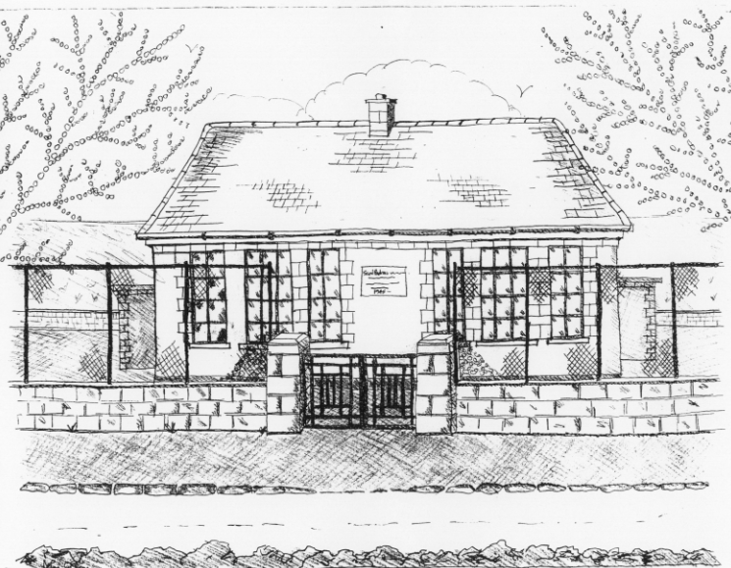 St. Patrick’s NS Booklist 2017 - 2018

Senior Infants Class

Books to be Purchased by Parents

Books to be Bought
Planet Maths Senior Infants (Folens) (including mini Number practise book)
Grow in Love Senior Infants (Veritas)
All Write Now Senior Infants (Folens) (including mini letter practise book)

Copies & Ancillary materials
2 x 15A Project copies (half blank, half lined)
Zip Folder A4 for homework

Each child will need a pencil case containing the following items:
2 pencils, 1 rubber, 1 x 12 pack of twistable crayons, 1 large Pritt Stick Glue, 1 thin whiteboard marker. This pencil case will be left in school.

School Costs

Art & Crafts Fees  Photocopying Fees  Book Rental Scheme for English Guided Reading | €20  €20  €15
TOTAL: | €55

Costs can be paid in full or in instalments as suits.
Please enclose in an envelope labelled with your child’s name and class and amount

- Please put your child’s name on all books, coats, hats, jumpers/cardigans and other belongings.

