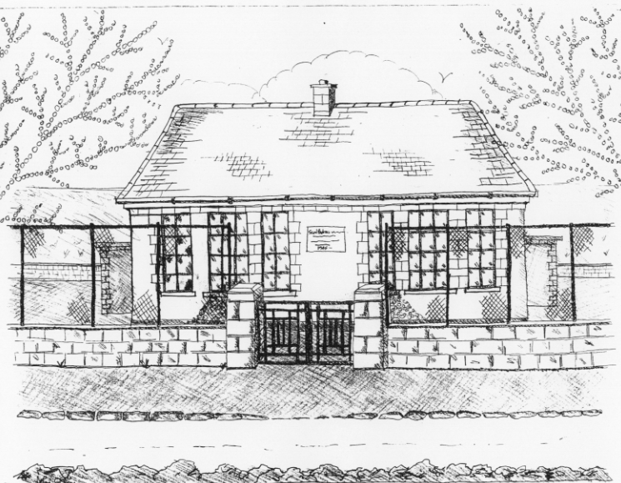 St. Patrick’s NS Booklist 2017 -2018

Junior Infants Class

Books to be Purchased by Parents

Books to be Bought

Planet Maths Junior Infants (Folens)
Planet Maths Junior Infants Number Practice (Folens)
Grow in Love Junior Infants (Veritas)
All Write Now Junior Infants (Folens)

Copies & Ancillary materials
2 x 15A Project copies (half blank, half lined)
1 x 20pg Display Folders (Poetry)
1 plastic button folder A4 (homework)
1 cardboard manila folder (finished worksheets)
Each child will need a pencil case containing the following items.
2 pencils, 1 rubber, 1 x 12 pack of twistable crayons , 1 large Pritt Stick Glue, 1 Thin Whiteboard Marker. This pencil case will be left in school.

School Costs

Art & Crafts Fees  Photocopying Fees  Book Rental Scheme for English Reading | €20  €20  €10
TOTAL:

Parents, the €100 paid on enrolment will cover the €50 swimming fee as well as the Art & Craft and Photocopying Fees.
Therefore no fee is required for school costs.

Please Note:
Going home times for children in Junior Infants are as follows:
12.30pm Wed 30th Thurs 31st and
Friday 1st Sept.
From Monday 4th September home time is 2pm.

- Please put your child’s name on all books, coats, hats, jumpers/cardigans and other belongings.

