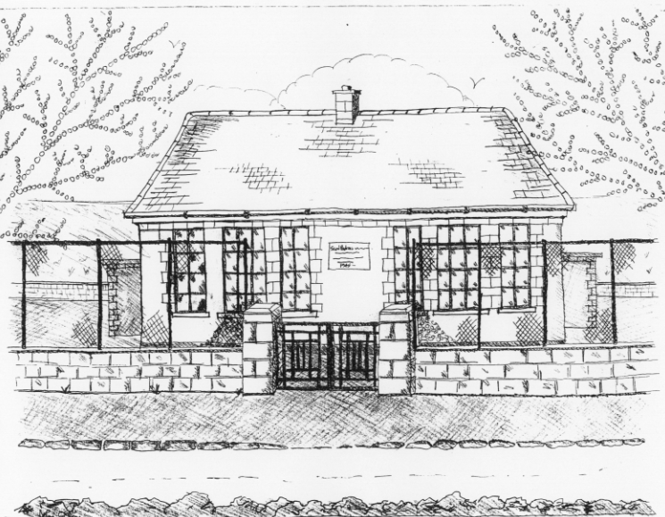
St. Patrick’s National School,
Glencullen,
Dublin 18.
Tel (01) 2954255
Email: secretary@glencullenschool.ie
Roll Number: 17507F

HOLIDAY LIST FOR SCHOOL YEAR 2017 – 2018
School Re-opens Wednesday 30th August 2017 at 9.20am.

Swimming Term 1: (4th & 6th class) Begins 7th Sept. – 19th Oct.

Swimming Term 2: (1st & 5th class) Begins 26th Oct. – Dec. 14th.

Mid-Term Break School closes Friday 27th October at 3pm
Re-opens Monday 6th Nov.

Parent/Teacher meetings Tuesday 21st & Wednesday 22nd November
(1st- 6th class)

School Closure School closed Friday 8th December
Christmas Holidays School closes on 22nd December at 12.30pm.
Re-opens on Monday 8th January 2018

Swimming Term 3(Sen. Inf. & 3rd class) Begins 18th January – 8th March

Parent/Teacher meetings Tuesday 6th & Wednesday 7th February.
(Junior/Senior Infants)

Mid-Term Break School closes on Wednesday 14th Feb. at 3pm
Re-opens on Monday 19th February

St. Patrick’s Day School closed Monday 19th March

Easter Holidays* School closes on Friday 23rd March at 12.30pm
Re-opens on Monday 9th April

Swimming Term 4 (Jun. Inf. & 2nd Class) Begins 19th April – 7th June

May Bank Holiday School closes on Friday 4th May at 3pm
Re-opens on Monday 14th May

June Bank Holiday School closed on Monday 4th June

Summer Holidays School closes on Friday 29th June at 12.30pm

* Following Circular 34/2011, please note that the Easter holidays may be subject to change should there be any unforeseen closures during the year (such as snow). Under this circular, the Easter break may be reduced by up to 3 days to make up for closures. Please be aware of this when booking holidays.

